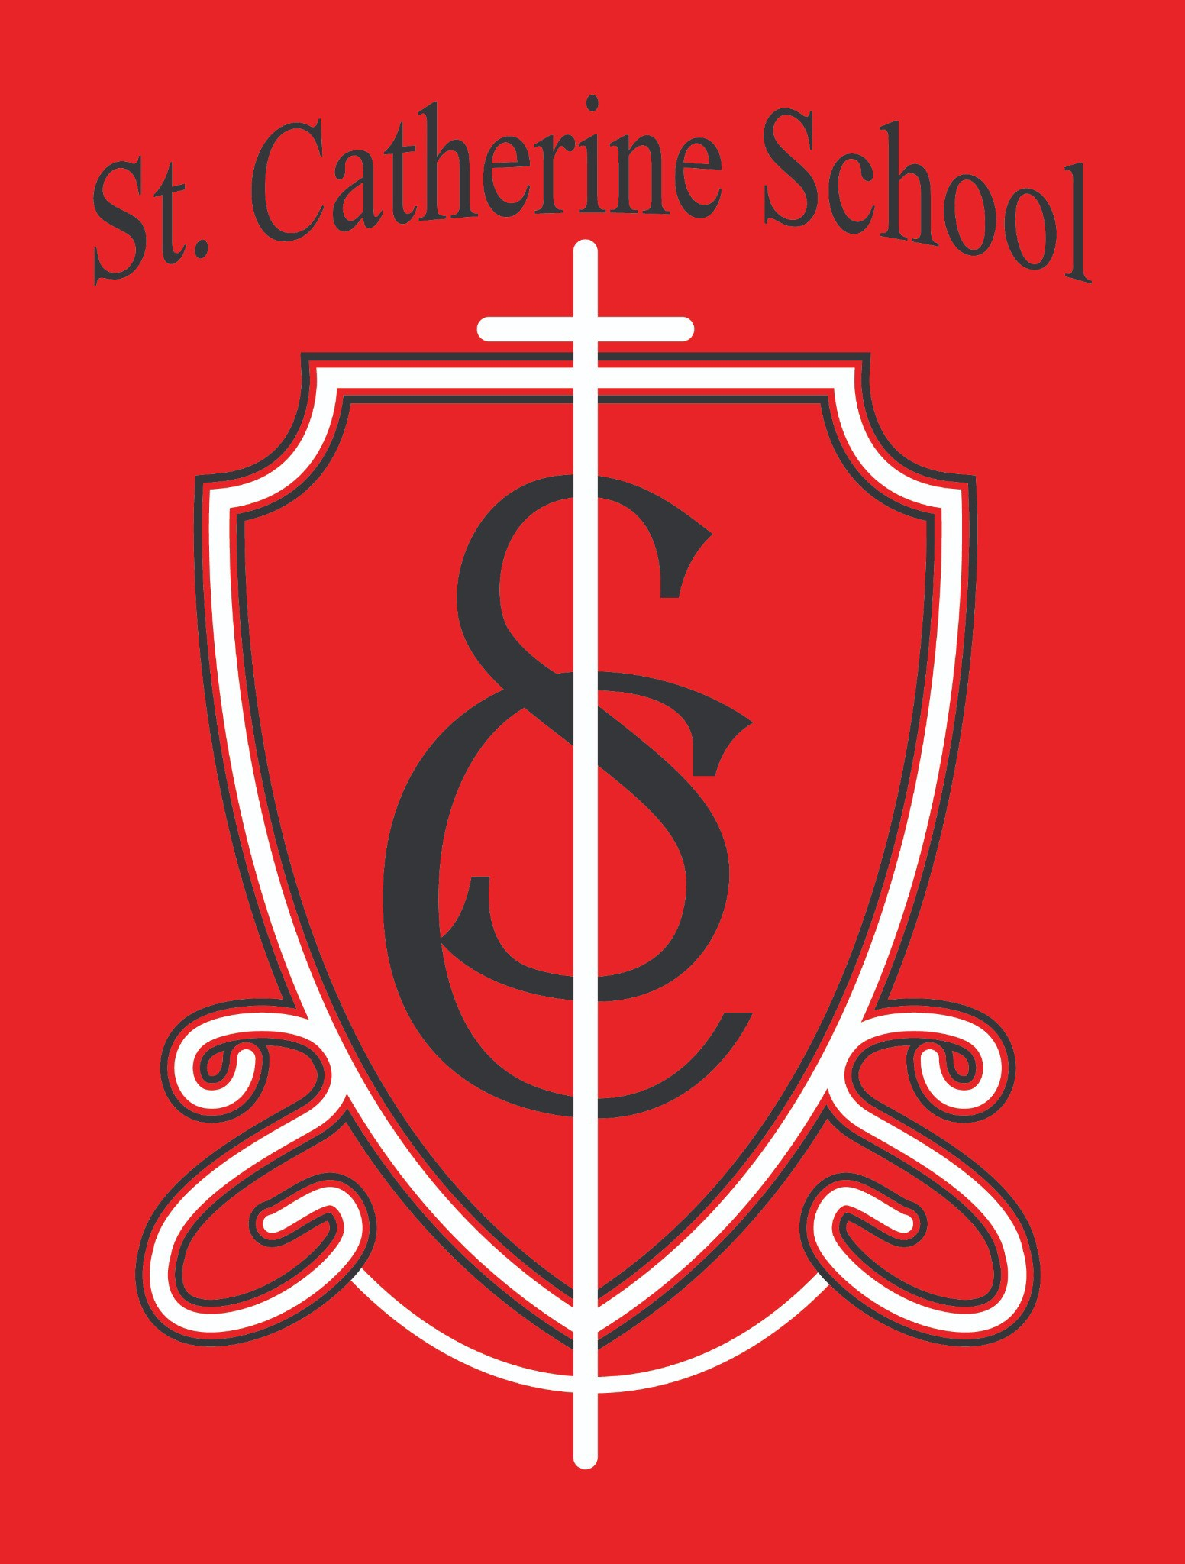

St. Catherine School Weekly Newsletter (Week of January 19-23)
https://www.stcatherine.k12.nd.us/parents

Principal's Message
Dear St. Catherine Families,
As we head into the coming week, our focus turns to one of the most meaningful celebrations of the year—Catholic Schools Week. This special week gives us the opportunity to celebrate the gift of Catholic education and the strong faith community that makes St. Catherine School such a special place.
The current Catholic Schools Week theme for 2023–2026 is “Catholic Schools: United in Faith and Community.” This theme reminds us that Catholic schools play an irreplaceable role in the Church’s evangelizing mission. At the heart of Catholic education is the call to form saints by educating the whole child—body, mind, and spirit—rooted in the belief that Christ is the foundation of all we do.
While faith is the binding element in Catholic schools, the Church also reminds us that parents are the first teachers of their children. Catholic schools exist not apart from families, but in partnership with them. Our school community extends beyond the walls of the building to include parents, parish members, and staff who work together to nurture faith, learning, and service.
As part of Catholic Schools Week, families are encouraged to view a special Catholic Schools Week reflection and message from Bishop Folda. His message reflects on the importance of Catholic schools in forming students grounded in faith and strengthened by community.
You can view the reflection here:

https://www.youtube.com/watch?v=x9xcYh1goRc

Reminders
Catholic Schools Week – January 25–31

Sunday, January 25 – PTO Breakfast
Thank you to all who have already volunteered to help with the PTO Breakfast. Your support is greatly appreciated.
If you are still able to help, please feel free to show up for either shift—additional help is always welcome. Volunteers who previously reached out have already received a follow-up email with additional details.

Shift 1: 8:00–10:30 AM
Cooking
Preparing the serving line Coffee
Setting tables
Serving (serving begins at 9:00 AM)

Shift 2: 10:30 AM–12:30 PM
Cleanup Dishwashing
Sweeping around tables
Wiping down kitchen tables and serving line Turning off coffee

Monday, January 26 – Veterans Program
Time: 11:00 AM
Veterans, active-duty military members, spouses, and community members are welcome to attend. Families are welcome to attend, too.
Lunch will follow for active-duty military members, veterans, and spouses.

Please RSVP by calling the school office at 701-845-1453 or by emailing Ms. Giesen at terra.giesen@k12.nd.us.

Veterans Slideshow – Last Call
We will once again create a slideshow honoring veterans connected to our school community.
This is a last call for submissions.
Photos in uniform are not required, and it is okay if no photo is available—we would still like to include all veterans.
If submitting, please send: Name
Branch of service Years served Photo (optional)
Send information to Ms. Busch at alexis.a.busch@k12.nd.us.

Thursday, January 29 – Catholic Schools Week Bingo
Time: 2:00 PM
Location: Church Hall
The event lasts approximately one hour. Families are welcome to attend.

Friday, January 30 – All-School Mass & Early Dismissal
All-School Mass: 11:00 AM Early dismissal to follow.

NO LUNCH WILL BE SERVED.
No buses will run.

Additional Reminders

Parent-teacher conferences will be held on Thursday, February 5.

Looking Ahead – Calendar Notes
Due to Easter and the NCEA Conference, our school calendar differs from Valley City Public Schools.
March 20 and April 17: School is in session, but no bussing.

No school April 3–12.
School resumes April 13.
Instructional staff will attend the National Catholic Educational Association Conference.

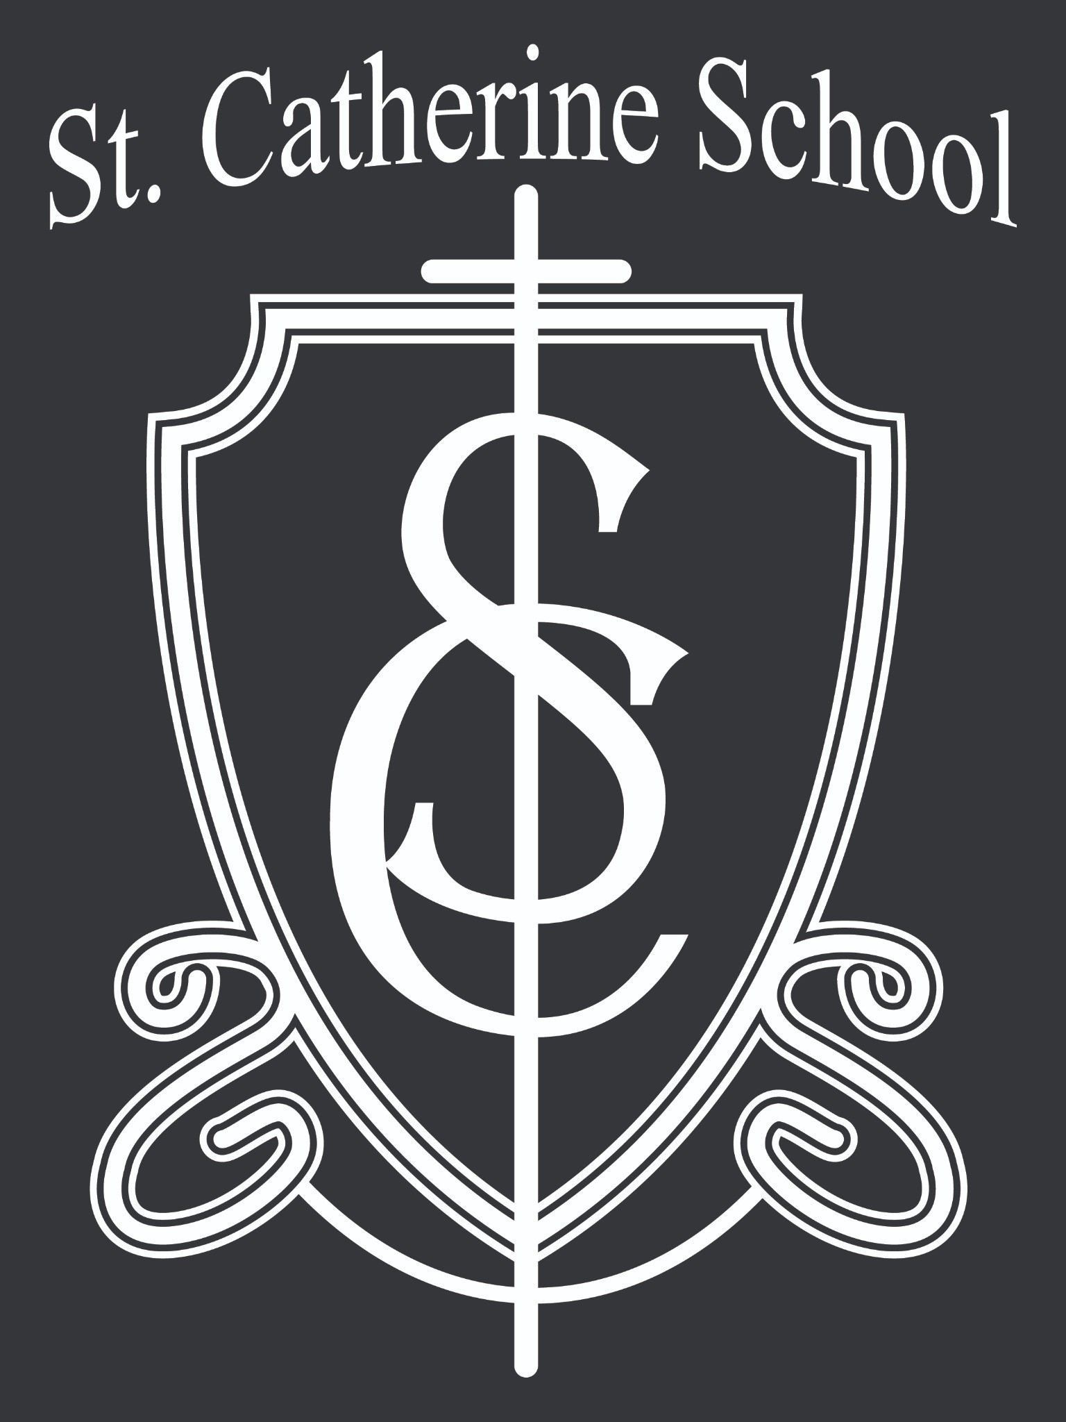St. Catherine Spotlight
We are excited to share that we have welcomed several new staff members to our school community. We have hired several new staff members downstairs at Little Saints Childcare Center: Ms. Ann Muggli, Ms. Tashina Baranko, Ms. Lilly Bjelde, Ms. Gracie Schumacher, and Ms. Roxanne Gabel.
Most recently, we hired Mrs. Cara Crow as our new custodian. Our previous custodian resigned due to personal health concerns, and we are very grateful that Mrs. Crow said yes to stepping into this important role. She will be a wonderful addition to our school and will help ensure our building continues to be a safe, clean, and welcoming environment for our students and staff.
Mrs. Crow is also Mrs. Kennedy’s sister, and we are thankful for the way our school community continues to support one another during times of transition. We appreciate Mrs. Crow’s willingness to serve St. Catherine School and look forward to having her with us.

Stay Connected with St. Catherine School
📍 Address: 540 3rd Ave. NE, Valley City, ND 58072
Email: nicholas.lee1@k12.nd.us
📧
Phone: 1-701-845-1453

📞
Website: www.stcatherine.k12.nd.us

🌐

📘 Follow Us on Facebook: St. Catherine School on Facebook

“Inspiring excellence through faith, learning, and service.”

