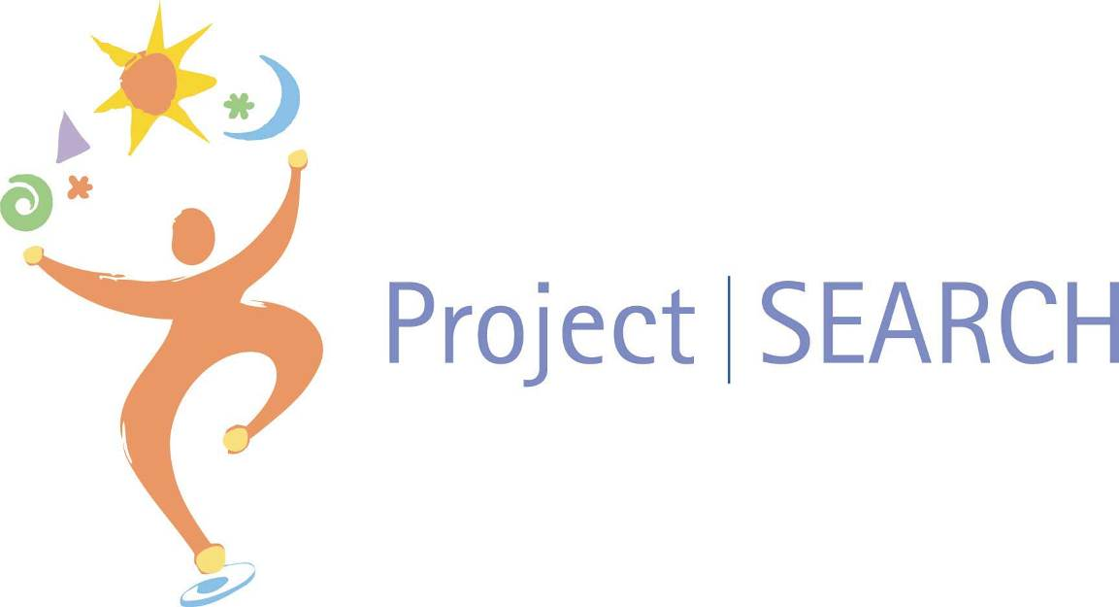

Student Application
2022-23

Name
High School

Date Received (official use only) _______________

Guidelines

The purpose of this application packet is to outline the skill set of the Project SEARCH student candidate. This application enables the Selection Committee to properly assess each student candidate’s skills, abilities and background. A parent, student, counselor, teacher or employer may be contacted by the Selection Committee

to gather additional information. Our final goal is to select students who will be successful in a Project SEARCH program and reach the outcome of competitive employment.

The Selection Process includes the following guidelines:

Submit the completed application by Friday, February 25, 2022 to:

Nichole Wetjen, Project SEARCH Instructor/Coordinator
2714 N. Lincoln Ave.
York, NE 68467
402.366.3536
nichole.wetjen@esu6.org

The student candidates will participate in an interview on Thursday, March 24, 2022, time and place to be determined. Students will interview with a Selection Committee represented by the various partners of Project SEARCH, who are: York General, ESU 6, DHHS Developmental Disabilities, Nebraska Commission for the Blind and Visually Impaired, Nebraska VR, and Assistive Technology Partnership (ATP).

If accepted into Project SEARCH, the student will receive written notification and an IEP will be developed with the IEP team for the 2022-23 school year.

If accepted, the student must be able to pass a criminal background check, a drug screen and will be required to take a Tuberculosis Test Skin Test (TB) and flu vaccination. There may be other screen or vaccination requirements, such as for COVID. Once it is known what is required by York General it will be share with the student and families.

Order of selection will be:

Students eligible for Nebraska VR

Students who desire to work competitively at the end of the Project SEARCH program

Oldest students (18 – 21 age range)

Students who have finished their necessary credits for graduation, and have not received a high

school diploma

Students eligible for DHHS Developmental Disabilities

Students who do not have a criminal record

Students who will benefit from career exploration by participation in a variety of internships

*PLEASE NOTE*
ALL THE REQUIRED DOCUMENTS MUST BE COMPLETED AND Submitted TOGETHER FOR CONSIDERATION

Completed Application Packet

Shot/Immunization Record Or Copy

Current Individual Education Plan (IEP) including Transition Goals or Current 504 Plan
Current Evaluation Team Report (MDT)
*Include Most Recent Math and Reading Scores/Grade Levels

High School Transcript
School Transcript from any other formal training
Attendance Record
Career Assessment (Reports/results could be from either the school or Nebraska VR. Information should be located within current IEP, but a separate report will be accepted.)

Student Contract

Project SEARCH Parent Transition Survey
Return completed packet to:
Nichole Wetjen, Project SEARCH Instructor/Coordinator
2714 N. Lincoln Avenue
York, NE 68467
402.366.3536

Fax:

Email: nichole.wetjen@esu6.org

York General Behavior Standards

Project SEARCH Application Timeline:
- Applications Due – Friday, February 25, 2022
- Student Interviews – Thursday, March 24, 2022
- Notification to families – Friday, April 8, 2022
- Summer:
  - IEP addendums
  - Project SEARCH Family Nights (June & August – time and date set later; Intern & a parent/guardian need to attend both nights)
- Completed background and criminal check will need to be completed by September 1, 2022 for accepted students/Interns.
- School Tentatively to begin Wednesday, August 10, 2022
- Project SEARCH Graduation/Celebration Tentatively – Wednesday, May 10, 2023

Application for Admission ^{(page 1 of 5)}

A. | Personal Data
Name
 |  |  | Last |  |  |  |  | First |  |  |  |  |  |  |  |  |  | Middle
Address:
 |  |  |  | Street |  |  |  |  |  |  |  | City |  |  |  |  |  |  |  |  | Zip Code
District of Residence: |  |  |  |  |  |  |  |  |  |  | School Currently Attending:
Date of Birth: |  |  |  |  |  |  |  |  |  |  | Choose One: |  |  |  |  | (optional) |  |  | Male |  |  | Female
Student e-mail: |  |  |  |  |  |  |  |  |  |  |  |  |  | Student Cell Phone:
Parent/Guardian Name: |  |  |  |  |  |  |  |  | Parent/Guardian e-mail:
Mailing Address:
 |  | Street |  |  |  |  |  |  |  |  |  |  |  |  | City |  |  |  |  | Zip Code
Home Address: |  | Street |  |  |  |  |  |  |  |  |  |  |  |  | City |  |  |  |  | Zip Code
Parent/Guardian Home Phone: |  |  |  |  |  |  |  |  |  | Cell Phone:
Work Phone:
Guardianship – Who is your guardian

Myself

My Parent(s) (Name of Parent(s) )

Someone else (Name of person and connection to you )

B. | Parent/Student Information:
 | 1. | Release: The student records concerning my son/daughter will be utilized by the selection committee/representatives of the Project SEARCH program for review and selection into the Project SEARCH program.
 | 2. | Equal Opportunity: Project SEARCH placement will be made without regard to race, color, national origin, sex, religion or presence of a disability.

Parent/Guardian Signature: |  |  | Date:
Student Signature |  |  | Date:

TRANSPORTATION:
All Project Search students will receive assistance in coming up with a plan to utilize independent transportation and will be trained in using the best transportation route from their residence.

How does the applicant plan to get to Project SEARCH during the 2022-23 year? (Travel Training may be something worked on throughout the Project SEARCH year. It is based on need of young adult.)

 | York County Transportation (Public Transportation within York) |  | Drive Self |  | Parents/  friends |  | Other |  | School Transportation

FUTURE EMPLOYMENT PREFERENCES and BACKGROUND:

Application for Admission ^{(page 2 of 5)}

How do you want to be employed in the community upon completion of Project SEARCH?
Full time |  | Part time

Which shift would you prefer working after graduating from Project SEARCH?
1st Shift |  | 2nd Shift |  | 3rd Shift

Would you be willing to work holidays and/or weekends?
Yes |  | No

Do you plan to work during the school year, in addition to being in the Project SEARCH Program?
Yes |  | No

If yes where? |  | How many days/ hours?

List any paid or unpaid jobs you have or have done in school or in the community:

Employer | Job Tile | Job Duties | Supervisor Name | Contact Number | Paid | Unpaid
1.
2.
3.
4.
1.
2.
3.
4.
1.
2.
3.
4.

Has your employment ever been terminated?
Yes |  | No
If yes, please explain:

Have you ever quit a job?
Yes |  | No
If yes, please explain:

SERVICE AGENCIES:

Do you have a Nebraska Vocational Rehabilitation Counselor?
Yes |  | Name |  | Phone Number:
No

Are you eligible for services from the DHHS Developmental Disabilities?
Yes |  | Name |  | Phone Number:
No

Who is your IEP case manager/contact person in school?
Name __________________________________ Phone Number: ______________________

Personal Information:
Medications/ dosage/ Time of day taken by student

Medication | Dosage | Time of day

List any health or medical issues that may impact a successful job placement:

Please list any limitations that impact employment:

Please describe the support you will need to be successful in the workplace.

STUDENT RESPONSE QUESTION

Why do you want to come to Project SEARCH? (Complete in your own words and/or person assisting will write the responses in the student’s own words)

List Three References:
 | Name | Type of Reference | Phone Number | Email Address
1. |  | Family Reference
2. |  | School Reference
3. |  | Other Community or Agency Reference

The person assisting the student to complete this application is:
Name | Title | Phone Number | Date
Organization | Phone Number | Email contact

Signature

Student Contract

Read the student contract below and sign and date.

I, ___________________________, understand that if I am accepted into the Project SEARCH program and must abide by the following terms and conditions:

- I will complete at least three unpaid internship rotations within the host business.
- I will attend the program every day from 8:30am- 3:15pm, Monday through Friday.
- I understand that the Project SEARCH program has their own school calendar, and that is what Interns will follow during the 2022-23 year.
- I will dress appropriately and wear required attire.
- I will call my instructor and departmental director(s) when I am absent or tardy.
- I will make up any time missed due to unexcused absences.
- I understand that I am responsible for transportation to the host site.
- I will follow all the rules established by the program and host business.
- I will attend monthly meetings with my Nebraska VR counselor, parents, York General staff, and Project SEARCH Instructor.
- I will be an active participant and communicate any issues at our monthly meetings.
- At completion of the program, I will receive my high school diploma, and a Project SEARCH Certificate of Completion.
- I will actively pursue employment.

I have read the above terms and conditions and agree to accept my placement in the Project SEARCH program. I understand that I may be asked to leave Project SEARCH if I fail to follow the terms and conditions of ANY of the partners in this program. If dismissed from the Project SEARCH program I will return to my high school where I could be assigned a new IEP case manager, and return any uniform/clothing and equipment to Nebraska VR if they purchased it for me.

____________________________________ ____________________________
Student Signature Date

____________________________________ ____________________________
Parent/Guardian Signature Date

Behavior Standards
As a member of York General, I understand that I am a reflection of the
entire organization and I pledge to uphold the Behavior Standards as outlined below.
Attitude
- I will treat everyone, at all times, with dignity, respect, empathy, honesty, compassion, courtesy, and sincerity.
- I will come to work with a smile and an optimistic mind knowing my attitude is contagious.
- I will value and respect differences in backgrounds, culture, and experiences, recognizing the power and strength of our diverse organization.
- I will demonstrate a positive attitude, and will be both gracious and grateful, thanking those with whom I interact.
- I will have an open mind to new ideas and innovative ways of thinking to improve our organization.
Teamwork
- I will make a conscious effort to work positively with everyone and seek opportunities to manage up my co-workers.
- I will achieve balance between presenting my own solutions to problems and accepting the ideas of others for the greater good of the organization and those we serve.
- I will build up my team as a member of this organization sharing in both successes and failures.
- I will work as part of a team and accept new ideas and innovative thinking as an opportunity to make positive changes and improvements in our organization.
- I will maintain my focus on caring for our patients, residents, families, and all others we serve.
Ownership
- I will take pride in my workplace, accept responsibility for my goals, and support those across the organization.
- I will strive to meet or exceed my customer’s expectations and apologize when we fall short.
- I will take an active role in using resources effectively, efficiently, and responsibly.
- I will hold myself and others accountable for behavior and performance.
- I will make every effort to keep our organization safe and secure, whether environmental, behavioral, or clinical.
Integrity
- I will be truthful, take responsibility for my actions, and consider my conscience when making decisions.
- I will respect all those we serve as individuals.
- I will adhere to the values and uphold the mission of the organization by giving my best effort every day.
- I will handle all confidential information appropriately.
- I will strive to maintain unity within our organization while practicing sound and evidence based care.
Appearance
- I will dress according to written policies, take pride in my appearance, and wear my name tag visibly at all times.
- I will keep my personal work area neat, organized, professional, and will return equipment to its proper place.
- I will do my part to maintain an appropriate cultural appearance that promotes an inviting, courteous, supportive, approachable, and respectful atmosphere throughout the organization.
Communication
- I will communicate professionally and clearly at all times.
- I will listen attentively, be focused in all interactions, avoid distractions while communicating, and be willing to receive and provide honest feedback.
- I will prepare for, anticipate, and understand the needs of all those with whom I interact.
- I will respond appropriately, in a timely, friendly, and empathetic manner.
- I will convey compassion and respect in my non-verbal language, such as tone of voice, posture, and eye contact.

______________________________________ __________________________________ ________________________
Project SEARCH Candidate Name Printed Project SEARCH Candidate Signature Date

