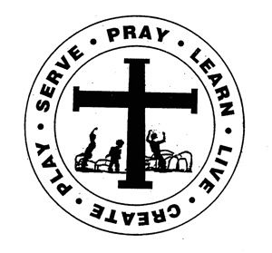
St. Edward Catholic School
Fr. Todd Petersen, Pastor * Jaci Garvey, Principal
210 W. 4th Street * Minneota, Minnesota 56264
Phone:(507) 872-6391 * Fax: (507) 872-5263
Email: jgarvey@stedscatholicschool.com
Website: www.stedscatholicschool.com

September 15, 2022
Photoworks will be here tomorrow morning to take school pictures. Please remember to return your photo envelopes.
The annual St. Edwards Church Fall Festival will be held Sunday, September 18th serving from 11 am to 1:30 pm. This year’s menu will consist of pork roast, mashed potatoes with gravy, corn, vegetable sides, homemade desserts, and a beverage. There will also be a carnival, silent auction, and country store available.

NWEA testing has begun and will continue into next week. The testing schedule is listed on the school calendar on our website (www.stedscatholicschool.com).
We have had our first two marathon turn-in days. Kellen Noyes was the winner of the boxes of candy and Brisbyn Traen was the winner of the 8-pack of Gatorade. So far the students have raised $2,779. The next turn-in date will be Tuesday, September 20th. Everyone that turns in a pledge with money with receive a monster cookie and their name will go into a drawing for a pack of markers. Please encourage students to get out there and collect pledges for our school.
The Education Committee meeting will be held at 6 pm on Tuesday, September 20th. We are still in need or a committee member. This is a three-year term. All are welcome to attend.
Our next school Mass is Wednesday, September 21st at 10:30 am. The 1st and 2nd-grade students will be leading us.
We will be celebrating our August and September birthdays on Thursday, September 22nd for Birthday Lunch.
Permission slips will need to be resigned for the Ninja Everywhere which will now take place on September 23rd. They will be going home in today’s family folders.
St. Edward School promises to supervise children arriving to school at 7:40 am or later. Please strive to drop your children off no sooner than that. Often when I arrive there are children already on the playground. This is a safety concern as there may not be an adult present for proper supervision.
Our new security system is now in place and Trudy and I are able to “click” people in. Please be patient as we learn the capabilities of this new system.
Included in the family folder is an informational letter regarding “Peace of Mind”. This is a diocesan Catholic school initiative to bring mental health and wellness resources to our students and their families as well as to our staff. Please read through this letter. There will be more information coming on these programs and how we will be able to participate.
May God Bless, Mrs. Garvey

