Millbrooke Elementary Jr. Beta Club
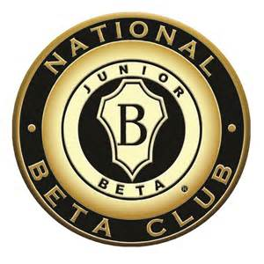

Upcoming Events

March 16
Jr. Beta Meeting in Mrs. Cansler’s room until 3:15 (rides must be here on time at the Playground side Gym door)

March 23
Jr. Beta Meeting in Mrs. Cansler’s room until 3:15 (rides must be here on time at the Playground side Gym door)
Keep Updated….

Check out our Jr. Beta page on the Millbrooke website for announcements and pictures! The webpage will be updated monthly with information about the service project for the month and meeting dates. If you have any good pictures from Induction, please email them to Mrs. Cansler so she can upload them at Brittney.cansler@christian.
kyschools.us
Thank you!

Dear Students and Parents;
We are beginning our first service project! We are planning our Easter Egg Hunt for the residents of the Chapel House. We will be needing individually wrapped candy to stuff the hundreds of eggs we have, as well as prizes for our prize table that go with our sparkly prize eggs. For prizes, these residents love garbage bags, soap, lotion, Fiddle Faddle, snack cakes, Knick-knacks, and puzzle books. Extra items will be kept as prizes for Bingo at the Chapel House.
Sincerely,
Mrs. Cansler
See the back of this sheet for a list of ideas of items to bring in for the Easter Egg Hunt.

