Math Review Week #29~Day 1 Name________________________

1. Circle the number that is 10 more than 167: 257 177 277

2. I am 349. How many do I have? ____ ONES ___TENS ___ HUNDREDS

- Count back. ‘X’ the error and correct it. 86, 85, 84, 81, 82, 81, 80

4. Make an ABCC pattern. ______, _____, ______, _______, ______, ______

5. What number is this?______

Mental Math ______________________
____________________________________________________________
____________________________________________________________
Math Review Week #29~Day 2 Name________________________

1. Write the number that is 10 LESS than 45:____ 10 MORE than 45:___

- I have 2 HUNDREDS, & 7 ONES. What number am I?__ __ __

3. How much money is this?_________¢
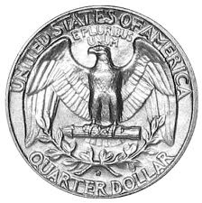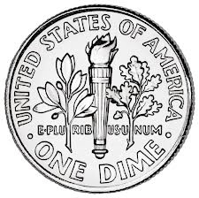

4. Skip count by 2’s: ____, 80, 82, ____, 86, _____
- Danielle sorted these shapes: 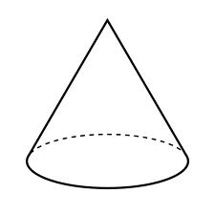 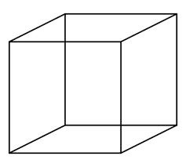 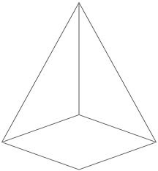 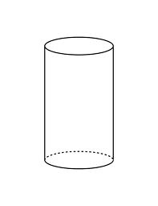
What is her sorting rule? a. 3D shapes b. 2D shapes

Mental Math ______________________

Math Review Week #29~Day 3 Name________________________

1. Circle the number that is 100 less than 587? 567 578 577

- Circle all the equations that are False.
12 + 2 – 2 = 12 9 + 3 = 10 5 + 3 = 10 – 2 3 + 4 + 5 = 3 + 5 + 4

3. Write the number 139 in expanded notation: ______ + ______ + _______

4. Circle the equations that belong in this fact family: ( 8, 9, 17)
8+8=16 17-9=8 8+9=17 17-0=17 17-8=9

- Luke is sorting 3D shapes. Circle all the shapes that belong in his group.
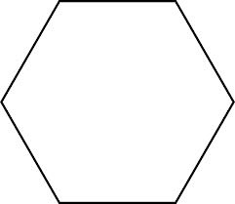

Mental Math ______________________
____________________________________________________________
____________________________________________________________
Math Review Week #29~Day 4 Name________________________

- Write the number that is 100 LESS and 100 more than 537:

_______, 537, ________

- You have 4 dimes, 3 nickels, and 2 pennies on the table. How much money do you have? _____________

3. 2 girls got on the bus. Then some boys got on. Now there are 9 kids on the bus. How many boys got on? 2 + _____ = 9

4. Count back. ‘X’ the error and correct it. 276, 275, 274, 273, 275, 271
- Seth sorted these shapes:
What is his sorting rule? a. 3D shapes b. 2D shapes

Mental Math ______________________

Math Review Week #29~Friday Five Name________________________

1. What number is this?______

2. How much money is this?_________¢

3. Circle all the equations that are False.

12 + 2 – 2 = 12 9 + 3 = 10 5 + 3 = 10 – 2 3 + 4 + 5 = 3 + 5 + 4

4. Luke is sorting 3D shapes. Circle all the shapes that belong in his group.

5. 2 girls got on the bus. Then some boys got on. Now there are 9 kids on the bus.

How many boys got on? 2 + _____ = 9

Mental Math ______________________

Math Review Week #30~Day 1 Name________________________

- Circle the equations that belong in this fact family: ( 4, 7, 11)

4+7=11 7-4=3 11-4=7 7+0=7 11-7=4

2. Fill in the missing number to make the equation correct: 1 + 8= ______ + 1

3. Solve. 19 + 11 = ____

4. Fill in symbol to make the sentence correct: 43 _____ 100

5. Draw a model using hundreds, tens and ones for the number 182.

Mental Math ______________________
____________________________________________________________
____________________________________________________________
Math Review Week #30~Day 2 Name________________________

1. Fill in the missing number to make the equation correct:
9 + 5 = 14 so 5 + ____= 14

2. Create an HTO chart to solve the problem.
16 + 9 = _______

3. Circle the TRUE statement: 29 < 88 or 77 > 90

4. Write the equations that belong in this fact family: (3, 6, 9)

______+______=______ ______-______=______

______+______=______ ______-______=______

5. Which number is the least? 20 120 102 22 122

Mental Math ______________________

Math Review Week #30~Day 3 Name________________________

1. Fill in the missing number to make the equation correct:
1 + 5 + 5= 11 so 1 + ____= 11
2. Write these numbers in order from GREATEST to least: 23 29 19 33

________, ________, ________, ________
3. Circle the equations that belong in this fact family: ( 6, 8, 14)
8-6=2 14-8=6 6+8=14 8+6=14 14-2=12

4. Use the v-strategy to solve the problem. 37 - 12 = ______

5. Draw a model using hundreds, tens and ones for the number 109.

Mental Math ______________________
____________________________________________________________
____________________________________________________________
Math Review Week #30~Day 4 Name________________________

- Fill in the missing number to make the equation correct: 23 + 14= ____ + 23

- Write the equations that belong in this fact family: (2, 11, 13)

______+______=______ ______-______=______

______+______=______ ______-______=______

3. What number is this?____________

4. Circle the correct expanded notation for 367: 300+60+7 200+60+7

5. Circle all numbers that are LESS THAN 67: 99 23 28 85 46 100

Mental Math ______________________
Math Review Week #30~Friday Five Name________________________

1. Solve. 19 + 11 = ____

2. Write the equations that belong in this fact family: (3, 6, 9)

______+______=______ ______-______=______

______+______=______ ______-______=______

3. Write these numbers in order from GREATEST to least: 23 29 19 33

________, ________, ________, ________

4. Fill in the missing number to make the equation correct:
1 + 5 + 5= 11 so 1 + ____= 11

5. Circle all numbers that are LESS THAN 67: 99 23 28 85 46 100

Mental Math ______________________

Math Review Week #31~Day 1 Name________________________

- Fill in the missing number to make the equation correct: 0 + _____= 13
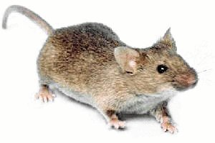
2. The motorcycle is (shorter / taller) than the mouse.

3. Look at the clock. What time does it show?

9:30 9:00 8:30 6:30

4. What is this fraction? one-fourth one-half one-quarter

5. Color the shapes with 0 sides: 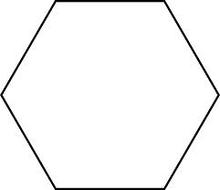

Mental Math ______________________
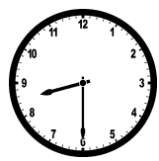
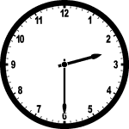
____________________________________________________________
____________________________________________________________
Math Review Week #31~Day 2 Name________________________

1. What time does this clock show? ___________

2. Fill in the missing number to make the equation correct: 6= ______- 1

3. Circle the picture that shows one-half: 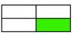

4. If you held a paperclip, would it be shorter or longer than your hand? _______

5. I have 0 HUNDREDS, 6 TENS, & 2 ONES. What number am I? __ __ __

Mental Math _____________________
Math Review Week #31~Day 3 Name________________________

- 3 kids have flowers. John’s is long. Fred’s is longer. Sam’s in the longest.
Circle Fred’s flower.
2. Write the name and value for this coin: _____________ _______¢

3. Circle the fraction one-fourth: 2/4 1/2 1/4

4. Which clock says four thirty? 4 : 00 4 : 30 4 : 20

5. Complete the following sentence: 49 > _______ 52 24 89 100

Mental Math ______________________
____________________________________________________________
____________________________________________________________

Math Review Week #31~Day 4 Name________________________

1. Is a chair shorter or longer than you? _______

- Which clock says seven o’clock? 7 : 00 7 : 30 5 : 00

3. Circle one: Half of / a quarter of the rectangle is shaded.

4. Fill in the missing number to make the equation correct: 18= _____- 5

5. Draw a model using hundreds, tens and ones for the number 194.

Mental Math ______________________

Math Review Week #31~Friday Five Name________________________
- What is this fraction? one-fourth one-half one-quarter

2. If you held a paperclip, would it be shorter or longer than your hand?_______

3. Write the name and value for this coin: _____________ _______¢

4. Which clock says four thirty? 4 : 00 4 : 30 4 : 20

5. Fill in the missing number to make the equation correct: 18= _____- 5

Mental Math ______________________

Math Review Week #32~Day 1 Name________________________

Students’ Pets
Cat
Dog
Fish

1. Which pet do the fewest number of students have? _____________

2. How many kids were surveyed total? ____________________

3. How many kids total have fish and cats? ____ + _____ =______

- How many MORE kids have Dogs than cats? _____ - _____ = ______

5. Create your own question about this graph and answer it.

Question:_____________________________________________________

____________________________________________________________

Answer:______________________________________________________

____________________________________________________________

Mental Math_____________________________
Math Review Week #32~Day 2 Name________________________

1. How much money is this? _______________¢
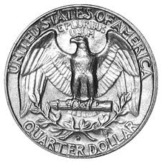

2. Use the place value blocks to solve the problem.
30-10=_____

3. Circle the number that is 10 less than 77? 67 78 78

4. Write the number that is 10 LESS than 49:____10 MORE than 49:___

- Add the problems in the box: 47 92
+ 31 + 6
Mental Math ______________________
____________________________________________________________
____________________________________________________________

Math Review Week #32~Day 3 Name________________________

1. How much money is this? _______________¢
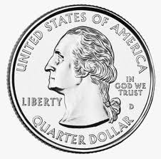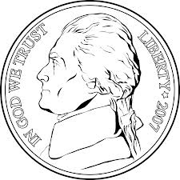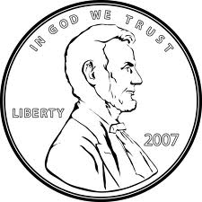
2. Use the place value blocks to solve the problem.
90-40=_____
3. Write the number that is 10 LESS than 82:____10 MORE than 82:___

4. Skip count by 5’s. 45, _____, ______, ______, 65

5. Subtract the problems in the box: 86 74
- 50 - 13
Mental Math ______________________

Math Review Week #32~Day 4 Name________________________

1. Which special did more kids like? _________________

- How many kids liked music better? _________________

- How many more kids liked art than music? ____ - _____ = _____

- How many kids total like PE and art? ____ + _____ = ____

5. Create your own question about this graph and answer it.
Students’ Favorite Specials
IIII
PE
Music
Art
IIII IIII
I

IIII I

Question:_____________________________________________________

____________________________________________________________

Answer:______________________________________________________

____________________________________________________________

Mental Math_________________________
Math Review Week #32~Friday Five Name________________________

1. How much money is this? _______________¢

2. Use the place value blocks to solve the problem.
30-10=_____

3. Write the number that is 10 LESS than 49:____10 MORE than 49:___

4. Skip count by 5’s. 45, _____, ______, ______, 65

5. Subtract the problems in the box: 86 74
- 50 - 13

Mental Math ______________________

Math Review Week #33~Day 1 Name________________________

1. Write the number 340 in expanded notation: ______ + ______ + ______

2. Luke is sorting 2D shapes. Circle all the shapes that belong in his group.

3. Find the unknown number in the following equation: 4 + 8 = _____

4. Solve: 600 - 200 = ______
- Use the place value blocks to help you add:

+
Mental Math ______________________
____________________________________________________________
____________________________________________________________
Math Review Week #33~Day 2 Name________________________

1. Circle the correct number for 200 + 50 + 3: 235 253 352

2. We started with 18 soccer balls. Some were kicked over a wall. Now we have 6. How many were kicked over the wall? 18 - _____ = 6

3. What are two numbers that are GREATER THAN 30: ______ & _______

4. Is this equation true or false? 7 = 8 -1 ___________
5. Use the place value blocks to help you add:
+
Mental Math ______________________
Math Review Week #33~Day 3 Name________________________

- Circle the correct number for 100 + 9: 109 190 901
- Peter sorted these shapes:
What is his sorting rule? _______________________________________

3. Count forwards: 96, 97, 98, ______, ______, ______, ______, ______

4. Is this equation true or false? _____________ 8 = 1 + 2
5. Use the place value blocks to help you add:
+
Mental Math ______________________
____________________________________________________________
____________________________________________________________

Math Review Week #33~Day 4 Name________________________

1. Write the number 255 in expanded notation: _______ + ______ + ______

2. Count backwards: 136, 135, 134, ______, ______, ______, ______, ______

3. There are 9 girls and some boys in our class. We have 20 kids total. How many boys are there all together? 9 + _____ = 20

4. I have 3 HUNDREDS, 0 TENS, & 6 ONES. What number am I? __ __ __
5. Use the place value blocks to help you add:
+

Mental Math ______________________

Math Review Week #33~Friday Five Name________________________

1. Use the place value blocks to help you add:
+

2. What are two numbers that are GREATER THAN 30: ______ & _______

- Peter sorted these shapes:

What is his sorting rule? ______________________

4. Is this equation true or false? _____________ 8 = 1 + 2

5. There are 9 girls and some boys in our class. We have 20 kids total. How many boys are there all together? 9 + _____ = 20

Mental Math ______________________

Math Review Week #34~Day 1 Name________________________

1. Circle the equations that belong in this fact family: (5, 9, 14)
9+0=9 9+5=14 14-5=9 5+9=14 9-5=4

2. Fill in the missing numbers to make the equations correct:
9 + 0= _____ + 9 2 + 10 = 12 so 10 + _____= 12

3. Solve the problem. 20 + 5 + 7 = ____

4. Joey has 15 pieces of candy. He gave 9 pieces to his friend. How many pieces of candy does Joey have left? ____________________

5. Add: 48 + 26 = __________

Mental Math ______________________
____________________________________________________________
____________________________________________________________
Math Review Week #34~Day 2 Name________________________

1. Write the equations that belong in this fact family: (1, 9, 10)

______+______=______ ______-______=______

______+______=______ ______-______=______

2. Fill in the missing numbers to make the equations correct:
7 + 2= ____ + 7 6 + 1 = 7 so 1 + ____= 7

3. Write the equation shown on the number line.
_______-_______=_______

4. Circle the TRUE statement: 66 < 99 or 22 < 2

5. Complete the following sentence: 56 < ______
Mental Math ______________________

Math Review Week #34~Day 3 Name________________________

- Fill in the missing numbers to make the equations correct:
5 + 4 + 6= 15 so 5 + _____= 15 8 + _____= 8

2. Use the number line to solve the problem. 30 - 20 = _______

3. Sally has 10 red socks, 3 black socks, and 4 white socks. How many socks does she have in all? __________

4. Circle the equations that belong in this fact family: ( 3, 10, 13)
10-3=7 10+3=13 3+10=13 10+13=23 13-3=10

5. Circle all numbers that are LESS THAN 50: 22 43 88 60 46 100

Mental Math ______________________
____________________________________________________________
____________________________________________________________

Math Review Week #34~Day 4 Name________________________

- I found 3 quarters in my pocket. How much money did I find? _____________

- Write the equations that belong in this fact family: (4, 9, 13)

______+______=______ ______-______=______

______+______=______ ______-______=______

3. I have 3 HUNDREDS, 6 TENS, & 8 ONES. What number am I? __ __ __
- Fill in the missing numbers to make the equations correct:
7 + 3 + 7= 17 so 7 + _____= 17 5 - _____= 5

5. Circle the number sentence that is true: 33 > 44 or 19 < 91

Mental Math ______________________
Math Review Week #34~Friday Five Name________________________

1. Circle the equations that belong in this fact family: (5, 9, 14)
9+0=9 9+5=14 14-5=9 5+9=14 9-5=4

2. Write the equation shown on the number line.
_______-_______=_______

3. Sally has 10 red socks, 3 black socks, and 4 white socks. How many socks does she have in all? __________

4. Circle all numbers that are LESS THAN 50: 22 43 88 60 46 100

5. Fill in the missing numbers to make the equations correct:
7 + 3 + 7= 17 so 7 + _____= 17 5 - _____= 5

Mental Math ______________________

Math Review Week #35~Day 1 Name________________________

1. There are 3 ducks. Jan is tall. Chris is taller. Dave is the tallest. Circle Jan.
2. 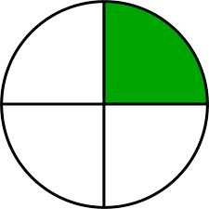 What is this fraction? ________________

- Fill in the missing number to make the equation correct: 7= _____- 1
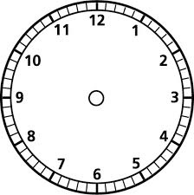
4. Show six thirty on the clock:

- Count by 10’s: ____, _____, ____, 60, 70

Mental Math ______________________
____________________________________________________________
____________________________________________________________
Math Review Week #35~Day 2 Name________________________

1. Which fraction shows 1/4? 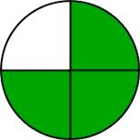 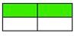

2. How much money is this? _______

3. Circle the correct number for 100 + 30 + 7: 137 107

4. Fill in the missing number to make the equation correct: 9 + _____= 17

5. Show half past nine on the clock:

Mental Math ______________________

Math Review Week #35~Day 3 Name________________________

1. What fraction does this show? ____________

2. Fill in the missing number to make the equation correct: 14= _____- 5

3. Billy found 3 seashells, Michael found 9, and Rebecca found 5. How many seashells did they find altogether? ____________

4. Sam has 4 dogs. He gets 3 more. How many dogs does Sam have now?
_______ + _______ = ________
5. There is a house between 2 trees. Draw a tree that is taller than the house on the right. Draw a tree that is shorter than the house on the left.

Mental Math ______________________
____________________________________________________________
____________________________________________________________

Math Review Week #35~Day 4 Name________________________

1. I have 0 HUNDREDS, 7 TENS, & 0 ONES. What number am I? __ __ __

- Fill in the missing number to make the equation correct: 10= _____- 1
3. Which fraction shows 1/2? 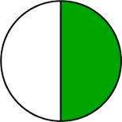 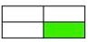

4. Is a giraffe shorter or taller than a dog? ___________
5. Show noon on the clock:

Mental Math ______________________

Math Review Week #35~Friday Five Name________________________

1. There are 3 ducks. Jan is tall. Chris is taller. Dave is the tallest. Circle Jan.

2. Fill in the missing number to make the equation correct: 9 + _____= 17

3. Sam has 4 dogs. He gets 3 more. How many dogs does Sam have now?
_______ + _______ = ________

4. What fraction does this show? ____________

5. I have 0 HUNDREDS, 7 TENS, & 0 ONES. What number am I? __ __ __

Mental Math ______________________

Math Review Week #36~Day 1 Name________________________

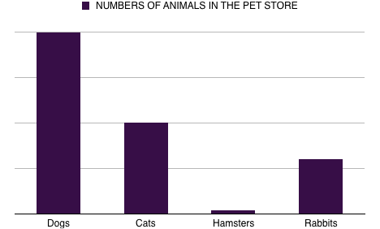

1. Which animal does the pet store have the MOST of? _________________

2. How many Dogs are in the pet store? _________

3. How many more Dogs than Cats? _____ - _____= _____

- How many Cats and Hamsters are there together? ____ + ____ = _____

- Create your own question about this graph and answer it.

Question:_____________________________________________________

____________________________________________________________

Answer:______________________________________________________

____________________________________________________________

Mental Math_________________________
Math Review Week #36~Day 2 Name________________________

Where would you want to go?

0 2 4 6 8 10 12

1. Where do the most kids want to go? _____________

2. How many kids voted total?____________________

- How many kids total prefer Disneyland & Sea World?____ + ____ =___

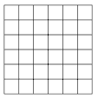
4. How many MORE kids prefer Lego Land than Disneyland ___-___=___
Disneyland

Sea World

Lego Land

5. Create your own question about this graph and answer it.

Question:_____________________________________________________

____________________________________________________________

Answer:______________________________________________________

____________________________________________________________

Mental Math____________________________

Math Review Week #36~Day 3 Name________________________

1. How much money is this? _______________¢

2. Use the place value blocks to solve the problem.
50-40=_____
3. Write the number that is10 LESS and 10 more than 194:____194:____

4. Josh read 2 books on Monday. He read 5 more books on Tuesday. On Wednesday he read 1 book. How many books did he read in all? __________

5. Add these problems: 82 56
+ 16 +40
Mental Math ______________________
____________________________________________________________
____________________________________________________________
Math Review Week #36~Day 4 Name________________________

- How much money is this? _______________¢

- Use the place value blocks to solve the problem.
30-20=_____
3. Skip count by 2’s. _____48, 50, _____, ______, _______

4. Circle the number that is 10 less than 52? 42 32 62

5. Subtract the problems: 79 65
- 52 - 22
Mental Math ______________________

Math Review Week #36~Friday Five Name________________________

1. How much money is this? _______________¢

2. Use the place value blocks to solve the problem.
50-40=_____

3. Josh read 2 books on Monday. He read 5 more books on Tuesday. On Wednesday he read 1 book. How many books did he read in all? __________

4. Subtract the problems: 79 65
- 52 - 22

5. Skip count by 2’s. _____48, 50, _____, ______, _______

Mental Math ______________________

Math Review Week #37~Day 1 Name________________________

1. Fill in the missing number to make the equation correct: 11 + ____= 17

2. Is this equation TRUE or FALSE? _________ 7 = 8 – 1

- Our pizza came with 8 slices. I ate 3. How many pieces are left?___ - ___=___

4. 7 first graders, 6 second graders, and 7 third graders all got on the bus. How many kids are on the bus? _____ + _____ + _____ = _____

5. Add:
+
Mental Math ______________________
____________________________________________________________
____________________________________________________________
Math Review Week #37~Day 2 Name________________________

1. Is this equation TRUE or FALSE? _________ 1 + 1 + 3 =7

2. The bird had 4 feathers on its wing. While flying, 3 feathers fell out and floated to the ground. How many feathers are left in its wing? _____-_____=_____

- My dog had 3 black puppies, 2 blonde puppies, and 6 spotted puppies. How many puppies did she have in all? _____ + _____ + _____ = _____

4. Skip count by 5’s. 45, _____, ______, 60, 65, ______
5. Add:
+
Mental Math ______________________
Math Review Week #37~Day 3 Name________________________

- Circle all the equations that are True.
6 – 1 = 1 – 6 8 = 8 4 + 3 = 3 + 4 3 + 4 + 5 = 7 + 5

2. Circle the equation that matches the word problem. I baked 6 cookies. My sister baked 8 cookies. How many cookies do we have in all?
6 + 8 = 14 or 8 - 6 = 2

3. Write the number 188 in expanded notation: ______ + ______ + _______

4. Circle the TRUE statement: 77 < 90 or 19 > 38
5. Add:
+
Mental Math ______________________
____________________________________________________________
____________________________________________________________

Math Review Week #37~Day 4 Name________________________

- Circle all the equations that are False.
12 + 2 – 2 = 12 9 + 3 = 10 5 + 3 = 10 – 2 3 + 4 + 5 = 3 + 5 + 4

- Subtract 24 - 7 = ________

3. Fill in the blank to make the sentence correct: 126 < _______

4. Circle all numbers that are GREATER THAN 80: 87 13 88 39 97
- Add:

+
Mental Math ______________________
Math Review Week #37~Friday Five Name________________________

1. 7 first graders, 6 second graders, and 7 third graders all got on the bus. How many kids are on the bus? _____ + _____ + _____ = _____

2. Is this equation TRUE or FALSE? _________ 1 + 1 + 3 =7

3. Add:
+

4. Circle the equation that matches the word problem. I baked 6 cookies. My sister baked 8 cookies. How many cookies do we have in all?
6 + 8 = 14 or 8 - 6 = 2

5. Subtract 24 - 7 = ________

Mental Math ______________________

