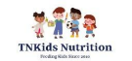
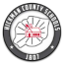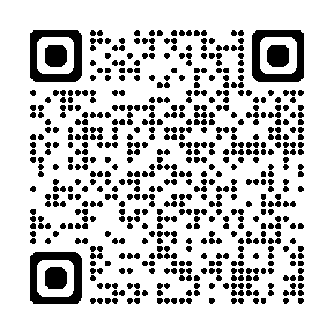

Hickman County School Nutrition will be partnering with TNKids Nutrition to help feed the children in our communities over the summer.
TNKids Nutrition will deliver food boxes to the listed locations at the estimated time. Deliveries will be every Tuesday during the summer starting May 26th and ending July 28th. The food boxes will consist of a combination of shelf-stable and frozen items and will contain enough food for seven breakfasts and seven lunches.
- The child does not have to be school age and does not have to be enrolled in Hickman County Schools.
- Parents/Guardians may pick up the boxes, and the child does not have to be present.
- A photo ID is required for the person picking up the food.
- To receive a box please be at the delivery site most convenient to you at the time listed. The truck will only be there for a short time, so DO NOT be late.
- You may only pick up once a week, so DO NOT visit multiple sites in the same week. It is OK to go to a different site each week.

Thank you and have a fun summer!!!

Kara Hobbs Donny King
Coordinated School Health Director Executive Director
Hickman County Schools TNKids Nutrition
Location | Address | Time
Bon Aqua | Bon Aqua United Methodist Church  10762 Church Road  Bon Aqua, TN 37025 | 9:00 to 9:45
Nunnelly | Hidden Valley Lake Clubhouse  2114 Design Road  Nunnelly, TN 37137 | 10:15 to 10:45
Nunnelly | Pinewood Church of Christ  4760 Highway 48  Nunnelly, TN 37137 | 11:00 to 11:30
Centerville | Duck River Park  142 North Central Avenue  Centerville, TN 37033 | 12:15 to 1:00
Centerville | Bernard Community Center  113 Bernard Avenue  Centerville, TN 37033 | 1:15 to 1:45
Lyles | East Hickman High School  7700 Highway 7  Lyles, TN 37098 | 2:15 to 3:00

