

MENU SUBJECT TO CHANGE
CNP IS AN EQUAL OPPORTUNITY EMPLOYER
Grilled Cheese
Cheeseburger
Fries
Fruit/Milk
Lunchable
Quesadilla
Refried Beans
Fruit/Milk

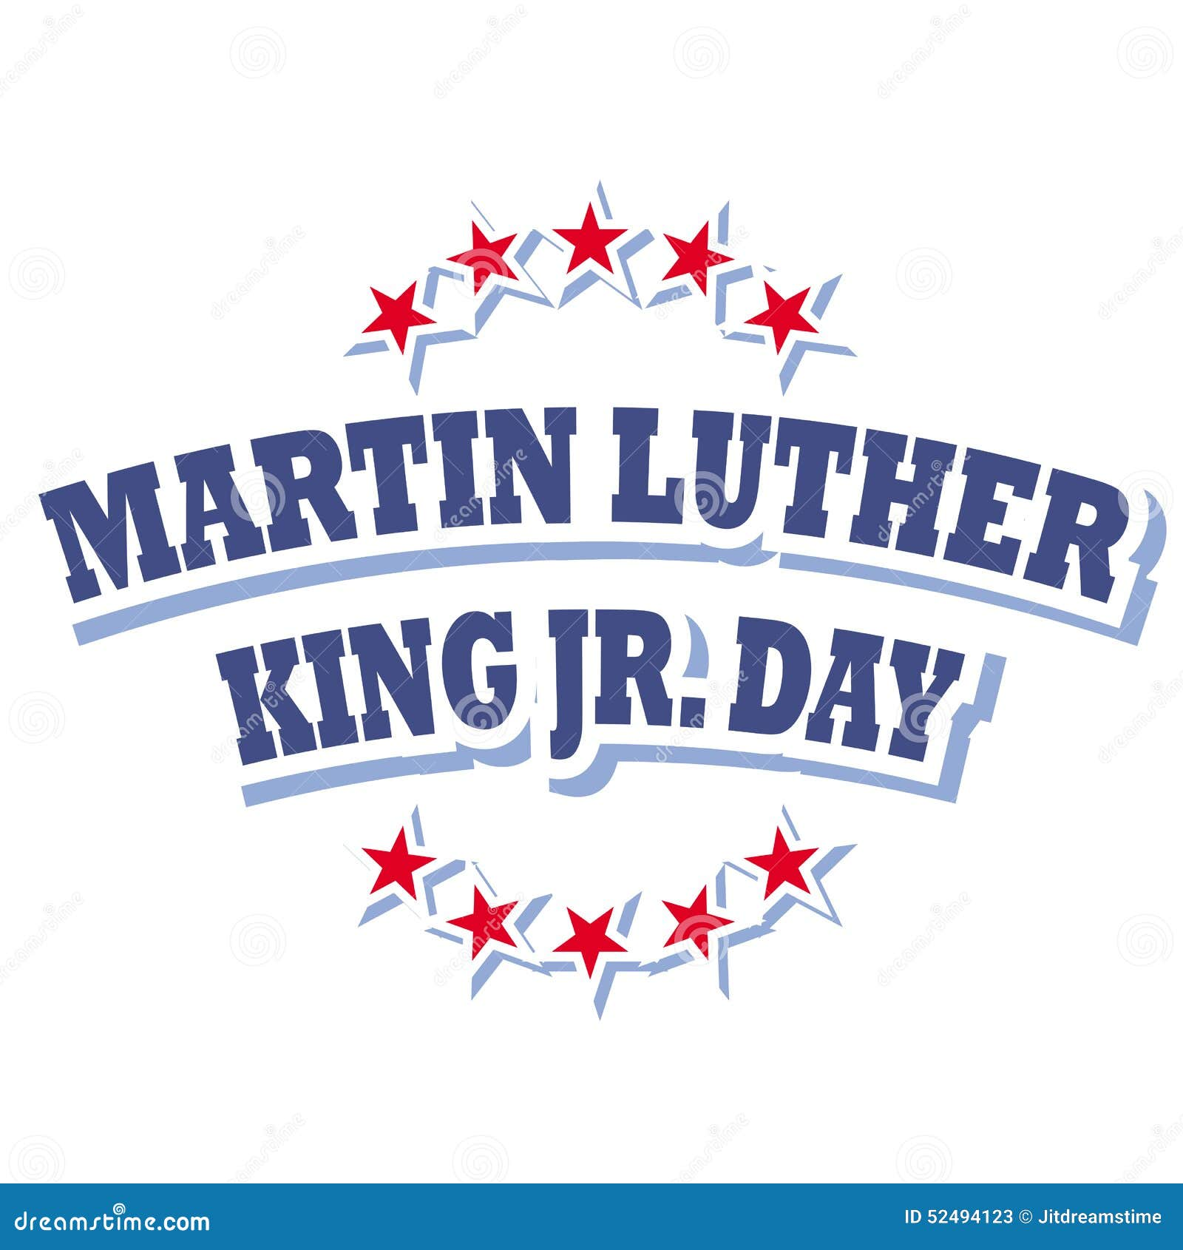
Soybutter
Mozzarella Sticks
Marinara Sauce
Green Beans
Fruit/Milk
Chicken Wrap
BBQ Sliders
Baked Beans
Chips
Fruit/Milk
JANUARY 2026
PRATTVILLE KINDERGARTEN
Lunchable
Taco Soup
Chips/Cheese
Fruit/Milk

Grilled Cheese
Spaghetti
Peas/Roll
Fruit/Milk
Chicken Wrap
Corndog
Sweet Potato Fries
Fruit/Milk
Soybutter
Mozzarella Sticks
Marinara Sauce
Green Beans
Fruit/Milk
Grilled Cheese
Hotdog
Fries
Fruit/Milk
Grilled Cheese
Grits/Eggs
Sausage/Hashbrown
Toast/Jelly
Fruit/Milk
Chicken Wrap
Chicken Nuggets
Waffles/Syrup/Carrots
Fruit/Milk
Grilled Cheese
Chicken Parmesan
Green Peas/Rolls
Fruit/Milk
Lunchable
Taco
Chili Beans
Fruit/Milk
Grilled Cheese
Chicken Noodle Soup
Carrots
Fruit/Milk
Chicken Wrap
Salisbury Steak
Potatoes/Gravy/Roll
Fruit/Milk
Soybutter
Pizza
Broccoli
Fruit/Milk

Soybutter
Pizza
Corn
Fruit/Milk

