Michael Chavez, Superintendent
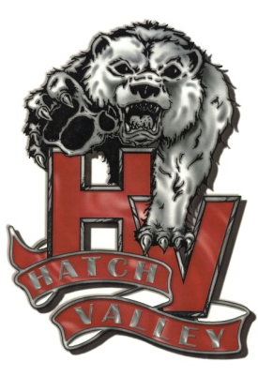
Hatch Valley Public Schools
P.O. Box 790
Hatch, NM 87937
575-267-8200
______________________________________________________________________________

-NOTICE OF INTENT TO AWARD-

Request for Proposal: 2022-003

TITLE: Food Service Management Company

PURPOSE: Hatch Valley Public School has scored proposals received in response to RFP 2022-003. HVPS is hereby giving notice to the public that intent is to award Southwest Food Excellence with a Food Service Management Contract for 1 year with option to renew to provide the services specified in the RFP document pending school board approval.

ISSUANCE: June 15, 2022

NOTE: Any protests shall follow the New Mexico Procurement Code Section 13-1-172 which states:

“Any bidder or offeror who is aggrieved in connection with a solicitation or award of a contract may protest to the state purchasing agent or a central purchasing office. The protest shall be submitted in writing within fifteen calendar days after knowledge of the facts or occurrences giving rise to the protest.”

Shelly Ortega
Business office Manager

