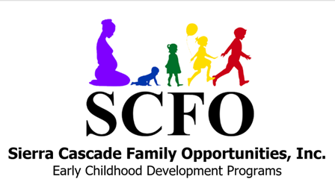

2026-27
0 - 6 Months Menu

Children in this age range are fed on demand. This menu is for the purpose of meeting meal reimbursement requirements set forth by the federally and state funded food program – CACFP

Monday | Tuesday | Wednesday | Thursday | Friday
Breakfast  Breast Milk  OR Formula  4-6 oz | Breakfast  Breast Milk  OR Formula  4-6 oz | Breakfast  Breast Milk  OR Formula  4-6 oz | Breakfast  Breast Milk  OR Formula  4-6 oz | Breakfast  Breast Milk  OR Formula  4-6 oz
Lunch  Breast Milk  OR Formula  4-6 oz | Lunch  Breast Milk  OR Formula  4-6 oz | Lunch  Breast Milk  OR Formula  4-6 oz | Lunch  Breast Milk  OR Formula  4-6 oz | Lunch  Breast Milk  OR Formula  4-6 oz
Snack  Breast Milk  OR Formula  4-6 oz | Snack  Breast Milk  OR Formula  4-6 oz | Snack  Breast Milk  OR Formula  4-6 oz | Snack  Breast Milk  OR Formula  4-6 oz | School out at 12:00

This institution is an equal opportunity provider.

The cereal specified (rice or oat) on the 6-11 month menu will be available on demand for the duration of the day.

All infant formula will be iron fortified.

All infant cereals will be iron fortified.

