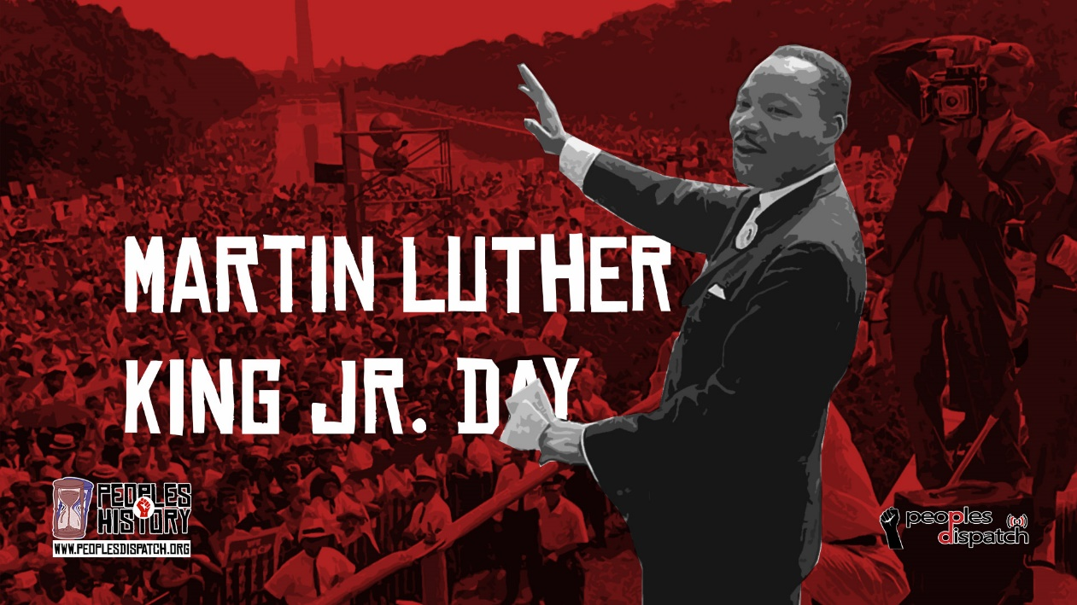
Reading News
Mrs. Williams
Date: January 19, 2026

Reading: Practice Makes Perfect for Rotten Ralph

Word Study: Bossy R review

Vocabulary:
problem – has to be something that the characters might really have or won’t enjoy
decision – to choose to do something
resolution – the problem gets solved or fixed

