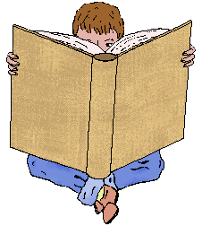 **Reading News**

**Mrs. Williams**

**Week of: September 8, 2025**

**Story:**

Ivy and Bean

-this is our first novel, so we will be doing this book for 2 weeks

**Word Study:** Bossy R – ir ex: stir, birthday, twirl

**Vocabulary:**

relationships – connections

mischievous – causing trouble in a playful way

creative – to make something new with a good imagination

suspense – feeling excitement about what might happen

beware – watch out for dangers

distraction – something that makes you stop thinking about one thing and think about another

disappointed – sad because something unexpected happened

revenge – doing something mean to someone who has done something mean to you