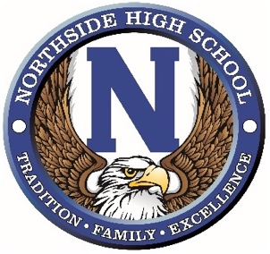
Contestant #

Miss Northside Application 2023

Contestant Name:
Sponsor:
Parents or Guardians:
Talent:

Hobbies, Interests, and Interesting Facts about you:

Ten years from now, what will you have accomplished and be doing?

List all clubs, sports, and other organizations you have participated in at Northside:

List all honors, awards, and accomplishments you have received at Northside, including leadership roles and offices held:

List all community activities in which you have been involved:

What local, state, or national cause or organization do you believe in, and why is it special to you?

How would you describe Northside High School to a community organization?

What will be your legacy if you are selected as Miss Northside?

