JES PTO Meeting Minutes

February 24, 2025

5:30

JES LIBRARY

​

​ Mrs. Burrows welcomed everyone to the meeting and shared the two main goals with the committee members. One goal focuses on academic improvement, while the other aims to enhance our school environment.

The academic goal is to continue increasing test scores in Reading and Math. To achieve this, we will implement the following procedures:

- iReady

- Tier 3 Instruction

- Tier 1 Instruction with Classroom Rotations in Reading and Math

- ATSI Recovery Plan

- MTSS

The second goal related to our school environment is for JES to promote and ensure a positive, collaborative, and constructive climate that centers around students, leading to positive outcomes and achievement. We will utilize the following strategies to accomplish this goal:

- Capturing Kids’ Hearts

- Individualized Instruction using iReady

- Tier 3 Instruction

Mrs. Burrows then invited any comments or concerns regarding the goals. Mrs. MK expressed her agreement, stating, “I agree with those two goals.” Other committee members also voiced their support for the goals.

These goals were created during our JES SIC Meeting. I would like to thank our SIC Committee for serving on this committee and helping our school.

Following this discussion, Mrs. Burrows shared the Winter iReady scores in Reading and Math.

The next steps to achieve our goals include:

- Continuing ATSI support

- Providing additional support with Tier 1 Instruction

- Utilizing iReady Individual Path for JES students

- Continuing with SC READY questions and test preparation

​

Mrs. Robin Altman from the Florence 5 District Office provided enrollment information.

Mrs. Burrows then passed the meeting over to our JES students, who began our Black History Month program.

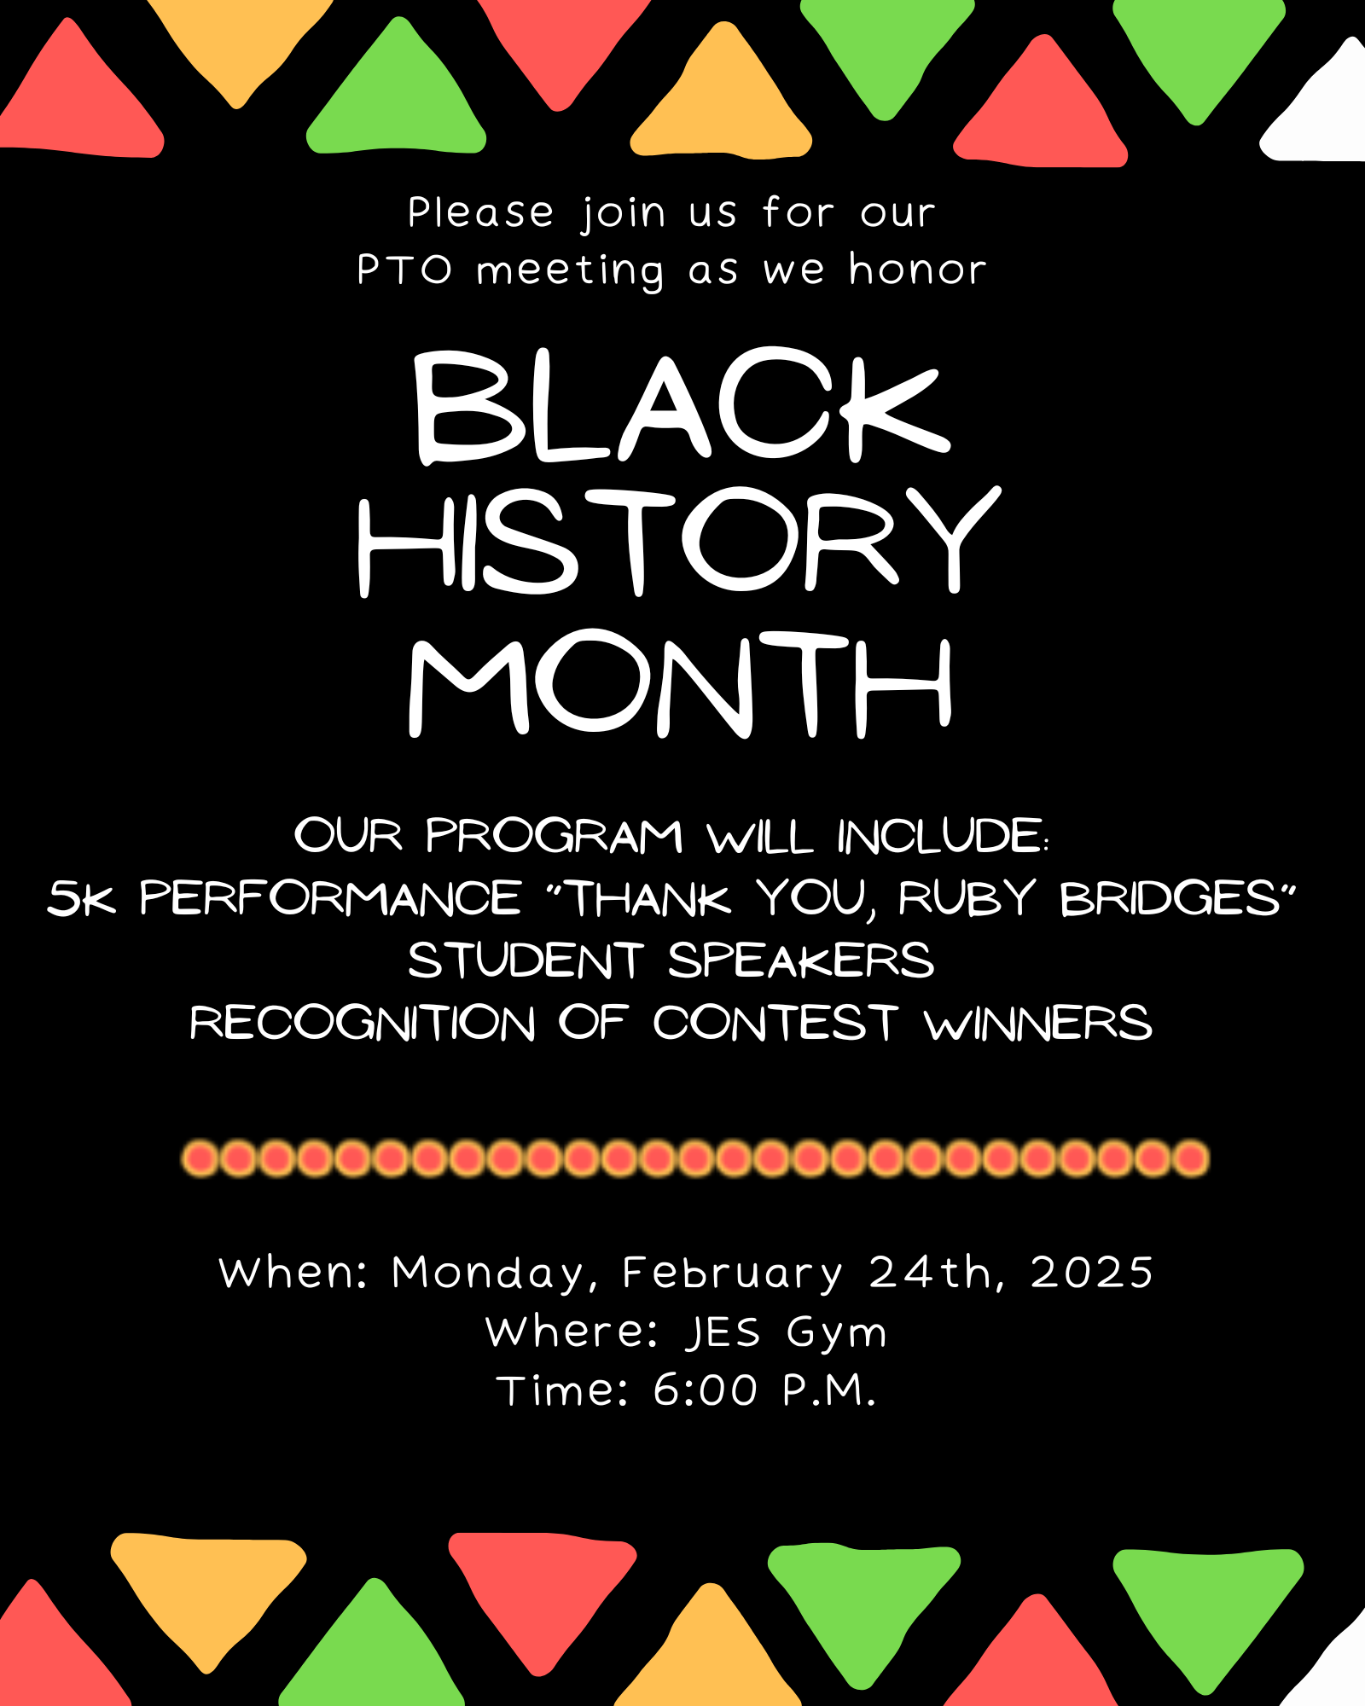

Black History Month

* Welcome—Makenzie McClary
* Purpose/History—Paris Lewis and Adalynn Johnson
* Poem—Lily Robin Ellison and Alayziah Wilson
* Did you Know?
  + One—Kamden Moore
  + Two—Elias Cherifi
  + Three— DJ Woodberry
  + Four— Zy’Rhianna Eaddy
* 5K Ruby Bridges
* Recognize Poster winners

Paris: Black History Month was created to focus attention on the contributions of African Americans to the United States. It honors all Black people from all periods of U.S. history.

Adalynn: In 1976, President Ford recognized Black History Month. Each year, the president chooses a theme for Black History Month. The 2025 Black History Month theme is African Americans and Labor.

Lily Robin: We will now read a poem by Amanda Gorman who is award-winning American poet activist and the first-ever National Youth Poet Laureate. This poem titled “The Hill We Climb” was written and read by Gorman at President Biden’s swearing in ceremony.

Alayziah: When day comes, we ask ourselves,  
where can we find light in this never-ending shade?  
The loss we carry,  
a sea we must wade.  
We’ve braved the belly of the beast,  
We’ve learned that quiet isn’t always peace,  
and the norms and notions  
of what just is  
isn’t always justice.

Lily Robin:

And yet the dawn is ours  
before we knew it.  
Somehow we do it.  
Somehow we’ve weathered and witnessed  
a nation that isn’t broken,  
but simply unfinished.

Kamden (Thurgood Marshall):

Thurgood Marshall was America’s first African American Supreme Court Justice and was the most successful lawyer arguing cases before the high court. After his death, he was awarded the Presidential Medal of Freedom, the highest civilian honor.

Elias (Muhammad Ali):

Muhammad Ali was one of the greatest heavyweight boxers of all time. In his 21-year pro boxing career, Ali won 56 fights with only 5 defeats before retiring as the first boxer to win the heavyweight championship 3 times. In 2001, Ali received the Presidential Citizens medal.

DJ (Michael Jordan):

Michael Jordan was cut from his high school basketball team as a sophomore, but came back as an upperclassman to become all-American. In a 15-year professional career, he led the NBA in scoring 10 times and was elected to 14 All-Star Games. Jordan won 5 MVP awards and led the Chicago Bulls to 6 NBA championships. President Obama award Jordan the Presidential Medal of Freedom in 2016.

Zy’Rhianna (Ruby Bridges):

Ruby Bridges is an American civil rights activist. In 1960, Ruby became one of the first Black students to integrate the New Orleans public schools. She was just 6 years old. She was awarded the Presidential Citizens Medal in 2001 for her courage. She still travels around the world as a speaker, author, and civil rights activist.

Makenzie: Good evening. We would like to welcome you to our JES Black History Month Program. During our program, you will hear the purpose and history of Black History Month. We will share a poem from an influential African American poet and highlight some contributions made by African Americans. Also our 5k students will perform a musical tribute. We hope you enjoy!