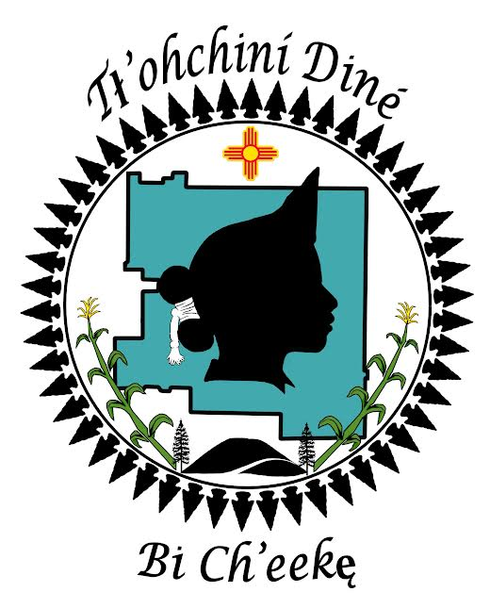
31st Annual Ramah Navajo Community Fair
Miss Ramah Navajo Pageant
2026-2027
Theme: “Soil to Soul, Growing a Healthier Community”

CONTESTANT APPLICATION CHECKLIST:

- COMPLETED APPLICATION FORM-
- Rules and Regulations Contestant Signature on pages 3 & 4
- PLATFORM ESSAY
Deadline: Friday August 14th ,2026 by 5:00PM
Drop off locations:
*Property and Procurement Office- Mt. View
*RNSB Business Office- Pine Hill
If you have any questions, please feel free to contact the Pageant Committee: ramahnavajopc@gmail.com

*Rachel Thom: (801) 624-9899 - Cell email: thomrachel24@gmail.com
*Tonona Begay: (505) 862-4571- Cell email: Tononavbegay@gmail.com
*Merinda Yazzie: (505) 388-4890 - Cell email: msyazzie822@gmail.com

Drug and Alcohol-free event. Miss Ramah Navajo Pageant Committee will not be held liable for theft, injuries and/ or unforeseen incidents.
31st Annual Ramah Navajo Community Fair
Miss Ramah Navajo Pageant
2026-2027
Theme: “Soil to Soul, Growing a Healthier Community”

CONTESTANT APPLICATION

PERSONAL INFORMATION:
Name: __________________________________________ Date of Birth: _____/_____/__________
Mailing Address:_____________________________________________________________________
City: ________________________________________ State: __________ Zip Code: ____________
Main Phone: ( ) _______–______________ Message Phone: ( ) _______–______________
E-Mail Address: ___________________________________________________________
Tribal Affiliation: ____________________ Census #: _______ , _______ Chapter:_________________
Mother's Name: ______________________________________________
Father's Name: _______________________________________________
Maternal Clan: _____________________________________________________________
Paternal Clan: ______________________________________________________________
Maternal Grandfather's Clan: ________________________________________________________
Paternal Grandfather's Clan: _________________________________________________________
EDUCATION:
For Miss Ramah Navajo Princess:
Elementary School: ___________________________________ Present Grade Level: ___________
Middle School: _______________________________________ Present Grade Level____________

For Miss Ramah Navajo Queen:
High School: _________________________________________ Present Grade Level: _________
Date of Graduation: _____/_______ College/University:_____________________________________
Present Grade Level: ___________________ Date of Graduation: ______/________

1
31st Annual Ramah Navajo Community Fair
Miss Ramah Navajo Pageant
2026-2027
Theme: “Soil to Soul, Growing a Healthier Community”

RULES & REGULATIONS for CONTESTANT

1. Contestants MUST be an enrolled member of the Ramah Navajo Tribe with a census number.
2. Contestant must be: 16-24 years of age - Miss Ramah Navajo Queen
8-15 years of age - Miss Ramah Navajo Princess
3. Contestants must be single, never married, & with no children before and after Crowning.
(NOTE: This Pageant is very important to the Ramah Navajo/Pine Hill Community. All contestants must uphold the responsibilities of the title “Miss Ramah Navajo Queen/Princess” throughout the Pageant and throughout her reign, as well as her commitment to Ramah Navajo/Pine Hill Community.)

4. Contestants should be able to speak, or be willing to learn to speak, their native language. Fluency is not required. Contestants should be able to introduce themselves in the Diné language, acknowledging their: Clans, Parents/Grandparents, School, Grade
5. Contestants must not be holding any other titles at the time of the Pageant. NO EXCEPTIONS!

6. Contestants will answer impromptu questions asked by the judges during the modern/traditional categories.

7. Contestants will be judged on personality, appearance, participation, speech, essay, modern and traditional skill/talent.

8. Contestants must be knowledgeable of Ramah Navajo History, Navajo Culture, Values, & Traditions.

9. Contestants pursuing the Title of “Miss Ramah Navajo Queen” must not be registered for active duty with any military service.

10. All Contestants must understand that if she engages in any activities, during or after the Pageant, which is characterized as dishonest, immoral, immodest, indecent, the Pageant Coordinators will address the misconduct immediately with the Contestant, which may result in disqualification to compete in the Pageant or hold the Title of “Miss Ramah Navajo Queen/Princess”. If for any reason she (Miss Ramah Navajo Queen/Princess) shall violate or does not abide by the listed rules and regulations, she shall relinquish her title to the first-runner up recipient.

11. All Contestants need to understand the primary function of the “Miss Ramah Navajo Queen/Princess” is to
serve as a Goodwill Ambassador for our Elders, Youth and Community Members, and serve as an official representative of the Ramah/Pine Hill Navajo Community. She is the ambassador for the surrounding communities, and the State of New Mexico, Arizona, and throughout the Navajo Nation.

2

12. All Contestants must understand the Title of "Miss Ramah Navajo Queen/Princess" is one of the most prestigious titles that represent the Ramah Navajo people. “Miss Ramah Navajo Queen/Princess” will need to represent and promote the Tradition, Custom and Values of the Navajo People. The "Title" must be respected, and treated with honor, dignity, and integrity because it signifies the beauty of our people, language, tradition, culture, and our ways of life. It is not to be disrespected and treated unfairly in any way during the Pageant and throughout the reign.
13. Contestants will be assigned a number for judging purposes and must wear their number through-out the pageant.
14. All Contestants MUST PARTICIPATE in the following events for points (5 pts for participation, and 0 pts for no show):
*Events to attend for participation points will be discussed at the welcoming meeting, TBA
*Please attach a copy of your “platform essay” when returning the application.
15. “Miss Ramah Navajo Queen/Princess” Contestant Application deadline is Friday, August 14th, 2026, by 5:00 p.m.

UPON SIGNING, I AGREE TO THE TERMS & CONDITIONS ABOVE.

Contestant Signature _____________________________________ Date_______________

(* Required if CONTESTANT is under the age of 18*)

* PARENT SIGNATURE: __________________________________ DATE: _______________ *

If you have any questions feel free to contact the Pageant Committee: ramahnavajopc@gmail.com

*Rachel Thom: (801) 624-9899 - Cell email: thomrachel24@gmail.com
*Tonona Begay: (505) 862-4571 email: Tononavbegay@gmail.com
*Merinda Yazzie: (505) 388-4890 - Cell email: msyazzie822@gmail.com

3
31st Annual Ramah Navajo Community Fair
Miss Ramah Navajo Pageant
2026-2027
Theme: “Soil to Soul, Growing a Healthier Community”

RULES & REGULATIONS

1. Contestants are prohibited from using drugs & alcohol during the pageant competition & throughout her reign 2026-2027.
2. NO BOYFRIENDS will be permitted to fraternize with contestants during the Pageant & throughout her reign 2026-2027. NO EXCEPTIONS.
3. The Pageant Committee will provide the score sheets for each contestant.
4. If circumstances should occur that a contestant is conducting herself in an improper manner, she will be addressed about her behavior by the pageant committee.
5. Family members of contestants shall not interfere with the judges, before, during, & after the pageant.
6. Only the contestant and (1) Person will be allowed to assist the contestant during the pageant with any physical set up and talent props during the competition.
7. Contestants must not be holding any other titles at the time of Pageant. NO EXCEPTIONS!

UPON SIGNING, I AGREE TO THE TERMS & CONDITIONS ABOVE.

____________________________________________________ _________________
Contestant Signature Date

(* Required if CONTESTANT is under the age of 18*)

*PARENT SIGNATURE: __________________________________ DATE: __________________*

PAGEANT COMMITTEE SIGNATURES:
Coordinator: _________________________________________ Date: ________________
Coordinator: _________________________________________ Date: ________________
Coordinator: _________________________________________Date: _________________

4
31st Annual Ramah Navajo Community Fair
Miss Ramah Navajo Pageant
2026-2027
Theme: “Soil to Soul, Growing a Healthier Community”

MODERN TALENT (You must provide your own equipment for your talent.)
Briefly describe your Modern Talent Presentation: Need more space attached to a Separate sheet.
________________________________________________________________________________________________________________________________________________________________________________________________________________________________________________________________________________________________________________________________________________________________________

MODERN SPEECH: (You must provide your own equipment for your speech)
Briefly describe your Modern Speech Presentation: Need more space attached to a Separate sheet.
________________________________________________________________________________________________________________________________________________________________________________________________________________________________________________________________________________________________________________________________________________________________________

TRADITIONAL TALENT: (You must provide your own materials for your talent)
**For Queen Contestants Only – They will tie their own traditional Navajo hair bun (Tsiiyéél) & present a talent.
**For Princess Contestants Only - Briefly describe your Traditional Talent Presentation: Need more space attached to a Separate sheet.
________________________________________________________________________________________________________________________________________________________________________________________________________________________________________________________________________________________________________________________________________________________________________

TRADITIONAL SPEECH: (You must provide your own equipment for your speech)
Briefly describe your Traditional Talent Presentation: Need more space attached to a Separate sheet.

________________________________________________________________________________________________________________________________________________________________________________________________________________________________________________________________________________________________________________________________________________________________________

Please attach your platform essay when returning your application. What do you want to accomplish while you hold your title as royalty? What goals do you want to achieve for your community? What awareness do you want to share while holding your title as royalty?

5

