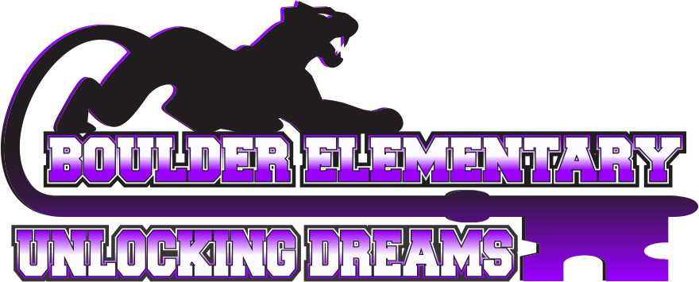
Vision Statement: Committed to pursuing a community of excellence.

Mission: Here at Boulder Elementary School, we are committed to pursuing a community of excellence by engaging students in a positive environment that supports all they do.

AGENDA
BOULDER ELEMENTARY BOARD OF TRUSTEES MEETING
5:30 P.M, October 11th, 2021
BOULDER ELEMENTARY SCHOOL LIBRARY

- Call to order-Chairperson
  - Pledge of Allegiance

- Agenda Review
  - Consent Agenda
    - Approval Claims
    - Approval September 2021 Payroll
    - Approval previous month minutes
    - Approval Student Activities Ledger
- Elementary Announcements and Public Comment on Elementary Issues.
THE BOARD WELCOMES AND ENCOURAGES PUBLIC COMMENT. ANYONE WISHING TO ADDRESS THE BOARD IS ENCOURAGED TO DO SO WITH THESE STIPULATIONS:
1. The Board may limit the amount of time for comment if they become extensive.2. If the speaker begins to infringe on the right to privacy of another, the Board may interrupt and end the comments
on that issue.
3. Even if the comments are entirely appropriate, the Board will take no action on them at this meeting.
To insure that others who want to address the same issue have the opportunity to do so, the item may be placed
on the agenda for a later meeting.
- Communication and Comments.
  - Letters to the Board
  - Student Issue
- Commendations and recognitions.
- Unfinished business.
- Committee reports.
  - Leadership – Carrie Harris & Matt Strozewski
  - Handbook/Policy – Niki Conroy & Cheryl Hecht
  - Budget/Finance and Negotiations/Personnel – Niki Conroy & Cheryl Hecht
  - Facilities – Matt Strozewski & Andrea Dolezal- Kip Weeda presentation.
  - Transportation – Andrea Dolezal & Cheryl Hecht-

Superintendent/Principal’s Report
  - Jeff Elliott

New Business
- Personnel – Recommendation to hire Leslie Woodrow as a substitute teacher and para.
- Non Resident Student Acceptance – Standing Agenda Item -
- Liquidation of School Property – Standing Agenda Item-
- Boulder Child Care Working Group –
- Recommendation to approve ESSER III budget as presented.
- Recommendation to allow Elkhorn Basketball League to practice in our gym.
- Proposal to add depot hill to basin bus route.

Topics for Future Meeting Agendas

Adjournment
***Next Board Meeting Scheduled NOVEMBER 8th, 2021***
NEXT REGULARLY SCHEDULED ELEMENTARY BOARD MEETING IS AT THE BOULDER ELEMENTARY LIBRARY. PLEASE HAVE AGENDA ITEMS, APPROVED BY BOARD CHAIR AND SUPERINTENDENT, TO DISTRICT OFFICE BY LAST THURSDAY OF EACH MONTH.

