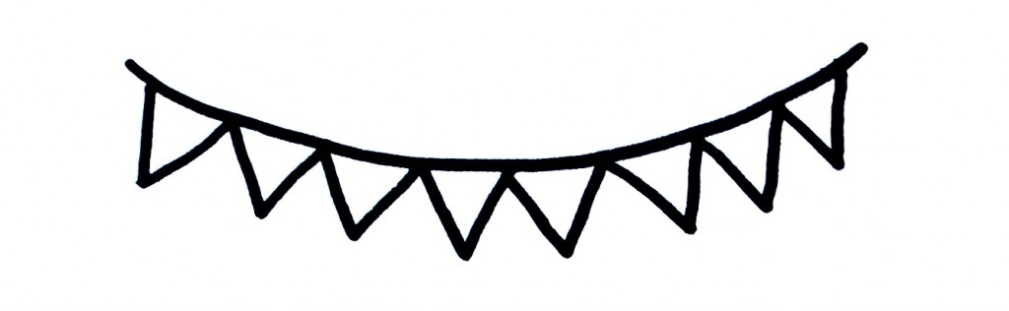

Messick’s Messages
August 29-Sept. 2, 2022
This Photo by Unknown Author is licensed under CC BY-NC-ND
**We will have a math test on Topic 1 TOMORROW. Please help your child complete the attached math homework tonight.**
Math Skills for Topic 2: Fluently Add & Subtract within 10
Lesson 1: Counting On
Lesson 2: Doubles
Lesson 3: Near Doubles

Important Dates
August 30: Curriculum Night @ 5:30
Sept. 5: Labor Day holiday
Sept. 28: Fall pictures

Oct.21: Pumpkin Patch field trip (more info. coming)

Language Arts Skills for Lesson 1
*Sounds /s/, /m/, /a/, & /t/
Science/Social Studies/Leader in Me
*Rules and expectations (Social Studies)
*The 5 Senses
*Compare & Contrast
*Character
*Forming letters l, t,
*Writing left to right, top to bottom
*Vocabulary: jitters, besides, act, too, stinks,
rather, again, fair, minute, poor
Announcements
*Please try to come to Curriculum Night tomorrow! This will be an informative time for parents learn more about our PPS expectations and procedures. There will be someone to supervise students if you need to bring them with you.
*Remember to sign up for Class Dojo to receive important updates and see pictures of our class in action! This will be our primary source of communication.
*A newsletter and homework will be sent every Monday. I will collect homework each Friday. It is not graded but a treat will be given for completion.
*Please initial your students DOT folder each day under their pawprint. Also, please keep all papers at home that are in the back pocket.
*Tuesday folders will be sent home tomorrow. Please keep all papers in the “Keep at Home” side and return papers that are in the other pocket.

Wishlist
*band-aids
*plastic spoons
*tissues
*paper towels
*Air Wick air freshener refills (seasonal, fruity, or calming…not floral)

