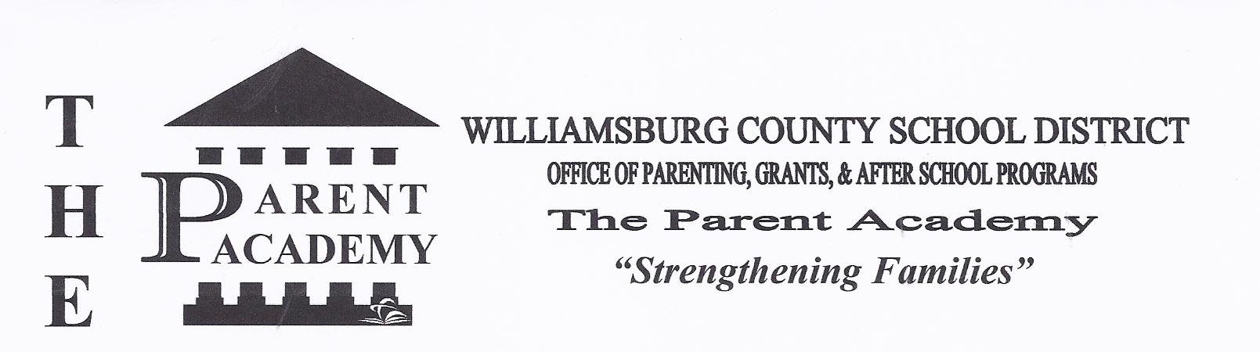

**WILLIAMSBURG COUNTY SCHOOL DISTRICT TITLE 1 & PARENT MEETING**

KINGSTREE HIGH SCHOOL

616 MARTIN LUTHER KING JR AVENUE

KINGSTREE, SC 29556

843-355-6525

*Strengthening Families*

August 19, 2020

Dear Parents:

Welcome back! This is Mrs. Patrick greeting you to a new wonderful school year. For those of you who are new to this school, I am the parenting liaison for the school and I am looking forward to working with you and my other parents.

I am available daily to handle or forward any of your concerns and provide you with resource information. You can email me if necessary at [mpatrick@wcsd.k12.sc.us](mailto:mpatrick@wcsd.k12.sc.us) or you call me at 843-355-6525 x4426.

Our children are our future. Please help me in helping you not let them slip through the crack of life. Their education is what will make or break them. Let us come together with a united front and educate our children for a bright, rewarding future.

Sincerely,

Michelle T. Patrick

Parenting Liaison



**WILLIAMSBURG COUNTY SCHOOL DISTRICT TITLE 1 & PARENT MEETING**

KINGSTREE HIGH SCHOOL

616 MARTIN LUTHER KING JR AVENUE

KINGSTREE, SC 29556

843-355-6525

*Strengthening Families*

August 19, 2020

Dear Parents:

Welcome back! This is Mrs. Patrick greeting you to a new wonderful school year. For those of you who are new to this school, I am the parenting liaison for the school and I am looking forward to working with you and my other parents. This year is a new norm for us due to covid19, but as long as we follow the rules, stay home if sick, wear our masks, wash our hands, and social distance, we will flatten the curve, and stay as safe as we can. If you have chosen face to face or virtual, please contact me for assistance if necessary and I will serve you as best I can, or find the person who can.

I am available daily to handle or forward any of your concerns and provide you with resource information. You can email me if necessary at [mpatrick@wcsd.k12.sc.us](mailto:mpatrick@wcsd.k12.sc.us) or you call me at 843-355-6525 x4426.

Our children are our future. Please help me in helping you not let them slip through the crack of life. Their education is what will make or break them. Let us come together with a united front and educate our children for a bright, rewarding future.

Sincerely,

Michelle T. Patrick

Parenting Liaison