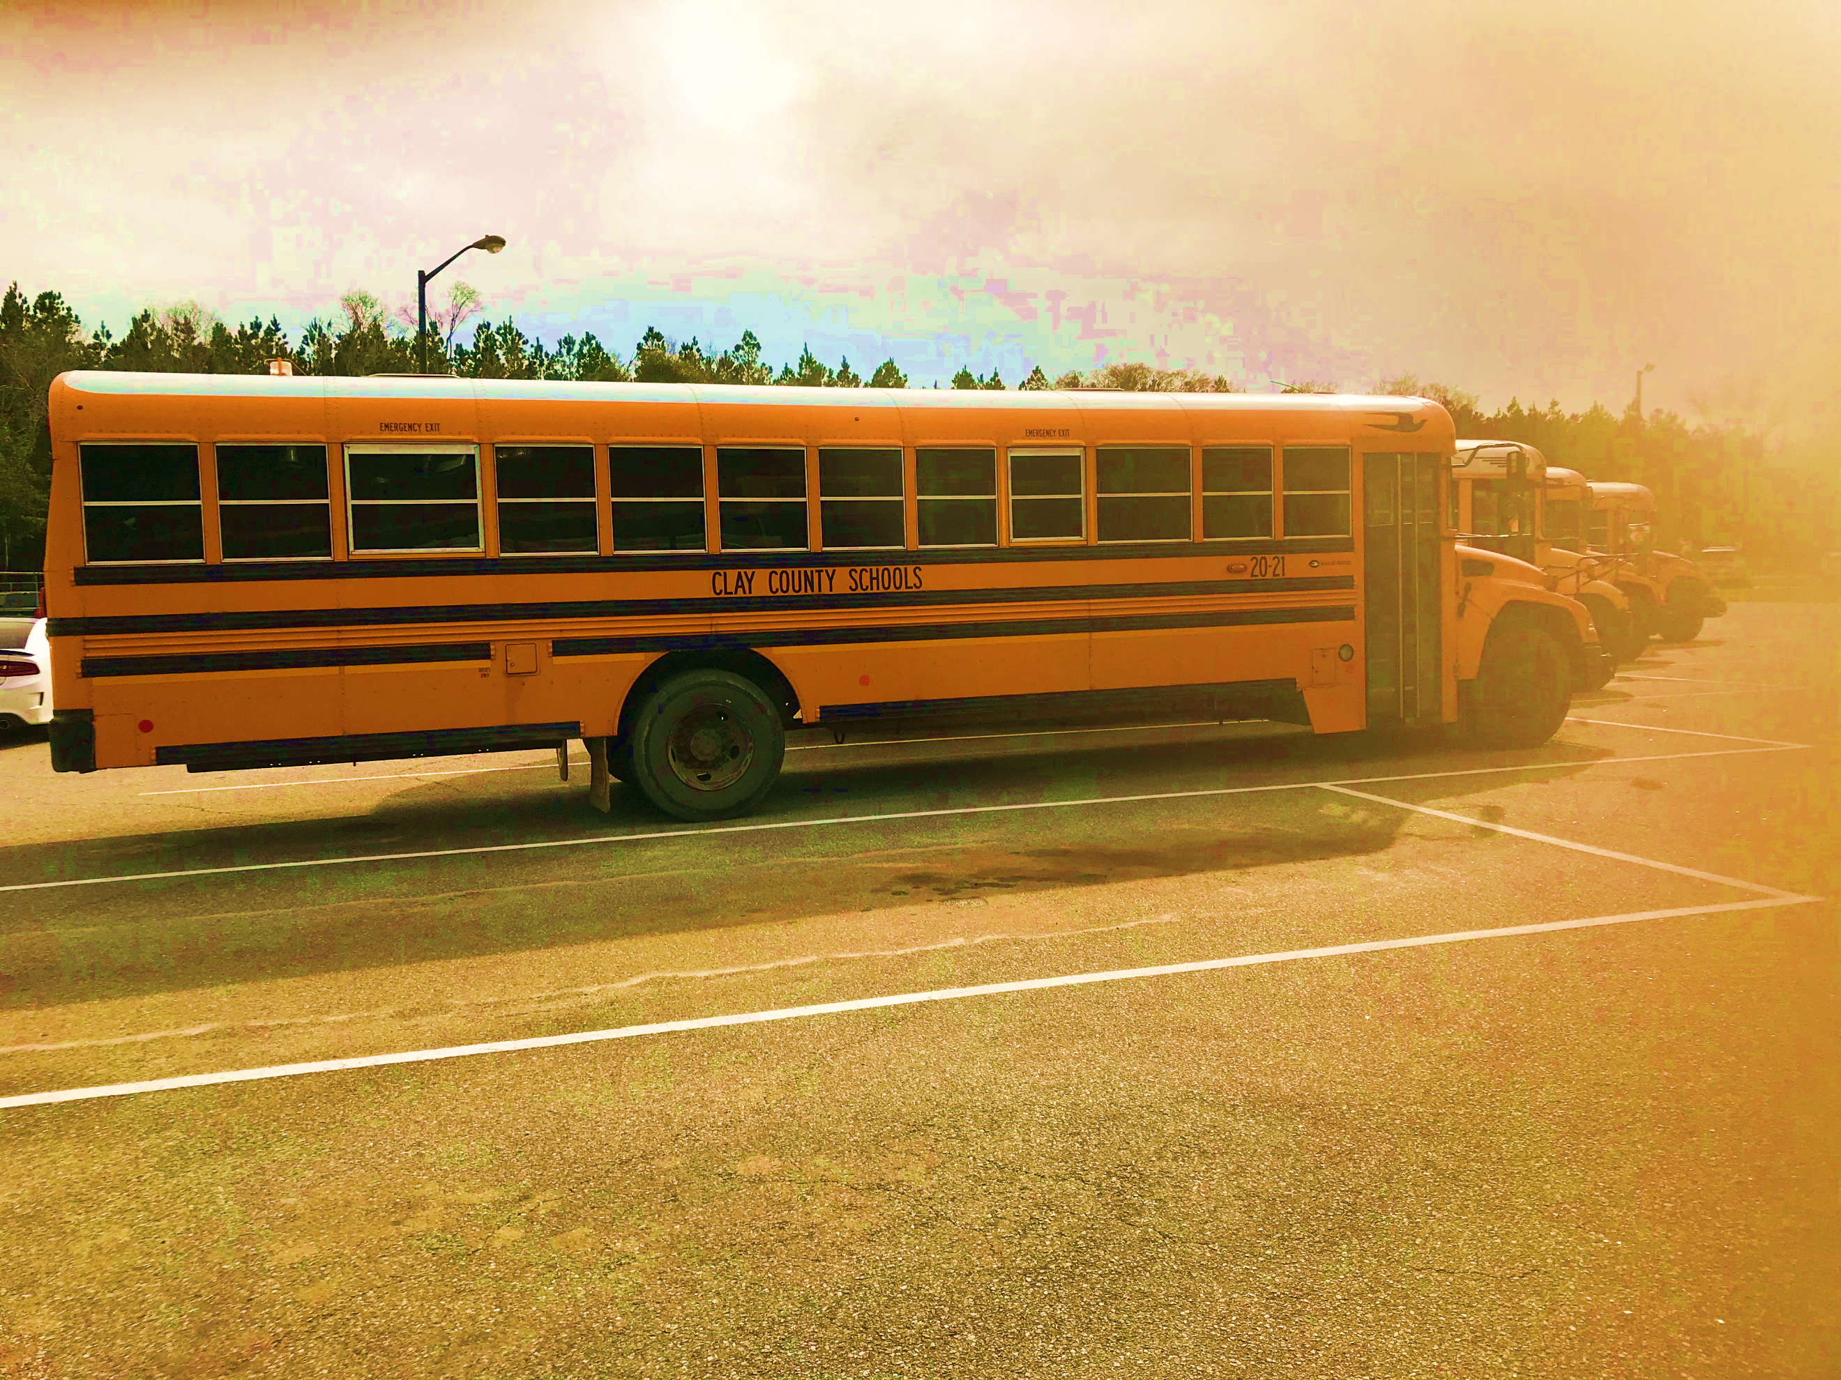
BACK

SCHOOL!!
2

Clay County School District Reopening Plan 2023

*12:00 – 12:55 Lunch

 | 7:45 – 8:00 | 8:00 – 10:05 | 10:05 – 11:00 | 10:35 – 11:05 | 11:05 – 11:50 | 11:55 – 12:55 | 1:00– 1:50 | 1:55 – 2:45 |  | 2:45 – 3:00
K  (Harris) | Homeroom/Morning Sponge  Morning Sponge Activities | Reading Block | Science/SS | Writing | LUNCH and RECESS (11:05 – 11:50) | Math | Connections | Math Intervention |  | Dismissal
 |  | 8:00 – 10:05 | 10:05 – 11:05 |  |  | 11:55 – 1:00 | 1:00– 1:50 | 1:55 – 2:45
1A  (Moreno) |  | Reading Block | Math |  |  | Writing  12:30 – 1:00  SC/SS | Connections | Math Intervention
1B  (Young) |  | Reading Block | Math |  |  | Writing  12:30 – 1:00  SC/SS | Connections | Math Intervention
 |  | 8:00 – 10:05 | 10:05 – 11:05 |  |  | 11:55 – 12:50 | 12:55 – 1:55 | 1:55 – 2:25 | 2:25 – 2:45
2A  (Brown) |  | Reading Block | Math |  |  | Connections | Math  Intervention | Writing | Science/SS
2B  (Green) |  | Reading Block | Math |  |  | Connections | Math  Intervention | Writing | Science/SS

 | 7:40- 8:00 | 8:00 – 8:50 | 8:50 – 9:40 | 9:40 – 10:30 | 10:30 – 10:40 | 10:40 – 11:30 | 11:30 - 12:20 | 12:20 – 12:55 | 12:55 -  1:45 | 1:45 -  2:35 | 2:35 -  3:15
6th | D.E.A.R (Reading Time) | ELA  Enrichment  (Freeman) | SCI  (Sullivan) | Math Enrichment  (Johnson) | BREAK | ELA  (Freeman) | ELA  (Freeman) | LUNCH | SS  (Freeman) | MATH  (Johnson) | CON  (Thornton)  1st – P.E.  2nd – Tech  3rd –P.E.  4th – Music
 |  | ELA Intervention  (Minton) |  | Tier 3 Math  (Hamilton)
7th |  | CON  (Thornton)  1st – P.E.  2nd – Music  3rd – Tech  4th – P.E. | SS  (Freeman) | SCI  (Sullivan) |  | MATH  (Pollard) | ELA  (A. Turner) |  | ELA  (A. Turner) | Math Enrichment  (Pollard) | ELA  Enrichment  (Freeman)
 |  |  |  |  |  |  |  |  |  | Tier 3 Math  (Hamilton) | ELA Intervention  (Heard)
8B |  | ELA  (A. Turner) | ELA  (A. Turner) | MATH  (Pollard) |  | SS  (Johnson) | Math Enrichment  (Pollard) |  | SCI  (Wimberly  & Sullivan) | ELA  Enrichment  (Heard) | CON (Heard)  1st - Tech  2nd – P.E.  3rd – Music  4th – P.E.
 |  |  |  |  |  |  | Math Intervention  (Smith) |  |  | ELA Intervention  (Minton)
Tier 3 Math
(Hamilton)
8A |  | Math Enrichment  (Pollard) | MATH  (Pollard) | ELA  (A. Turner) |  | ELA  (A. Turner) | SCI  (Wimberly  & Sullivan) |  | SS  (Johnson) | CON  (Inzetta)  1st - Music  2nd – P.E.  3rd – Tech  4th – P.E. | ELA  Enrichment  (Turner)
 |  | Math Intervention  (Smith) |  |  |  |  |  |  |  |  | ELA Intervention  (Minton)

 | 7:45 – 8:00 | 8:00 – 9:55 | 10:00 – 10:50 | 10:50 – 11:45 | 11:45 – 12:35 | 12:35 – 1:50 | 2:20 – 2:45 | 2:20 – 2:45
3A  (Gilbert) | Homeroom/D.E.A.R | Reading Block  (Gilbert) | Connections | Writing  (Gilbert) | LUNCH/RECESS | 12:35 – 1:35  Math (Peterson)  1:35 – 2:20  Math Intervention  (Smith) | Science/SS  (Sub) | Dismissal
 |  | 8:00 – 9:55 | 10:00 – 10:50 | 10:50 – 11:45 |  | 12:35 – 1:00 | 1:00 – 2:45
3B  (Peterson) |  | 8:05 – 9:05  Math  9:05 – 9:55  Science/SS  (Sub/Peterson) | Connections | Intervention  Math  (Peterson)  ELA- Glaze |  | Writing  (Gilbert) | Reading Block  (Gilbert)
 |  | 8:00 – 9:55 | 10:00 – 10:50 | 10:50 – 11:45 |  | 12:35 – 1:05 | 1:40 – 2:45
4th  (Beard) |  | Reading  Block  (Beard) | Connections | Writing  (Beard) |  | Science/SS  (Sub)  1:05 – 1:40  Intervention  (Minton/Gibson) | Math  (Peterson)
 |  | 8:05 – 9:05 | 10:00 – 10:50 | 10:50 – 11:45 |  | 12:35 – 1:00 | 1:00 – 2:45
5th  (Johnson) |  | 8:05 – 9:05  Math (SJ)  9:05 – 9:55  Math Intervention  (Smith/Gibson) | Connections | Science  (Sullivan)  11:25 – 11:45  S.S. (Sub) |  | Writing  (Beard) | Reading Block  (Beard)

What Returning to School Will
Look Like for Students and Staff

Overview
We know how important it is for our students to come back to school for face to face instruction. Our plan is to return to face to face instruction for five days per week during the 2022-2023 school year. As always, we will continue to keep our students and staff safety at the forefront of all of our decisions. The partnership between the school and the parent is essential now more than ever. We will continue to engage in vital conversations with all stakeholders to make the best decision possible when it comes to the safety of the students and staff.

Instruction
- Microsoft Teams will continue to be the learning management system for all Clay County School District students.
- Assessments (DRC Beacon, iReady, Acadience, formative, etc.) will be administered to measure the amount of learning loss to guide instructional decision-making.
- Collaborative planning and learning communities will be utilized to analyze data to determine students’ specific learning needs and to plan for addressing the learning gaps.
- After school and Saturday school will be available.
Nutrition
- We will begin the school year with students being served lunches in the classroom. By October 2022, we hope to have all meals served through the serving lines in the cafeteria. Meals will be pre-plated in carryout containers if the need arises.
- Lunchroom staff will be retrained in food safety and hygiene procedures while working in the kitchen and dining areas.
Safety and Security
Face Masks: Face masks will be encouraged on all Clay County schools. For the 2022-23 School Year, masks are NOT required.
Physical Distancing: With all students returning to in-person instruction, physical distancing in the school setting and on the buses will be encouraged. As always, Clay County School District will continue to follow recommended CDC guidelines.
Handwashing: Proper handwashing is important to slow the spread of COVID-19. The district will continue to provide hand-sanitizer throughout all school buildings, in every classroom and on every bus. We will continue to encourage handwashing for students and staff throughout the day.
Cleaning and Maintaining Healthy Facilities: Clay County School District will continue to ensure that our buildings are cleaned. Each room continue to have air purifiers in them. Bathrooms, buses and other high touch areas will be cleaned regularly as well.
Health Protocols: Staff and students are encouraged to continue conducting health assessments prior to coming to school. As always, we will continue to provide the most up-to-date criteria on our schools and district websites.
Contact Tracing: When made aware of a COVID-19 case, the district will continue to investigate the case and determine quarantine protocol. We will continue to work with the Clay County Health Department to ensure the health and safety of our school community.
Vaccinations: Clay County School District held a vaccination clinic for all staff members who wished to receive a COVID-19 vaccine in the Spring of 2021 and Booster Clinics in Fall of 2022. While vaccines are not required, we encourage all those who are eligible to receive a vaccination in order to contain the spread of COVID-19.
Social-Emotional Learning/Mental Health Needs: In the 2022-23 School Year, we will continue to work with RESA Wraparound Services and our local health department to assist our students in this area. We will also establish a new partnership with GaDOE Communities In School (CIS).
Extended Learning Programs: Clay County School District recognizes that student learning has been impacted by the COVID-19 Pandemic. The district will continue to offer After School programs, Saturday School and Summer School for students at all schools during the 2022-23 School Year.
Accommodations: Clay County School District will continue to provide accommodations for students with disabilities, along with providing support services for student’s academic, social emotional, and mental health needs through various intervention services.
Periodic Review: Clay County School District will continue to review this plan every six months, or as CDC, local or state guidelines change.
Public Input: Clay County School District encourages input from all stakeholders regarding our plan. We will take into consideration all feedback as we make decisions regarding the health and safety of our students and staff. Please contact the appropriate building administrator with any questions and/or concerns.

