|  |
| --- |
| GED/HSE Class 23 |
| GED Practice Set 3 |
| 25-36 |

|  |
| --- |
| Kevin Adams |

1. What is the equation, in slope-intercept form, of the line shown on the graph?

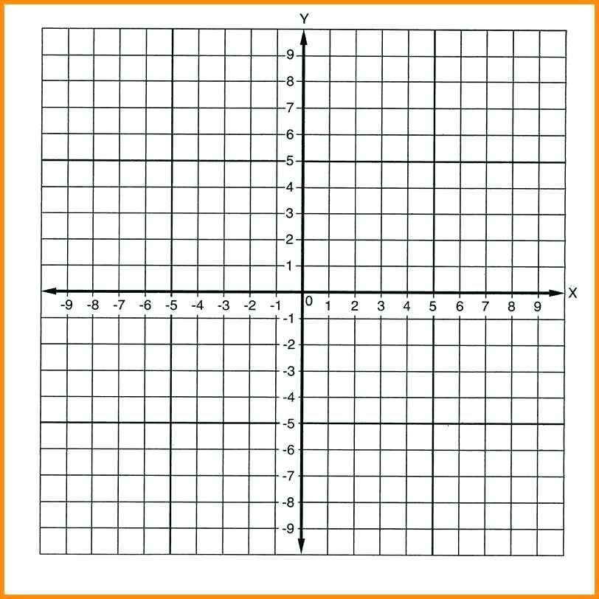

(a) (b)

(c) (d)

2. 2. Subtract.

(a)

(b)

(c)

(d)

3. What is the value of $x$ in this system of equations?

(a) (b)

(c) (d)

4. Which expression can represent: *the quotient of the product of a number and three, and the sum of the same number and seven?*

(a)

(b)

(c)

(d)

5. At the City of Kyle’s New Year’s Eve Celebration, a giant spherical disco ball is going to be suspended from the top of City Hall. The disco ball measures 10 feet across, and is going to be painted solid gold. Each can of specialty paint can cover 80 square feet. How many cans of paint will the painters need to have on hand?

(a)

(b)

(c)

(c)

1. Which line on the graph represents the equation ?



**A**

**B**

**C**

**D**

2. If , what is ?

(a)

(b)

(c)

(d)

3. For what value or values of is the following expression undefined?

(a) (b) (c) (d)

4. Which expression is the same as ?

(a)

(b)

(c)

(d)

5. The diameter of a spherical balloon is 10 inches. To the nearest tenth, how many cubic inches of air can it hold?

(a)

(b)

(c)

(d)

6. **(No Calculator.)** Between which two points would we find $\frac{5}{7}$ on a number line?

(a) 0.5 and 0.6 (b) 0.6 and 0.7

(c) 0.7 and 0.8 (d) 0.8 and 0.9

Questions 1-3 refer to the following table.

|  |  |
| --- | --- |
| **x** | **y** |
| 0 | 1 |
| 1 | 3 |
| 2 | 5 |
| 3 | 7 |
| 4 | 9 |

1. What is the slope of the line represented in the table?

2. What is the slope of a line perpendicular to the line represented in the table?

3. What is the equation of the line represented in the table?

4. Which expression and solution on the number line represents the inequality, *three more than the product of a number and two is greater than or equal to nine*?

(a)



(b)



(c)



(d)



5. 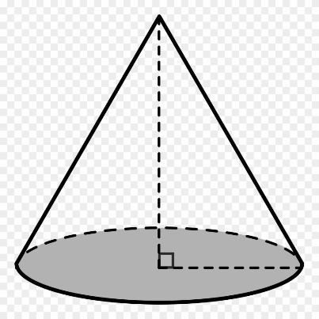A cone is shown. What is its volume, in cubic units?

(a) $100π$

(b) $300π$

12

(c)

(d)

10

6. Without using a calculator, express $\frac{3}{11}$ in decimal form, rounded to the nearest hundredth.

1. What is the slope of the line represented by the equation?

(a)

(b)

(c)

(d)

2. What is a possible value of $x$ in this equation?

(a)

(b)

(c)

(d)

3. Multiply:

(a)

(b)

(c)

(d)

4. A restaurant serves build-your-own bowls, where each customer selects a protein, a grain, and any 2 vegetables for his or her bowl. There are 6 choices of vegetable. How many combinations of 2 different vegetables are possible?

(a)

(b)

(c)

(d)

5. A rectangle has a length that is three times larger than its width. The area of the rectangle is 48 square units. What is the width of the rectangle?

(a)

(b)

(c)

(d) 12

1. What is the equation, in slope-intercept form, of the line on the graph below?

(a)

(b)

(c)

(d)

2. Evaluate.

(a)

(b)

(c)

(d)

3. Which algebraic inequality and solution on the number line represents *three less than the product of a number and two is less than or equal to nine*?

(a)



(b)



(c)



(d)



4. Which of the following is an undefined expression in the set of real numbers?

(a) (b) (c) (d)

5. Simplify the following expression.

(a)

(b)

(c)

(d)

1. What is the equation of the line shown on the following graph?



(a) (b)

(c) (d)

2. Rocky’s Ice Cream Parlor has a Saturday afternoon special: 2 scoops of any flavor of ice cream, 2 of any topping, and a choice of 3 different cones for $4.99.

There are 12 flavors of ice cream to choose from, and 7 different toppings.

How many possible ways could a customer to Rocky’s Ice Cream Parlor build a special?

(a) 22

(b) 252

(c) 7,056

(d) 21,168

3. Without a calculator, evaluate $2^{3}$.

(a) 5 (b) 6 (c) 8 (d) 23

Karla is an interior house painter. To determine the cost, $C$, of a job, she charges $.05 per square foot, $s$, and an additional $30.00 per hour, .

4. Write a formula that Karla could use to express how much she charges for a job.

5. If Karla spends 8 hours painting a rectangular room that is 30 feet wide and 40 feet long, how much will she charge for the job?

(a)

(b)

(c)

(d)

1. What is the slope of the line represented in the table below?

|  |  |
| --- | --- |
|  |  |
|  |  |
|  |  |
|  |  |
|  |  |

(a)

(b)

(c)

(d)

2. What is the slope of a line perpendicular to the line represented by the equation

(a)

(b)

(c)

(d)

3. Match each equation with its solution.

4. What is the equation of the line that passes through the point and has a slope of ?

(a)

(b)

(c)

(d)

5. Expand .

(a)

(b)

(c)

(d)

6. Which of the following is not a factor of 48?

(a) 3

(b) 6

(c) 7

(d) 12

1. What is the equation of the line that passes through the point and has a slope of ?

(a)

(b)

(c)

(d)

2. What are the factors of $x^{2}-2x-8$?

(a) $x-2$ and $x+8$

(b) $x+4$ and $x+2$

(c) $x+4$ and

(d) and

3. For what value or values of $x$ is the following expression undefined in the set of real numbers?

(a)

(b)

(c)

(d)

4. Which of the following tables does *not* represent a function?

|  |  |
| --- | --- |
| **Input** | **Output** |
| 3 | 7 |
| 6 | -7 |
| 9 | 7 |
| 12 | -7 |
| 15 | 7 |

|  |  |
| --- | --- |
| **x** | **y** |
| -1 | 10 |
| 0 | 2 |
| -1 | 10 |
| 0 | 2 |
| -1 | 10 |

(a)

(b)

|  |  |
| --- | --- |
|  |  |
|  |  |
|  |  |
|  |  |
|  |  |
|  |  |

|  |  |
| --- | --- |
| **Input** | **Output** |
|  |  |
|  |  |
|  |  |
|  |  |
|  |  |

(c)

(d)

5. A cubical box has a volume of 3375 cubic inches. What is the length of each of its sides, in inches?

(a)

(b)

(c)

(d)

1. Recently, an ocean-going oil tanker had an oil spill while it was at sea. Scientists studying the growth of the oil spill discovered that its area, in square feet, could be described by the equation

$$a\left(t\right)=1.3t^{2}-2.3t+1602.4$$

after $t$ number of days. What was the area of the oil spill, in square feet, after 7 days?

Enter your answer in the box below.

2. Which line on the coordinate plane below represents the equation ?



**A B C**

**D**

3. Without a calculator, evaluate the following expression.

(a) (b) (c) (d)

4. Evan is coating a cylindrical propane tank, illustrated below, with reflective paint. Each can of paint can cover 36 square feet. How many cans of paint will Evan need?

(a) 3

(b) 7

6

(c) 17

(d) 18

10

5. Destiny conducted a survey in which she asked people to choose their favorite color. She recorded the results in the table below.

The data for the color blue were erased, but Destiny remembers that the average (mean) for all colors was 37.

How many people chose blue as their favorite color?

|  |  |
| --- | --- |
| **Color** | **Number of People** |
| Yellow | 32 |
| Red | 38 |
| Blue |  |
| Green | 36 |
| Purple | 34 |

(a) 35 (b) 37 (c) 45 (d) 47

**Questions 1-5 refer to the following equation.**

1. What is the slope of the line represented by the equation?

2. What is the slope of a line parallel to the line represented by the equation?

(a) (b) (c) (d)

3. What is the slope of a line perpendicular to the line represented by the equation?

(a) (b) (c) (d)

4. Which of the following lines illustrates the line represented by the equation?



**A**

**B**

**C**

**D**

5. Which algebraic inequality and solution represents *three less than the product of a number and negative five is greater than twenty two*?

(a) (b)

(c) (d)

6. Grace is hanging paintings in a cafe for an art exhibition. She is trying to decide between 7 different paintings, but there is only space to choose 4 of them. How many different arrangements of the 7 paintings does Grace have to choose from?

(a) 22 (b) 28 (c) 840 (d) 2401

7. Simplify

(a)

(b)

(c)

(d)

8. A rectangle has a width of 6 and a perimeter of 36. What is the length of the rectangle?

(a) 6 (b) 12 (c) 18 (d) 24

Questions 1 and 2 refer to the following chart.

1. Dorothy asked a group of friends and family members what each of their favorite kind of novel is. She made a pie chart to illustrate the results.

If 8 people chose Romance, how many people did Dorothy survey in all?

(a) 20 (b) 30 (c) 40 (d) 100

2. Which 2 categories, combined, made up more than half of the responses?

(a) Mystery and Classics (b) Fantasy and Classics

(c) Romance and Fantasy (d) Romance and Sci-Fi

3. Simplify

(a) (b)

(c) (d)

4. Which expression below is the same as ?

(a)

(b)

(c)

(d)

5. Doug sells custom embroidered hats. To determine the cost of an order, he uses the formula

$$12n+5c+6$$

for $n$ number of hats ordered using $c$ number of different colors in the embroidery.

How much would an order for 16 hats using 7 colors cost?

1. What is the slope of the line that passes through the points $\left(2, -3\right)$ and ?

(a)

(b)

(c)

(d) 3

2. Subtract

(a)

(b)

(c)

(d)

3. On a scale drawing of a house floor plan, $1\frac{1}{2}$ inches represents 11 actual feet. If a certain wall on the drawing is $2\frac{3}{4}$ inches long, how long is the wall in real life? Round your answer to the nearest tenth of a foot.

(a) $.4$ feet

(b) $11.8$ feet

(c) $20.2$ feet

(d) feet

4. Susan is serving punch at a graduation party using conical paper cups. How many cups will Susan need if she is serving 5 gallons of punch into individual paper cups? ($1 gallon=231 in^{3})$. Answers are rounded to the nearest tens place.

3

5

(a) 10 (b) 20 (c) 80 (d) 100

5. What is the distance between $-17$ and $-9$ on a number line?

(a)

(b)

(c) 8

(d)

25. 1. b

2. c

3. d

4. a

5. c

26. 1. a

2. a

3. c

4. c

5. a

6. c

27. 1.

2.

3.

4. d

5. a

6.

28. 1. a

2. b

3. a

4. b

5. b

29. 1. b

2. b

3. b

4. a

5. d

30. 1. a

2. d

3. c

4.

or

5. b

31. 1. b

2. d

3.

4. c

5. b

6. c

32. 1. c

2. d

3. c

4. d

5. a

33. 1. 1650

2. d

3. c

4. b

5. c

34. 1.

2. c

3. d

4. c

5. c

6. b

7. b

8. b

35. 1. c

2. b

3. c

4. a

5. 233

36. 1. d

2. b

3. c

4. d

5. c