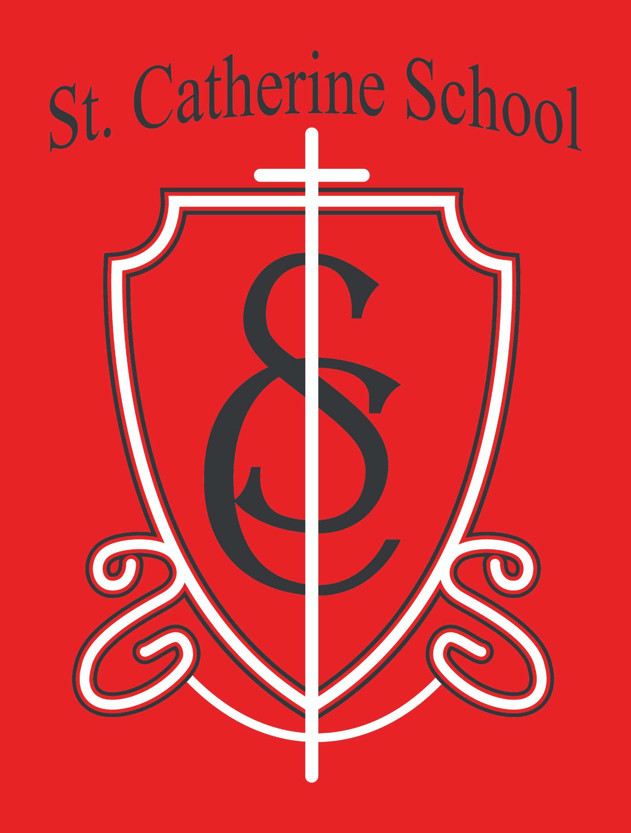

St. Catherine School Weekly Newsletter (Week of August 31st - September 5th)
https://www.stcatherine.k12.nd.us/parents

Principal's Message
Dear St. Catherine Families,
Each year, our St. Catherine School community comes together for one of the biggest highlights of the year: the St. Catherine School Fall Auction. This year, we will celebrate our 54th Annual Fall Auction with the theme “Anchored in Faith.”
What a fitting theme for our school community. Our shared faith is the anchor that grounds us and gives purpose to the important work of St. Catherine School. In partnership with parents, we are called to form our children, help them grow in faith, and lead them closer to the Lord.
Please save the date for Friday, November 6. Make plans to find a babysitter and join us for a wonderful evening of fellowship and support for our school. Every dollar raised through the auction goes directly back into supporting St. Catherine School and its students.
When I say that our school simply could not exist as it does without the Fall Auction, that is not an overstatement—it is entirely true. The generosity of our families, parishioners, alumni, businesses, and friends makes an incredible difference. We are deeply grateful for the many people who donate, volunteer, attend, and work behind the scenes to make this special evening possible.
Together, anchored in faith, we continue building a school community where children are known, loved, challenged, and brought closer to Christ.

Reminders

Procare Parent Portals

We have received several questions about Procare, and we appreciate your patience. We are working with the final few families to register and set up their parent portals. Once that is complete, we will send detailed guidance about adding payment methods and make the school office available to assist families.
Our goal is to begin helping families complete their parent-portal setup by Wednesday, September 9. We have encountered a few unexpected complications, so the process has taken longer than anticipated. Thank you again for your patience and understanding!

Handbook Acknowledgment Forms

If your family has not yet returned its handbook acknowledgment form, please return it to the school office. Both the student and the parent or guardian must sign the form. Thank you for helping us complete this important beginning-of-the-year requirement.

School Picture Day — September 15

School Picture Day will be Tuesday, September 15. The photographer will be at school that morning. Because retakes are not always easy to arrange, please avoid scheduling appointments that morning whenever possible. We certainly understand that illnesses and other unexpected circumstances arise.

First All-School Mass — September 17

Our first All-School Mass of the 2026–2027 school year will be Thursday, September 17. Mass will begin at 10:30 a.m. in the “big church,” with a guest lunch served afterward.
For our new families, we generally celebrate an All-School Mass about once each month. These Masses are typically held at 10:30 a.m., and many are followed by a meal. Our students actively participate in the ministries of the Mass, making these celebrations a beautiful opportunity for our entire school community to share and grow in faith together.
Ms. Giesen will email families with information about reserving a place for the lunch. Please RSVP by replying to that email if you plan to attend.

St. Catherine Spotlight
Reading Is the Golden Ticket to a Great School Year!
At St. Catherine School, we strongly emphasize making reading accessible to every child. Through large, structured academic blocks, our Title I support, Accelerated Reader quizzes, and dedicated silent-reading time in our classrooms, we work to foster a lifelong

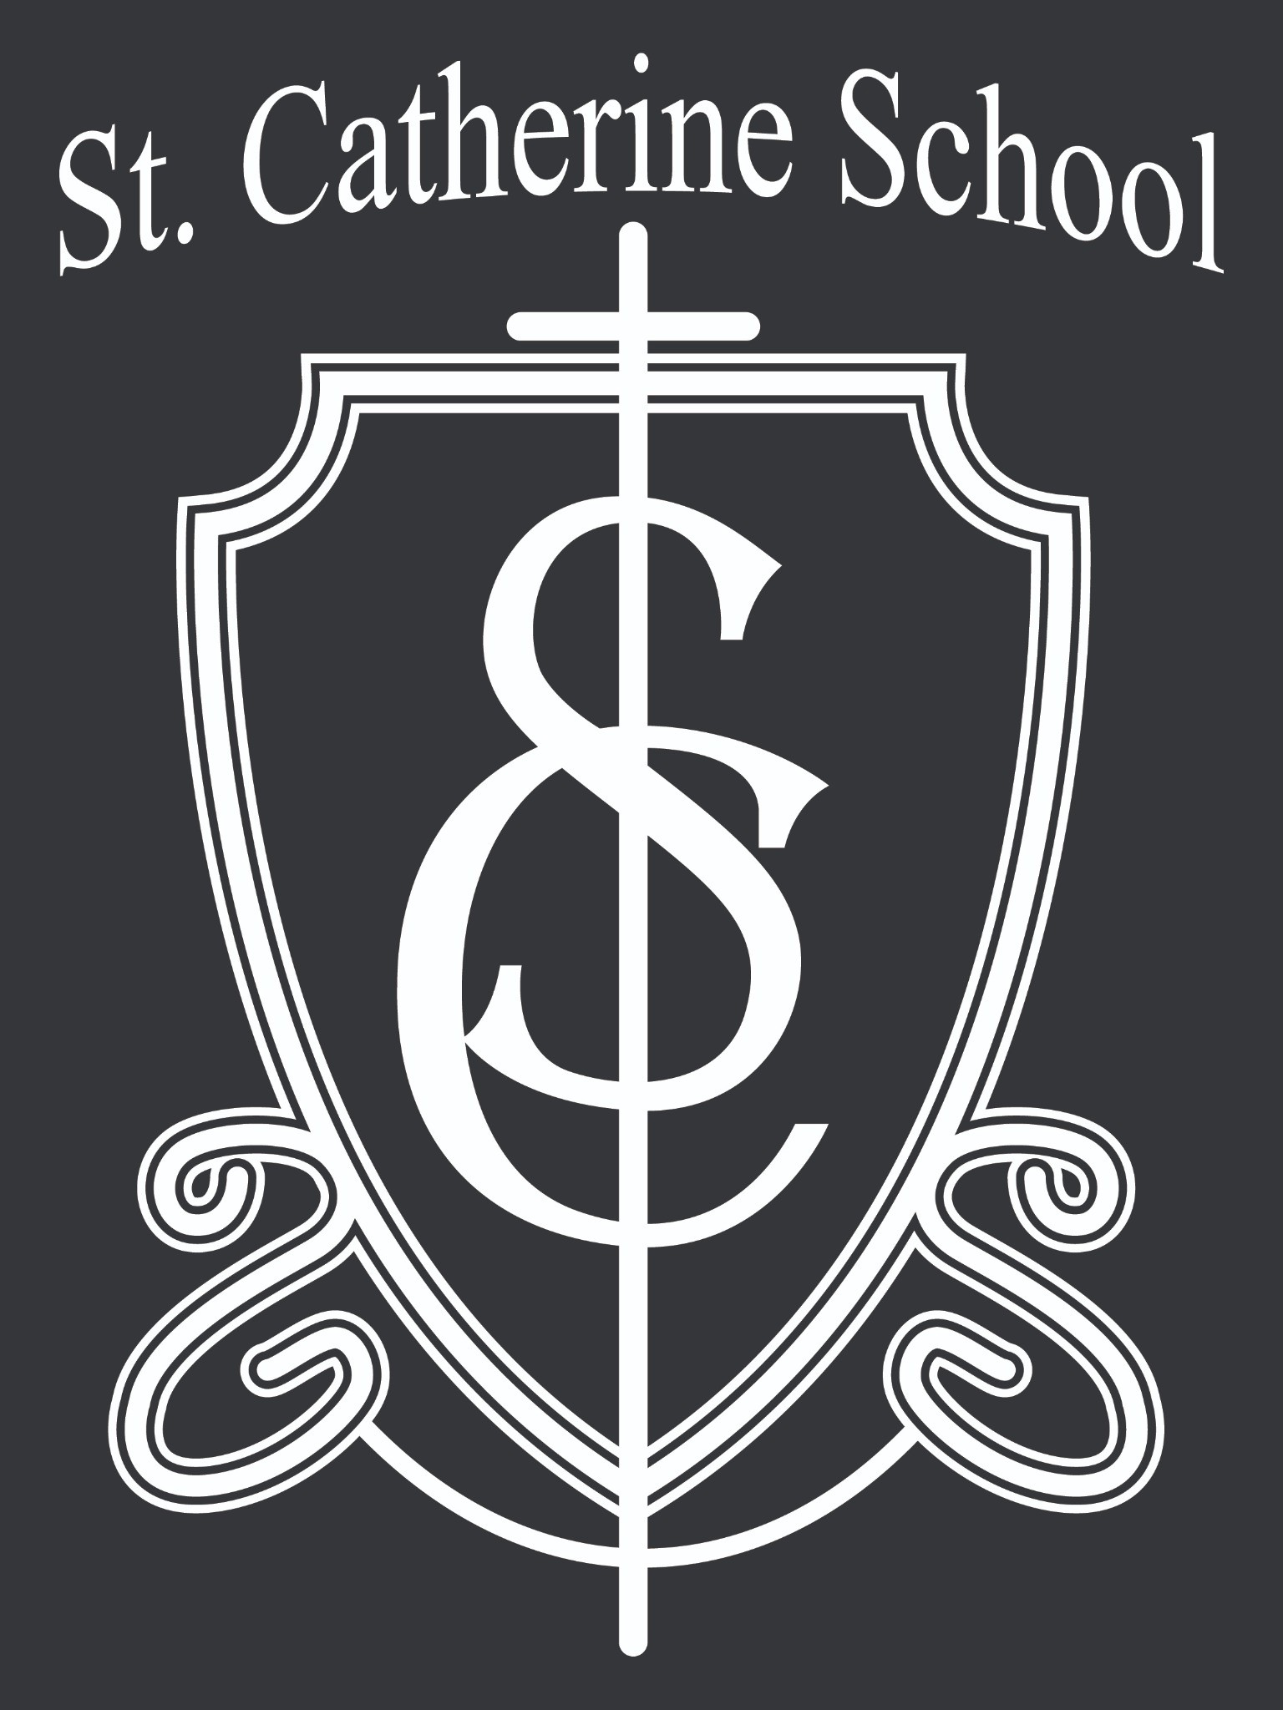love of reading in every student. Reading is foundational to our children’s learning and future success.
One way we make reading enjoyable—not simply something students “have to do”—is through our annual schoolwide reading theme. This year’s theme, inspired by Willy Wonka, is “Reading Is the Golden Ticket to a Great School Year!”
As students read throughout the year, they can earn recognition at chapel and receive special prizes. Students can also participate in our Pizza Wheels program, generously sponsored by Pizza Corner. Please visit with your child’s classroom teacher to learn how students earn stickers for their reading sheets and participate in the Pizza Wheels program.
We began our reading adventure with a special showing of Willy Wonka & the Chocolate Factory in the school gym. It was a wonderful way to build excitement and begin another great year of reading!
A special thank-you goes to our librarian, Mrs. Gulka, for the time, creativity, and energy she gives to making our reading theme come alive each year. We are grateful for the joy of reading she brings to our students and school!

Stay Connected with St. Catherine School
📍 Address: 540 3rd Ave. NE, Valley City, ND 58072
Email: nicholas.lee1@k12.nd.us
📧
Phone: 1-701-845-1453
📞
Website: www.stcatherine.k12.nd.us
🌐
📘 Follow Us on Facebook: St. Catherine School on Facebook

“Inspiring excellence through faith, learning, and service.”

