Hatch Valley Public Schools

District Staff Handbook

P.O. Box 790
Hatch, New Mexico 87937
(575) 267-8200
www.hatchschools.net

All Students and Staff Empowered to Succeed!

2023-2024

Hatch Valley Public Schools

 | Board of Education
Greg Mitchell, President  Elva Garay, Vice President |  | Chris Montez, Secretary  Merlinda Hinojos, Member  Lupe Castillo, Member
Michael M. Chávez |  | Superintendent
Dr. Toni Hull |  | Executive Director of Curriculum and Instructional Innovation
Sheila Offutt |  | Director of Finance and Operations
Taryn Fogle |  | Director of Special Education
Eduardo Fernandez |  | Director of Transportation & Safety Monitor
Carla Moffatt |  | Director of Health Services (RN)
Andrew Campbell |  | Director of Technology Services
Fernando Sanchez |  | Athletic Director
Bobby Cordero |  | Maintenance Supervisor
S. Elsa Ramirez |  | Admin. Assist. - School Board/Superintendent
Central Office |  | Support
Shelly Ortega |  | Business Office Manager
Sonia Moreno Rodriguez |  | Payroll/Benefits/Insurance
Raney Weiler |  | Accounts Payable
Jessica Batrez |  | Business Office Admin. Assist.
Yaling Hedrick |  | IEP Coordinator
Blanca Ramirez |  | Special Education Admin. Assist.
Carla Yaw |  | Special Education Admin. Assist.
Jimmy Martinez |  | Maintenance Specialist
Louis Reyna |  | Technician
Issac Garcia |  | Technician
Anel Mendoza |  | Technology Admin. Assist.
Gabriela Corrales |  | Transportation Admin. Assist.
Kim O’Byrne |  | Agriculture Instructional Specialist
Sandra Williams |  | EL Community Engagement Specialist
Olivia Paez |  | District Social Worker
Carrie Hernandez |  | District Community Schools Coordinator
Vicente Zamora |  | District Safety Coordinator
School Administration |  | School Building
Brandy Holguin |  | Hatch Valley High School Principal
Fernando Sanchez |  | Hatch Valley High School Assistant Principal/ Title IX
Amber Perry |  | Hatch Valley Middle School Principal
Latishia Zamora |  | Hatch Valley Middle School Assistant Principal/LT Hearings
Adetha Collins |  | Rio Grande Elementary School Principal
Amy Marquez |  | Hatch Elementary School Principal
Louis Meza |  | Garfield Elementary School Principal/Dist. Test Coordinator
Audra Bluehouse |  | High School Librarian/Data Specialist/PowerSchool/ Canvas

DISTRICT STAFF PROCEDURES

Absence from Work

All HVPS employees must inform their supervisor or designee prior to being absent from work, except in extreme emergency situations. A failure to do so may be considered job abandonment and result in disciplinary action up to and including termination.

All full-time school staff members have discretionary, professional, and sick leave, 12 month employees accrue annual leave. It is imperative that Certified Staff log in to iVisions as soon as possible and record your absences. Failure to do so will be a violation of this policy and may result in disciplinary action. Substitutes are paid after reconciling your absence with their work claim. Classified Staff need to enter their leave in NovaTime (employee timesheet). If your position requires a substitute, a minimum of 3.75 hours of leave should be entered since we cannot get a substitute for less than half of a day. Any leave less than 3.75 hours must be pre approved by your supervisor.

Leave Bereavement- Effective July 2013

Leave with pay for the three (3) workdays following the death of someone in the employee’s immediate family. In the case of the death of an employee's spouse, domestic partner, child, grandchild or parent (2) additional days are allowed. In extenuating circumstances, additional days may be granted by the Superintendent or designee to be charged against the employee's accrued sick leave. Documentation may be requested by your supervisor.

The immediate family defined; spouse, domestic partner, parent, grandparent children, grandchildren, sister, brother, son-in-law, daughter-in-law, sister-in-law, brother-in-law, mother-in-law, father-in-law, a person was the guardian for the employee prior to the employee becoming an adult, and others who reside in the same household with the employee.

Leave - Discretionary

All staff earn two discretionary days per school year for personal business. Please submit a leave request in iVisions or NovaTime two weeks in advance or as soon as possible before your absence so that a substitute may be secured. Unused discretionary leave reverts to sick at the end of the year.

Leave- Sick

Compensated leave that is granted to staff members for personal or family illness, injury, or quarantine, and is unable to perform the duties assigned. Family, for purposes of sick leave, shall include: Spouse, Children, Parents, Grandparents, Grandchildren, Parents, Relations created by marriage (e.g., stepchild, mother/ father-in-law). Family illness, for purposes of sick leave, shall not exceed three (3) days, without approval from your supervisor. 3 consecutive sick days or patterns of absences (every Monday or Friday for ex.) may require a doctor’s verification.

Sick leave may include other excused absences, such as medical, dental, or other examination or treatment impossible to schedule on non-duty days. Employees are credited with a sick leave allowance at the rate of one (1) day per month up to twelve (12) days. At the beginning of the fiscal year or school year, each employee earns a number of sick leave days by the number of contract days worked. Sick leave of any staff member who does not serve a full school year will be prorated at the rate of one (1) day per month.

All accumulated sick leave is forfeited upon termination from employment by the School District for any reason, with no payment in lieu thereof. Excessive absences or patterns of absenteeism may require verification of reason for absence.

Any employee who has willfully violated or misused the District's sick leave policy or misrepresented any statement or condition will be subject to discipline, which may include reprimand, suspension or termination.

*After leave has been exhausted, pay will be reduced for the hours that are not worked.

NOTE: Discretionary/Sick Leave may not be used to extend a scheduled holiday without prior approval from the Superintendent or Designee.

Compensatory Time (“Comp-Time” for Hourly Employees Only)

There should not be any compensatory time earned by hourly employees, except in the case of emergencies. Supervisors must approve any compensatory time. Compensatory time must be used within the next month. Comp Time leave should be entered in NovaTime for approval.

Leave Extended – Sick Leave Bank

See Board Policy Section GCCC for information concerning leave for extended periods, i.e. Family and Medical Leave Act 1993, etc. Staff members who wish to participate in the District Sick Leave Bank must upon initial participation donate one sick leave day. For additional information contact the payroll department.

Leave - Jury Duty

All employees summoned to jury duty must mark that you are a government employee on the reimbursement form. Also, all employees must get a note from the court to bring back to work to confirm the time released from jury duty. If the service time is less than 3.75 hours, you will need to come back to work or submit a request for approval to use personal leave for the remainder of the day. Your supervisor must approve the personal leave request.

Leave Military

Employee members of organized units of the Army, Air National Guard, Or Army, Air Force, Navy, Marines or Coast Guard Reserves shall be given (not to exceed) 15 working days military leave with pay when ordered to duty for training.

Leave Professional

Any out of district trip made by school personnel, must have prior approval by your supervisor. If there are costs associated with this trip your supervisor or designee will get budgetary approval before the trip will be authorized. Once the trip is approved: Please submit your professional leave request in iVisions/NovaTime at least 3 days prior to the scheduled trip. If expenses or vehicle are requested, complete the Excel Travel Estimate Form located on the District Website and submit to the Business Office for approval and request a vehicle from your school site secretary; at least 7 days in advance is preferred. Please include documentation for the trip; i.e. an agenda, flyer, etc. All staff using a school vehicle must abide by the District rules and regulations for use of a school vehicle.

Mileage will only be paid if there are no school vehicles available. The Transportation Department and Central Office must give prior Approval for Mileage. If fees (such as registration, lodging, etc) are requested, a separate Purchase Requisition must also be completed (See Purchasing Section).

Leave- Professional - Reimbursement

Employees must sign a travel agreement before traveling (attached at the end of the handbook).

Per Diem Reimbursement is a fixed rate per day (24 hour period) of travel and the employee will be required to purchase their own lodging and will be reimbursed the fixed rate per 2.42.2.1 NMAC - N, 07/01/03. A purchase requisition must be submitted for estimated costs after completing Travel Estimate Form. If the district is paying for the lodging, per diem is not allowable and actual receipts must be submitted for reimbursement.

If per diem is not requested employees will be reimbursed on actual itemized receipts “up to” limits listed on the Travel Estimate Form. No reimbursements will be made for alcoholic beverages. Actual expenses will be reimbursed upon return from the trip.

Meal Reimbursement – A purchase requisition must be submitted for estimated costs after completing Travel Estimate Form. Upon return you will need to verify exact times of departure and return and complete a Travel Log and attach agenda and all original receipts for trips overnight that exceed 24 hours out of the district. Employees will be reimbursed actual expenses per 2.42.2.1 NMAC - N, 07/01/03. See the Travel Estimate Form for reimbursement rates for actual lodging and meal expenses under 2.42.2.9 NMAC and Section 10-8-4(K) (2) NMSA 1978 (1995 Repl. Pamp.).

Same-Day Travel—Meals - If employees are out of district during the workday or after work hours, the meal reimbursement schedule will apply. No meals will be paid for trips within a 60-mile radius of the school district.

Deadline on Reimbursement -All requests for reimbursement must be submitted within 3 business days of returning from the trip. Requests over 3 days may be denied. Upon returning from a professional leave trip you must provide all receipts, conference documentation (certificate, badge picture, agenda, sign in sheet picture, etc.). Checks are run in the accounts payable department on Thursdays, therefore documentation must be in by noon on Wednesday to receive a check on Thursday.

General Expectations

Appearance

Faculty and staff are to dress appropriately for their work. Blue jeans are not appropriate attire for professional staff except on the following days;
- College Day Monday- to promote post-secondary education, staff may wear school appropriate blue jeans on Monday; IF worn with post-secondary attire (shirt, jersey, etc.).
- House Spirit Day Wednesday - to promote House unity, staff may wear school appropriate blue jeans on Mondays and House special event days when worn with House T-Shirts and/or house colors.
- Hatch Bear Friday – to promote HVPS Bear spirit, staff may wear school appropriate blue jeans on Fridays and any other“big game day” encouraging school spirit; when worn with Hatch Bear attire or red/black.
- Super Bowl Monday - Jeans may be worn the day after the Super Bowl with your favorite jersey or team shirt.

Cell Phones

Personal use of cell phones shall be limited to breaks, lunchtime or prep time. Cell phones are not to be used while supervising students, unless utilizing them for classroom instruction or job related activities that cannot wait. The District is not responsible for personal cell phones.

Electronic Devices

Staff members will be issued computers and electronic devices pertinent to their position. In return, they must sign an Acceptable Use Policy (AUP). Any personal computers used on campus must be approved by the Technology Department for security reasons. Staff members may be held financially responsible for electronic devices assigned to them if damaged or lost. Technology must be turned in upon leaving the Hatch Valley Public School District.

PLC Expectations

All schools are to operate using Professional Learning Communities. The PLC expectations are:
    - Data Analysis - at least once a month (MLSS/SAT)
    - Lesson Design and Planning for Quad D
      - Plan for ELTP/ House Days (Friday before the Wednesday)
    - Professional Development - Teach Like a Pirate and other subject PD

Other Professional Development
Other in-district Professional Development offerings will be scheduled throughout the year on many topics from Ag in the Classroom, parent engagement, teacher personal development and much more! Data/ PD days will occur every 6 weeks at each school.
If you are interested in outside professional development please see your supervisor.

New Teacher Induction/ Mentoring
All teachers with 3 or less years of teaching experience are expected to attend district new teacher induction training sessions. These will be after hours and teachers will get paid a stipend to attend. Also new teachers will be assigned a mentor and the mentor will participate in training as well and receive a stipend. (Documentation will be required for payment).

Government Disclosure

All Staff and School Board members are to sign a Government Disclosure Form indicating any outside employment that may be a conflict of interest. It is the signee’s responsibility to update this form as employment situations change.

Hours

Teachers are salaried employees who will have an eight (8) hour campus workday, which includes a 30-minute duty free lunch. Teachers’ hours are 7:00 a.m. -3:00 p.m. (GES), 7:30 am. - 3:30 p.m. (all other campuses). (See the school site for your specific hours depending on your role). See your building Principal for specific schedules for office staff, etc. to determine 7.5 hour days. Other hours may meet the needs of an office/department with approval from the Superintendent or designee. Non-certified staff must receive prior permission to work overtime. Staff employment contracts also outline time expectations.

Keys

Keys to your rooms, desks and locked cabinets are district property. A lost key may mean that the entire lock must be replaced. Persons losing keys may be held responsible for their replacement costs. Duplication of school keys is prohibited.

Planning & Grading

Lesson plans serve as documentation that you are planning in accordance with CCSS. All classroom teachers are required to have weekly lesson plans. These plans must be available for review by school or district administration at any time. We have a district model for planning available to teachers that aligns with our rigor and relevance framework can be found at https://tinyurl.com/rdmt47k4. We encourage teachers to be creative and innovative in their planning. Reach out to the Instruction Department for additional resources to support your planning.

Teachers will post a minimum of 2 grades per week in the electronic grade book (PowerSchool) to be available for students, parents and administration to view. All work assigned and completed by students shall be to meet the course standards and will be reviewed by the teacher. No failing grade should be a surprise to a child or parent. Please document communication with parents, especially those whose child is struggling in your class. The grading scale we will use this year is a 50-100 scale for completed work and a 0 for assignments not completed at all.

House System (541) 5 Schools - 4 Houses - 1 Bear Family

We have implemented a House system at Hatch Valley Public Schools. This means that ALL employees are sorted into one of 4 Houses (Altruismo, Isibindi, Amistad and Rêveur) to promote belonging, teamwork, collaboration and positive culture. We all wear our House shirts on WEDNESDAYS this year. If you have not yet been sorted please see your supervisor so you can spin the wheel and get your shirt/lanyard. Here is a great article about Houses if you would like more information about how it is a positive addition to schools. https://tinyurl.com/4pxnp33j. See Dr. Hull at the central office if you would like more information or have any questions.

Policies

Hatch Valley Public Schools Board of Education Policies are located on the district website, www.hatchschools.net. If you need assistance please see your supervisor. New Mexico Statutes and New Mexico Administrative Code also govern our work in the Public Schools. Links to these resources can be found on the NM PED Website www.ped.state.nm.us.
Safety

Mandatory Safety Trainings

HATCH VALLEY PUBLIC SCHOOL DISTRICT

MANDATORY DISTRICT TRAINING

You are required to complete certain training tutorials as an employee at the Hatch Valley Public School District. It is a responsibility to accomplish these training tutorials as soon as possible.
Please be sure to have your speakers turned on.

Hatch Valley Public Schools Vector Training, K-12 EditionTM

Website: http://hatchvalley.nm.safeschools.com/

Username: YOUR EMAIL ADDRESS (GOOGLE SIGN ON)
For questions, please contact your Hatch Valley Public Schools Vector Training, K-12 EditionTM contact - Elsa Ramirez - eramirez@hatchschools.net.

Thanks for making Hatch Valley Public Schools a safer place to work and learn.
After you complete the tutorials, return to the Main Menu. Please email Elsa Ramirez at eramirez@hatchschools.net when you are done so she can print certificates for your file.

Safety Procedures

Ladder Safety / Reaching Heights When using a step ladder ensure the supports are fully deployed and parallel to the ground. Never use the top rung as a step, and always have a “spotter” present. NEVER use a chair, desk or table as a device to reach heights that are normally unattainable.

Electrical / Extension Cords The use of power strips and extension cords is highly discouraged. If an outlet is a safety issue call Maintenance and they will address it immediately. Do not attempt to make any electrical repairs on your own!

Wet floors Custodians are instructed to placard all areas that are being wet mopped. If you see an area where the custodian has failed to placard a freshly mopped area, please bring it to the custodian’s or your supervisor’s attention immediately.

Chemicals All cleaners and degreaser employed by the custodial staff have an SDS (Safety Data
Sheets) and the SDS is available in the school’s main office. All science lab chemicals are stored in a lockable closet and monitored by the science teacher with the SDS for each.

Lifting Safety Lifting any object especially off the floor requires correct technique. Online videos do an excellent instructional job of showing the do’s and don’ts of lifting. Ask for help no matter how much the weight might be. Remember, one’s legs are much stronger than one’s back.

Appliances Due to electrical & fire safety concerns as well as utility costs no personal cooking appliances or refrigerators are allowed in classrooms or classroom office spaces.

School Based Health Center

SBHC is now located at Hatch Valley High School and available for staff use at extension 8293.

Social Media (i.e., Facebook, Twitter, Texting, Email, etc.)

Staff members will maintain professional conduct when posting any content or communicating with students or parents using social media. Any content posted by staff is subject to New Mexico Public Education Department Professional Ethics Regulations. All staff are expected to conduct themselves in an ethical manner and not post comments that could “erode the public trust.” See the District’s “Acceptable Use Policy” for additional details.

Student Nutrition Program

All students in the Hatch Valley Public Schools receive free breakfast and lunch. Staff members are encouraged to eat in the cafeteria for a fee of $3.00 for breakfast and $4.00 for lunch.

Surveillance Cameras

The Board has authorized the use of video cameras on district property to insure the health, welfare and safety of all staff, students and visitors to the district property and to safeguard district facilities and equipment. See Complete Surveillance Camera Policy online at www.hatchschools.net

Technology Help Desk Procedures

All Technology Help Desk tickets must be submitted in the Help Desk ticketing system. Here is the link to the Help Desk ticketing system and instruction page: https://hatchvalleypsd.gethelphss.com/Login/landing - Login
https://content.schoolinsites.com/api/documents/759e291b16654997a6855126acc4689f.pdf - Information

Video in the Classroom

The uses of multimedia items are a valid teaching technique. Please be aware of the District’s
Board Policy concerning the showing of movies that are not Rated G. (Policy I-6311) School administration will develop specific procedures for teachers to gain permission for the viewing of videos.

Work Orders- Repairs

If your work area is in need of repair please contact your supervisor or designee. They will direct you on your next steps.

Compliance Policies

ADA/Section 504

In accordance with Section 504 of the Rehabilitation Act of 1973 and the Americans with Disabilities Act, faculty, staff, and administration will take the proper steps to ensure that personnel and students are not discriminated against because of their disability.

The following information addresses the most important features of these Acts: Assistance can be requested from the 504 Compliance Officer/ADA Coordinator. Students who are disabled under Section 504 but not in need of special education and/or related services shall be provided reasonable accommodation to meet their special needs in the regular education setting. Such students shall be evaluated in accordance with procedures described in the Section 504 regulations. See the directory for specific contact information.

Blood Borne Pathogens

All staff should receive training and information in handling blood borne pathogens. See the District Nurse for details.

Child Abuse Reporting-Revised 2014 (22-10A-32 NM Statutes Annotated-Required Training)

Every person, including a school teacher or a school official who has information that is not privileged as a matter of law, who knows or has a reasonable suspicion that a child is an abused, sexually assaulted or a neglected child shall report the matter immediately.

The building administrator should be informed, and the "Agency Referral Form and Procedure" should be used in order to have documentation and follow up. A building administrator and/or their designee may permit a member of a law enforcement agency or an employee of the Human Services Department to interview the child with respect to a report without the permission of the child's parent, guardian or custodian.

A school employee who fails to report abuse as provided in 32A-4-3 NMSA 1978 is guilty of a misdemeanor.

Drug - Free Workplace

No employee shall violate the law or District policy in the manufacture, distribution, dispensing, possession, or use, on or in the workplace, of alcohol or any narcotic drug, hallucinogenic drug, amphetamine, barbiturate, marijuana, or any other controlled substance, as defined in schedules I through V of section 202 of the Controlled Substances Act (21 U.S.C. 812) and as further defined by regulation at 21 C.F.R. 1308.11 through 1308.15.

Workplace includes any school building or any school premises and any school-owned vehicle or any other school-approved vehicle used to transport staff members or students to and from school or school activities or on school business.

When employees are off school property, the workplace includes any school-sponsored or school-approved activity, event, or function where students or staff members are under the jurisdiction of the District. In addition, the workplace shall include all property owned, leased, or used by the District for any educational or District business purpose.

Any employee who has been convicted under any criminal drug statute for a violation occurring in the workplace, as defined above, shall notify the supervisor within five (5) days thereof that such conviction has occurred.

As a condition of employment, each employee shall abide by the terms of the District policy respecting a drug-free workplace. Any employee who violates this policy in any manner is subject to discipline, which may include, but is not limited to, dismissal.

Drug and Alcohol Abuse & Reporting Policy

The Hatch Valley Public Schools recognizes, under state and federal law, that it is illegal for students to use alcohol or controlled substances. According to Senate Bill 106, it is our legal responsibility; "A school employee who knows or in good faith suspects any student of using or abusing alcohol or drugs shall report such use or abuse pursuant to procedures established by the local school board." Therefore, school employees shall report to their building principals any of these suspicions.

Drug and Alcohol Testing (Random)

School bus drivers, activity drivers and employees who work in a “safety sensitive” environment, heavy equipment or handle prescribed medications and the supervisors of these employees are subject to random drug and alcohol testing.

Equal Opportunity Employer

Hatch Valley Public Schools is an Equal Opportunity Employer. If at any time an employee feels discriminated against (as defined by the Office of Civil Rights), they must report the incident to their immediate supervisor. A complete procedure for filing a complaint or grievance can be found in the Board of Education Policy Manual Section G.

Grievances

A grievance is a complaint by a District employee alleging a violation or misinterpretation, as to the employee, of any District policy or regulation that directly and specifically governs the employee's terms and conditions of employment.

It also includes all complaints of discrimination, including harassment and assault, based on sex or disability. See the HVPS Board of Education Policy for procedures.

No person(s) shall suffer retaliation, recrimination, discrimination, harassment, or be otherwise adversely affected because of the use of the grievance procedure.

Notice of Non-Discrimination

The Hatch Valley Public Schools does not discriminate on the basis of race, color, national origin, sex disability, or age in its programs or activities and provides equal access to the Boy Scouts and other designated youth groups.

The following person has been designated to handle inquiries or concerns regarding the District’s non-discrimination policies as well as Section 504 questions:
- Michael Chavez - Superintendent, 219 E Hill Street, Hatch, NM 87937

Title IX questions or concerns please contact:
- Latishia Zamora, Hatch Valley Middle School, 170 E. Herrera Road Hatch, NM 87937

HB 43 Black Education Act
At HVPS we believe in creating and fostering equitable and culturally responsive learning environments for all students regardless of their race or ethnicity.
To assist in this and to meet the requirements of HB 43, the district will:
- give all staff the opportunity to be a part of our district equity council to assist the district in fostering these inclusive learning environments
- require all staff to complete an online and/or in person racial sensitivity training each year
- inform all staff of the hotline for reporting racially charged incidents involving students and/or staff
- have discipline policies that reflect prohibition against racially charged incidents involving students or school personnel
- not hold staff liable for civil damages for reporting in good faith any known or suspected violation of school discipline policy in regards to racially charged incident
Anti-Racism Hotline The Anti-Racism, Anti-Oppression Hotline number is 833-485-1335. The hotline offers a way for students, families and community members to report school-based incidents of racism, injustice or discrimination against anyone. Callers will reach a trained department employee from 8 a.m. to 5 p.m. Monday through Friday; if calling after hours, they can leave a message. The hotline was established as a requirement of the Black Education Act, passed in the 2021 General Session of the Legislature.
To report an incident:
- Call 833-485-1335
- Email: ARAO.Hotline@state.nm.us
- Or complete an online form here.

Sexual Harassment
The administration, the staff, and students, are expected to conduct themselves at all times so as to provide an atmosphere free from sexual harassment. Report any violations of this policy to the immediate supervisor or Superintendent.

Sexual harassment includes unwelcome sexual advances, requests for sexual favors, and other verbal or physical conduct of a sexual nature when made by a member of the school staff to a student or to another staff member, or when made by a student to another student where:

- Submission to such conduct is either explicitly or implicitly made a term or condition of an individual's employment or education;
- Submission to or rejection of such conduct is used as a basis for employment or educational decisions affecting such individual;
- Such conduct has the purpose or effect of substantially interfering with an individual's educational or work performance, or creating an intimidating, hostile, or offensive employment or education environment.

Workers Compensation
In accordance with applicable workers’ compensation statutes, all employees of Hatch Valley
Public Schools who have a work-related injury are eligible for coverage. All work related accidents or injuries must be reported immediately to the injured employee’s supervisor by completing and submitting the Notice of Accident Form whether medical care is needed or not. Employees have the option to visit the School Based Health Center at the High School for an initial evaluation. See the Payroll/Insurance Department for more information.

STUDENT HARASSMENT / BULLYING / CYBERBULLYING PREVENTION

When a professional staff member receives information regarding a suspected offense, the staff member will transmit it to the school administrator no later than the next school day following the day the staff member receives the information or observes the incident. If the incident involves the school administrator, the professional staff member shall forward the information to the next administrative level.

At a minimum the licensed employee shall provide the identifying information on the suspected offense in writing and with such specificity of names, places and times as to permit an investigation to be carried out by the administration. The licensed employee should sign the written suspected offense report. However, an unsigned form will be processed in the same manner as a signed form.

The person reporting the suspected offense shall preserve the confidentiality of the subjects, disclosing names only to the appropriate school administrator or next higher administrative supervisor, or as otherwise required. A failure by the licensed professional staff member to timely inform the school administrator or next higher administrative supervisor of the allegation may subject the staff member to disciplinary action.

The incident will be investigated by the school administrator or a supervising administrator. The procedures to be followed are:

- An investigation of the reported suspected offense or activity shall be made within ten (10) school days when school is in session or within fifteen (15) days during which the school offices are open for business when school is not in session. Extension of the timeline may only be by necessity as determined by the Superintendent.

- The investigator shall meet with the student who is the target of the suspected offense at or before the end of the time period and shall discuss the conclusions and actions to be taken as a result of the investigation. Confidentiality of records and student information shall be observed in the process of making such a report.

- The investigator shall prepare a written report of the findings and a copy of the report shall be provided to the Superintendent.

See the Forms (English/Spanish) in this document and on the District Website or Google Drive.

Speak UP! –Students can call or text (575) 267-6133 to report bullying anonymously. Refer students to www.hatchschools.net for more information.

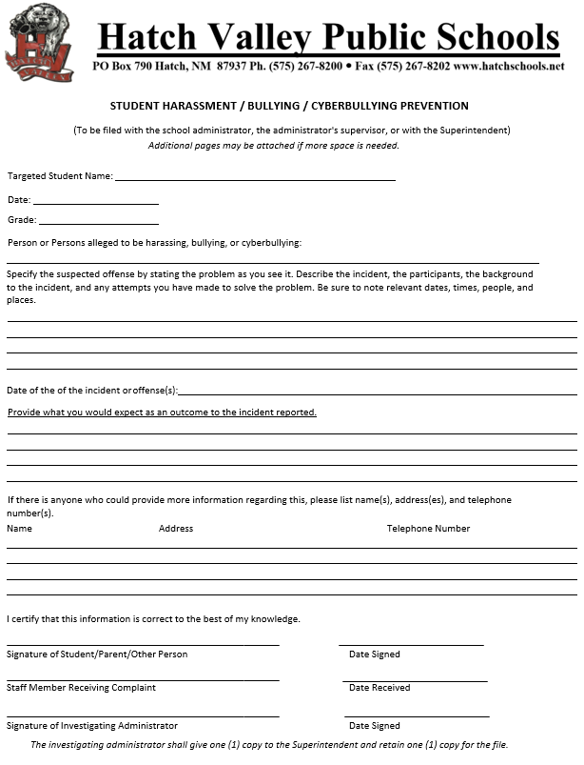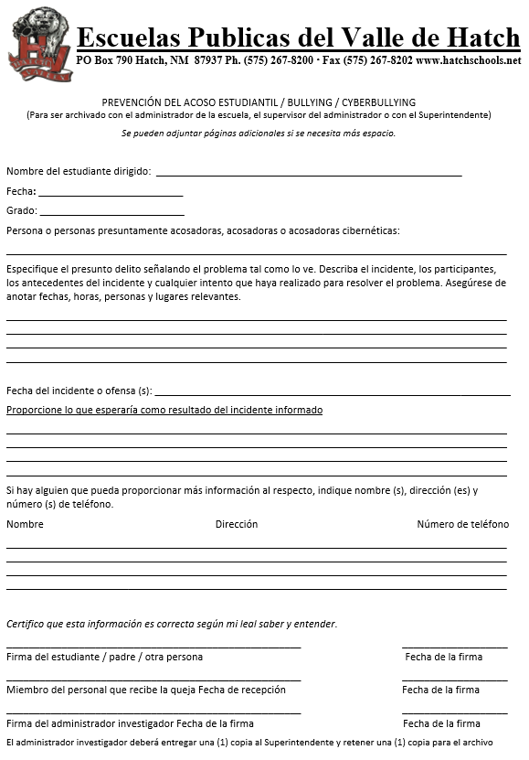
Field Trips

All Field Trips must support the School 90 Day Plan. Field trips must be pre-approved by your building principal and Superintendent/Designee. Field Trip Request should be submitted in TripDirect at least 7 days before the trip. Signed permission forms must be received for participation.

List all Staff Chaperones going on the trip under “Person(s) Requesting Field Trip.” This will serve as their “Professional Leave Permission.” List the 90 Day Plan Alignment under “Purpose of Trip/Curriculum Area.” (i.e. to the movie theater is not an academic field trip)

Meal Request

All district sponsored field trips require you to take a cafeteria sack lunch or breakfast. The PED will NOT reimburse the District for restaurant food so complete this section. Please designate a staff member to verify the request was received and coordinate the pickup time with your cafeteria.

Transportation Request

Indicate if a bus or other school vehicle is needed. Due to our limited buses and drivers please be certain the date has been approved by the transportation department before scheduling the trip. Any trip involving more than 18 people must use a bus per transportation regulations. Walking field trips are encouraged. Vehicle requests will be made in Transportation’s School Dude online scheduler. School site secretaries will have access to request vehicles.

All students must have parent permission to attend the field trip. Due to the academic nature of all field trips students may not be excluded from the experience. However, if circumstances arise where a student must miss a trip an alternative learning experience which includes similar Curriculum Standards shall be assigned.

Cancellations

Please notify Cafeteria and Transportation Staff ASAP if the trip is canceled!

*If a hotel room is canceled, request a cancellation number from the hotel.

Purchasing Procedures

Each employee of the district shall follow the purchasing policy when purchasing tangible goods or services. All purchases must have an approved Purchase Order prior to ordering or purchasing of any supplies, tangible goods, or services.

Any person who purposefully places an order for goods, services or construction without a duly authorized purchase order by the Superintendent or designee may be held personally liable for payment of delivered/purchased items. They also may be subject to the penalties of the NM Procurement Code.

Purchase Requisitions are to be created on Visions. Your SUPERVISOR will review Purchase Requisitions and if approved will forward to “Business Manager” for approval who in turn acquires the Superintendent’s/Designee’s Approval. IF it is a Special Programs Expenditure the requisition will be created by The Federal Programs or Special Education Director’s Office. When the purchase requisition has been approved your school will receive a PURCHASE ORDER. At this time only can the secretary or supervisor proceed with the actual order according to the final approved purchase order. Allow 5-7 working days for the processing of a purchase requisition once received at the business office.

Per NM Statutes Chapter 13 Regarding Public Purchases and Property:
- Any single purchase request at $20,000.00 or more must include 3 source quotes. (Any single purchase request using Federal Programs Funds over $5,000.00 must include 3 source quotes.) Any purchases of $60,000.00 of goods or any contract for services must be conducted through the bidding process according to the New Mexico Procurement Codes in New Mexico State Statute.

Contracts

The Superintendent or Designee (with Superintendent’s direction) and School Board are the only authorized persons to sign binding contracts for Hatch Valley Public School. If an individual signs a contract for a purchase without proper authority, they may be held personally liable for any expenses incurred.

PURCHASE REQUISITIONS/PURCHASE ORDERS

Procedure

PROCEDURE: Authorized users can initiate a purchase requisition by logging into iVisions Portal.

A purchase/service MAY NOT be obtained without an approved Purchase Order. A Purchase Requisition is Not a Purchase Order.

- Purchasing & Payables

- Purchasing

- Control Panel

- A purchase requisition will be assigned by the system. Enter ALL INFORMATION IE; VENDOR, DAC, PROJECT (information provided in the drop down).

- INTERNAL NOTES - A BRIEF EXPLANATION and regarding supplies/materials justifying why the purchase is necessary .

- DESCRIPTION-The product, material, services you are requesting (you may copy from the quote description); include Part Number in the appropriate field.

- ACCOUNT CODE: Describes how items will be charged; make sure the location code is the appropriate location code, i.e., 018000-District level purchase; 018001-RGE Purchase, etc.

Example: 11000.1000.56106.1010.018000 (supplies for instruction, regular education) 11000.2400.53330.0000.018000 (professional development Principal)
- The quantity, price per item/service.
- PO charges or Bank of America charges must be included on the PO.
- Shipping (Add to top line or distribute shipping.)
- If taxes are included on the quote, reach out to the vendor to obtain tax exemption. Tax is allowable on services and must be included on the PO.
- Attach Quote, Prior Approval from PED if applicable, Additional Source Quotes if over $10,000 for Federal Funds, or over $20,000 for all other Funds.
- Approve requisition to submit to the next approver.

Notes: Limit Bank of America use. Amazon can only be used as a final resort and must include approval from the Superintendent or Director of Finance.

Purchase requisitions will automatically default to the next approver. Final approval from the Superintendent or Director of Finance, initiates purchase orders. Purchase orders processed will be e-mailed to the originator for processing. Purchase requisitions shall be entered into iVisions five (5) to seven (7) days prior to allow ample time to process. Send the Vendor Copy of the PO and the Quote to the Vendor to place your order.

See Purchasing Flowchart below.
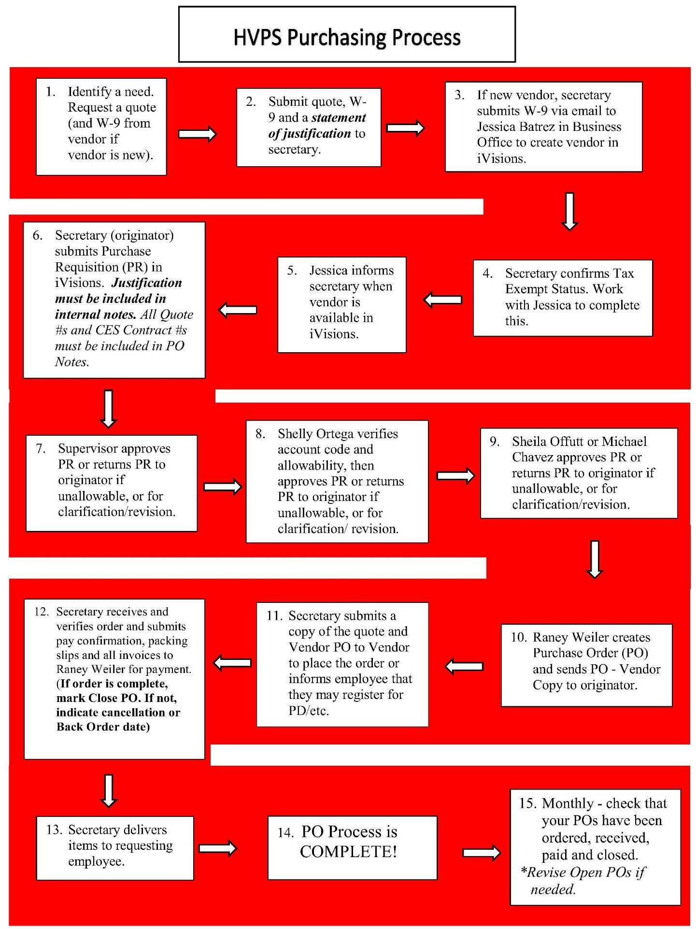
Receiving

When items are received, send a copy of the packing slip to Accounts Payable. When Invoices are received, ensure that all items have been received on the Invoice and submit a copy of the invoice and a pay confirmation to Accounts Payable. When all items on a PO have been received, mark on your final pay confirmation that the PO should be CLOSED.

Fundraisers
All fund-raising activities must designate the purpose for the money before the fund raiser begins. All fundraisers must provide a product or a service in return for the donation. Students should not ask the community for a “hand out.”
The building principal or athletic director must approve all fund-raising activities. Approval form must be uploaded to any relevant Purchase Requisitions in iVisions. Any food sales must comply with the District Wellness Policy Guidelines. (Contact Food Service before planning a fundraiser including food sales.) There is a NMAC Limit: 1 food fundraiser during school hours per semester.

NO RAFFLES - see Business Office Administration about State Regulations prohibiting raffles.

Do not use GO FUND ME or Donors Choose for school related purposes. All supply or instructional materials requests should be submitted to your building principal for approval.

School Activity Accounts

- All School Activity Account purchases will align to GASB 84 Standards (more information on GASB 84 available at the following website: https://www.gasb.org/jsp/GASB/Document_C/DocumentPage?cid=1176168786182&acceptedDisclaimer=true) and must follow the NM State Procurement Code.

- Enter purchase requisitions according to the above iVisions steps and in alignment with the NM Procurement Code.

- Monitor Account Detail for current account balance.

- Submit monthly reports to the Business Office for all expenditures and receipts for reconciliation.

Receipting Procedures

It is necessary that all teachers be aware of the procedures required by the New Mexico Department of Finance and Administration for any funds collected which might fall into the "public monies" category. Public monies include the following: (1) all fee money, (2) all money collected for lost textbooks or textbook damage, (3) all monies collected for breakage of articles purchased out of fee funds, (4) all monies from fund raising activities, (5) all money collected for the sale of items made by students.

Due to the volume in some schools, it may become necessary to have all monies from students receipted by the sponsor/s. Where teachers and others are assigned the responsibility of collecting money directly from students, the following will apply regarding receipting procedures:

Each day’s collections will be turned in to the office DAILY by 4:00 pm. Checks may be accepted from students or parents in payment of any account, but teachers are not to use any cash collected and replace it with their own personal check. ALL STAFF MUST turn in all checks/monies daily and deposit in the bank within 24 hours of receipt.

The money turned in must equal the total of receipts for the day! All money will be counted on the spot when being turned in. As money is turned in to the school office, the first and last receipt number should be given for the total amount collected.

The receipt numbers should be entered on the receipt form. This must be done each time you turn in money.

If, for any reason, you must VOID a receipt, do not tear either copy out. Staple together both copies (white and yellow) and leave them in place and mark them VOID. You cannot void a receipt without both copies!

Do not make refunds to anyone for any reason. If a student has paid you twice, or finds a book he paid for, please send him to the secretary with a note explaining the situation. The Business Office will be responsible for seeing that the refund is made; Contact Shelly or Sheila ASAP.

No employee shall receive any public monies which are not receipted on a pre-numbered, authorized receipt provided by the principal or his designated agent. You may obtain such a receipt book by seeing the school bookkeeper. Please do not send a student to pick up the receipt book as you must sign for the book. The receipt book must be turned in at the end of the school year.

Fight Song

HATCH VALLEY HIGH SCHOOL HATCH VALLEY HIGH SCHOOL

THE PRIDE OF EVERY LOYAL BEAR

COME ON YOU OLD GRADS, COME JOIN US YOUNG LADS HATCH VALLEY HIGH SCHOOL NOW WE CHEER.
RAH RAH RAH RAH

NOW IS THE TIME BOYS TO MAKE A BIG NOISE WHOO!

NO MATTER WHAT THE PEOPLE SAY

FOR THERE IS NONE TO FEAR THE GANG IS ALL HERE,

SO HAIL TO OLD HATCH VALLEY HIGH.

B- E- A- R- S

BEARS… BEARS

GO BEARS!

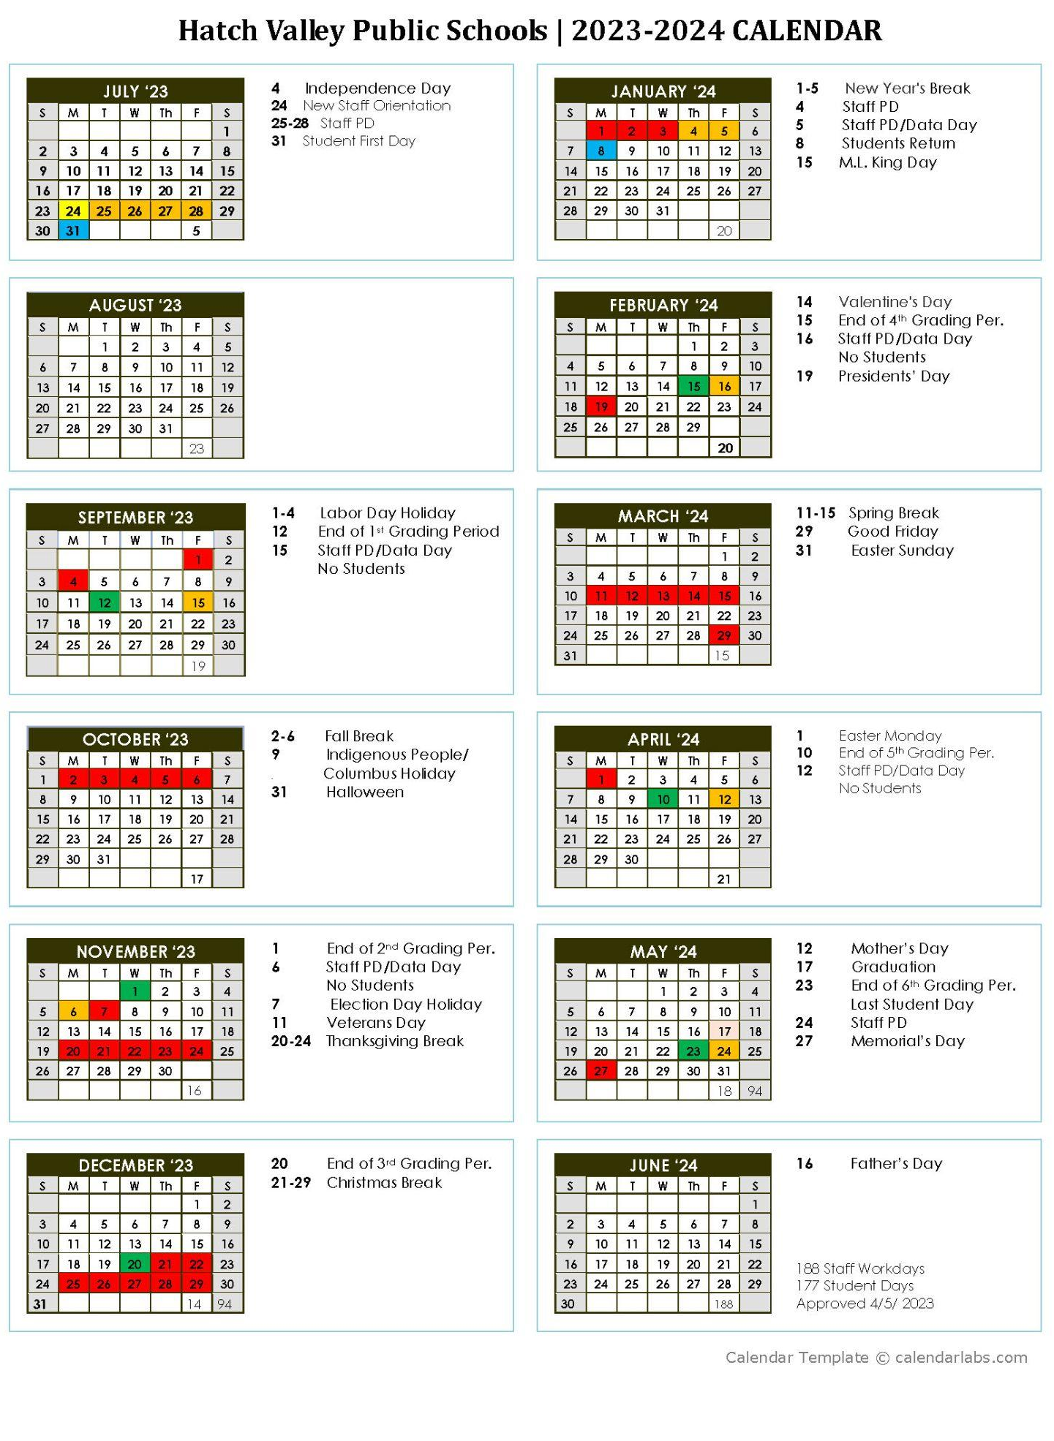
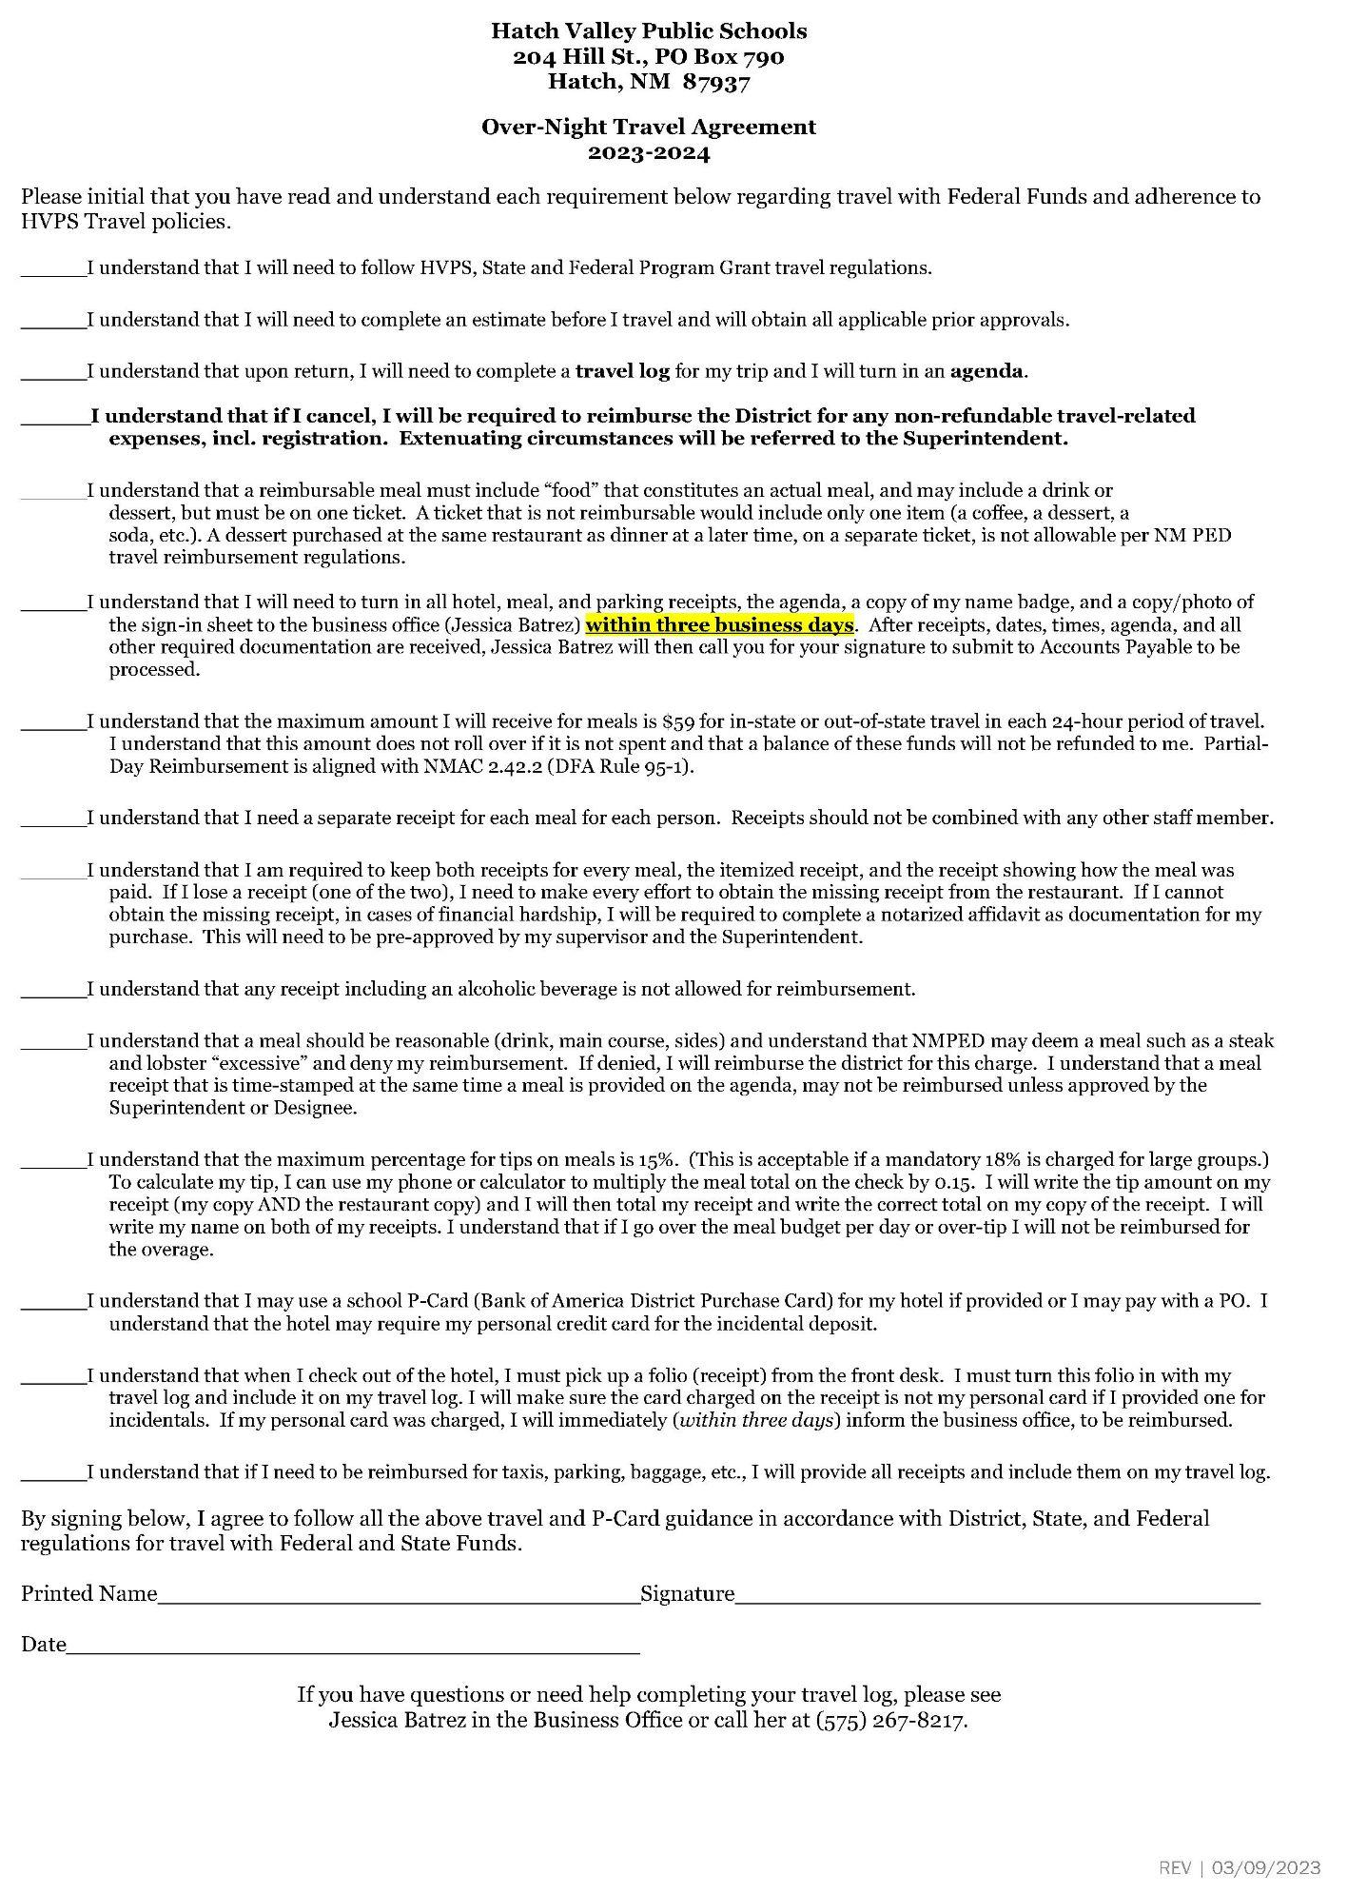

2023-2024

By signing below, I confirm that I have reviewed the Hatch Valley Public Schools District Staff Handbook. It is understood that I am held to these rules and procedures.

In the event that I fail to follow the rules and procedures specified in the Hatch Valley Public Schools District Staff Handbook I understand that consequences may include a verbal warning, written warning, written reprimand, suspension or termination of employment.

Employee Name: ____________________________

Employee Signature: ___________________________

Date: ___________________________

Please print this page, sign and turn into your supervisor.

