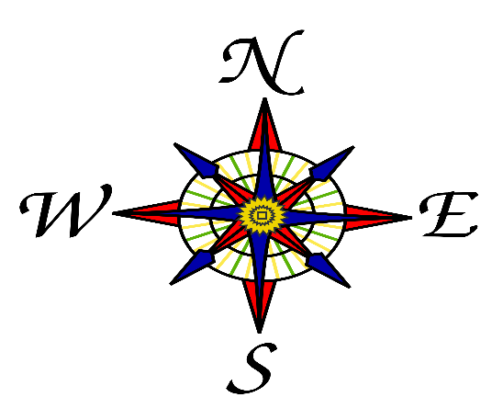

**CLASS NEWS**

**Mrs. Williams**

**Date: September 15, 2025**

**Math**:

-extend number patterns

**Science/Social Studies:**

-review continents/oceans

-four hemispheres, Prime meridian, equator

**Upcoming Events:**

**1 - Interim reports** go home Friday, September 12

**2 - REMINDER**- Field Trip money will be due on the 25th of September