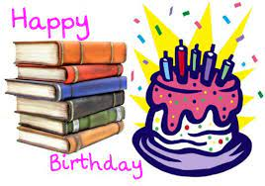
Park View Panthers

Birthday Book Program
Helps our library grow!!

What is a Birthday Book? It is a book that is purchased for $15.00 by family or friend and presented to a student or staff member in honor of their birthday during our monthly assembly that is closest to their birthday. The student’s picture, birth date and presentation date will be placed inside the front cover of the book. The student keeps the book for two weeks and then returns to the school library. The book will then be permanently added to the school library for other students to enjoy.

Birthday Books will be presented to the student during monthly assembly. July, August, and September birthdays will be presented during September’s assembly. April, May and June birthdays will be presented during April’s assembly.

Books are ordered in advance and kept in the library for purchase. These preselected titles have been recommended by teachers, students or were placed on a state recommended or accelerated reading list.

Books may be purchased any time during the school year and can be held until the student’s birthday as long as the book was paid for in advance.

If you do not select a book at the beginning of the school year, an attempt will be made to contact you when it is time to select a book.

Parents are welcome to come to the library to select a birthday book. Library is usually open before school, 8:00 a.m. and after school until 3:30 p.m. During school hours are reserved for classroom use.

This program helps our library to continue to grow and purchase more books for students to enjoy. If you have any further questions, please contact Janeen King, Librarian at (209) 599-1882, or by email at jking@riponusd.net

Complete form below and return to your child’s teacher, office or library with your payment. Exact cash or checks made payable to Park View Elementary. No credit at this time

____________________________________________________________________(______)_____________________
Parent/Guardian Name (please print) Contact Number

________________________________________________________________________________________________
Email Given by: (Love mom &/or dad, siblings)

________________________________________________________________________________________________
Childs Name (please print) Teacher/Grade M/D/Y of Birthday

________________________________________________________________________________________________
Childs Name (please print) Teacher/Grade M/D/Y of Birthday
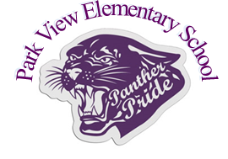
Library Use Only

