**Ms. Jaeda Boyd**

Jaeda.boyd@hcbe.net

Teacher website: https://vhs.hcbe.net/boyd-jaeda-t

**COURSE DESCRIPTION AND OUTLINE:**

Advanced Algebra: Concepts & Connections is the third course in a sequence of courses designed to ensure career and college readiness. It is intended to prepare students for fourth mathematics course options relevant to their postsecondary pursuits. High school course content standards are listed by big idea, including Data and Statistical Reasoning, Probabilistic Reasoning, Functional and Graphical Reasoning, Patterning and Algebraic Reasoning, and Geometric and Spatial Reasoning.

In Advanced Algebra: Concepts & Connections, students will continue to enhance their data and statistical reasoning skills as they learn specific ways to collect, critique, analyze, and interpret data. Students will learn how to use matrices and linear programming to represent data and to solve contextually relevant problems. Students will strengthen their geometric and spatial reasoning skills as they learn how to solve trigonometric equations using the unit circle.

In previous courses, students studied how to use linear and quadratic functions to model real-life phenomena. In Advanced Algebra: Concepts and Connections, students will further develop their functional and graphical reasoning as they explore and analyze structures and patterns for exponential, logarithmic, radical, polynomial, and rational expressions, equations and functions to further understand the world around them.

More detailed information about this course can be found at:

**Standards & Course Overview:** https://www.georgiastandards.org/Georgia-Standards/Pages/Math-9-12.aspx

**Textbook**: McGraw Hill Georgia Reveal Algebra 2. Students will have access to an electronic textbook through their SSO portal.

**GRADING POLICY:** Per Houston County Board of Education policy, each student’s average will be calculated as follow:

Major Assessments = 45%

Minor Assessments = 20%

Daily Work = 15%

Final Assessment/EOC = 20%

*This course includes a cumulative final exam at the end of each semester.

**INFINITE CAMPUS:** Student grades can be easily monitored by checking Infinite Campus regularly. Parents and students have access to Infinite Campus.

**Homework Policy:** Students are expected to attempt each problem to receive full credit (100). **If homework is not completed, a zero will be assigned**. Students can make up the assignment at which point the zero will be replaced. Students are limited to 3 homework make-ups per semester.

**Test Retake Policy:** Students will be allowed to retake two-unit tests per semester. In order to be eligible for a retake, students will need to attend tutoring and correct each missed problem on a separate sheet of paper accompanied by an explanation of the concept being assessed. I will review the test corrections to ensure they are correct and that the student is now prepared to demonstrate improved mastery of the content by taking the test retake. Retakes must be finished in a single sitting. Retakes will take place before or after school or during SOAR sessions.

**Tutoring:** I will be available for tutoring Monday and Wednesday from 3:00-3:30. Other days and times may be available on a week-by-week basis. These additional times will be posted in canvas.

**Chrome book:** All students are issued a district-provided chrome book for instructional purposes, student engagement, and student learning. Chrome book use is at the direction and discretion of the teacher.

**Consequences:**

If any student should fail to comply with the classroom rules, he/she will receive:

First: Reminder of classroom expectations

Second: Parent contact

Third: Office referral

**Classroom Rules:**

1. Bring all supplies to class every day.
2. Sharpen pencils before class starts.
3. Use the restroom before class starts.
4. Stay seated during instructional time.
5. No gum, food, or drinks in class.
6. Leave other student’s property alone.
7. Do not ask for a pass during instructional time.
8. All student handbook rules apply as well.

|  |  |  |
| --- | --- | --- |
|  |  |  |
|  |  |  |
|  |  |  |
|  |  |  |

**Bathroom Policy:** Students are expected to use the restroom between classes. Passes will not be issued during instructional time. Students are expected to be in the classroom where learning takes place.

**Testing Policy**: Students are expected to place all electronics in bookbags during assessments. Bags will be placed in front of the classroom until testing ends.

**Canvas:** To encourage blended learning, Canvas will be used on a weekly basis. Students should be familiar with how to navigate the online platform, communicate with their teacher, and submit assignments on time. If there are technological limitations, please notify the teacher.

**Accessing Canvas**:

Step One: ￼Go to the county’s website and click on SSO Portal.

Step Two: Students should sign in using their school/county username and password. If you have questions on your username and password, please ask your teacher.

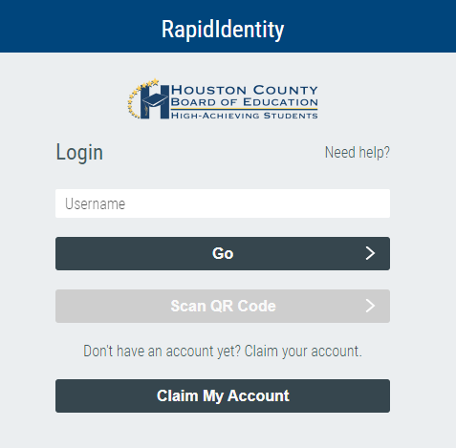

Step Three: Students should click on the Canvas app.

Advanced Algebra

Ms. Boyd

**By signing below I acknowledge that I have received, *read and understand all the objectives, student expectations, classroom rules and procedures, grading policy, disciplinary consequences, calculators, and tutoring information in the syllabus for the Advanced Algebra course.***

Parent/ Guardian, please include your email address and the single best phone number at which to contact you between 7:15-3:30.

Student Name (Print) ________________________________________ Period ______________

Parent/Guardian Name__________________________________ Number ____________________________

Parent/Guardian E-mail Address ______________________________________________________________

___________________________________ ___________________________________

Parent/Guardian Signature Student Signature