Math Review Week #19~Day 1 Name________________________

1. I am sending 30 birthday invitations. I’ve already written 20 of them. How many do I have left to write? 30 - 20 = __________ .

- Write the number 245 in expanded notation: _______ + ______ + ______

- True or False 6 + 9 = 4 + 7

4. Write a number that is 100 more and 100 less than the number: 453
_______ ,453, ________

- Put these numbers in order from least to GREATEST: 44 67 23 88

________, ________, _________, __________

Mental Math ______________________
____________________________________________________________
____________________________________________________________

Math Review Week #19~Day 2 Name________________________

- Solve to fill in the blanks: 12 - 8 = ______
_____+ 8 = 12

2. Use the associative property to solve: (4+9) + 2 = ______+______

3. Circle the equation that does not belong in the fact family (7, 5, 12)

7 + 5 = 12, 5 + 7 = 12, 12 - 2 = 10, 12 - 5 = 7

4. Circle all numbers that are LESS than 100: 120 87 45 1 14 75 230

- Count on. You’ve baked 44 cupcakes for the bake sale. You bake 4 more. How many did you bake all together? ___________

Mental Math ______________________
Math Review Week #19~Day 3 Name________________________

1. Use the number line to count back. 26 - 9 = ______

- Write the expanded notation for: 147= _______ + _______ + _______

- Solve: 33 + 5 = ________.

4. Fill in the number of Hundreds, Tens and Ones for the following number:

193: ______H _______T _______O

5. Circle the correct symbol to make the sentence correct: 56 < > = 65

Mental Math ______________________
____________________________________________________________
____________________________________________________________
Math Review Week #19~Day 4 Name________________________

- The weather man said it would rain for 13 days. It has already rained 4 days. How many days of rain are left? 13 - 4 = __________ .

- Start at 4. Count on 2. What answer do you get? Create a number sentence.

______ ______ _______

- I have 3 HUNDREDS, 5 TENS, and 0 ONES. What number am I? __ __ __
- Write the equations that belong in this fact family: (5, 8, 13)

______+______=______ ______-______=______

______+______=______ ______-______=______
  
5. Complete the following sentence: 68 < _______ 97 43 39 60
Mental Math ______________________
Math Review Week #19~Friday Five Name________________________

1. Put the numbers in order from least to GREATEST: 44 67 23 88

_____________, ___________, ___________, ___________

2. Count on. You’ve baked 44 cupcakes for the bake sale. You bake 4 more. How many did you bake all together? __________

3. Fill in the number of Hundreds, Tens and Ones for the following number:

193: ______H _______T _______O

4. Circle the correct symbol to make the sentence correct: 56 < > = 65

5. Solve to fill in the blanks: 12 - 8 = ______
_____+ 8 = 12

Mental Math ______________________

Math Review Week #20~Day 1 Name________________________

- Using place value blocks, show the number 142.

- Write the number 388 in expanded notation: ______ + ______ + ______

- Fill in the correct symbol to make the sentence correct: 156 ______ 178

4. Find the unknown number in the following equation: _____ = 19 - 2

- Put these numbers in order from Greatest to least: 44 67 23 88

___________, _________, __________, __________

Mental Math ______________________
____________________________________________________________
____________________________________________________________
Math Review Week #20~Day 2 Name________________________

- Use the number line to count back. 14 - 4 =___________

2. Use the commutative property to solve: If 9 + 7 = _____, then _____+ 9 = 16

3. Solve for the missing number: 5 + ____ + 2 = 10

4. Count by 2’s: 40, 42, _____, ______, 48, ______

- Subtract. The pet store had 11 mice. I bought 6 mice. How many mice are left in the pet store? ______ - ______ = _______

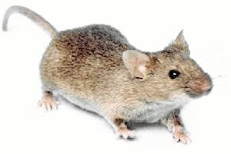

Mental Math ______________________
Math Review Week #20~Day 3 Name________________________

1. Use the number line to count on. 17 + 13 = ______

- Circle the correct expanded notation for 124: 100+20+4 100+24

3. Find the unknown number in the following equation: _____ = 7 - 1

4. Complete the following sentence: 42 = _______

5. If you held a marker in your hand, would it be shorter or longer than your hand?________

Mental Math ______________________
____________________________________________________________
____________________________________________________________
Math Review Week #20~Day 4 Name________________________

- Skip count by 5’s: 45, ______, 55, ______, _______

- What number is this? ______________

3. Circle the equations that belong in this fact family: (3, 4, 7)
3+4=7 7-7=0 7-3=4 4+3=7 3+7=10

- Use the number line to count on and solve the problem. 6 + 19 = _______
  
5. How many paperclips long is the line? ________
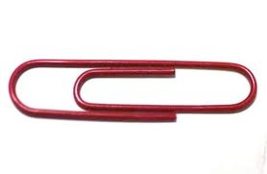
Mental Math ______________________
Math Review Week #20~Friday Five Name________________________

- Using place value blocks, show the number 142.

2. Put the numbers in order from least to Greatest: 50 78 46 13

________, ________, ________, _________

3. Use the number line to count on. 17 + 13 = ______

4. If you held a marker in your hand, would it be shorter or longer than your hand?________________

5. Circle the equations that belong in this fact family: (3, 4, 7)
3+4=7 7-7=0 7-3=4 4+3=7 3+7=10

Mental Math ______________________

Math Review Week #21~Day 1 Name________________________

- Draw a circle. Divide it in thirds. Color 1/3.

- Write the number 129 in expanded notation: ______ + ______ + ______

- Use the number line to count back and solve the problem. 20 - 7 = ______
4. Create an AABC pattern using simple shapes

_________, __________, ________, ________, _________, ________

- Fill in the missing number to make the equation correct: 1 + ____= 10

Mental Math ______________________
____________________________________________________________
____________________________________________________________
Math Review Week #21~Day 2 Name________________________

- Count back to solve the problem. 16 - 8 = ______

- Put the numbers in order from least to GREATEST: 23 55 18 76

____________<____________<_____________<____________

3. Circle the sentence that is true: a. The dotted line is longer than the solid line.
---------------------------------------------b. The solid line is longer than the dotted line.

4. Fill in the missing number to make the equation correct:
8 + 4 = 12 so 4 + ____= 12
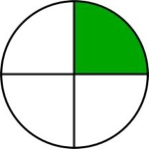
5. What fraction of the circle is shaded? _________
Mental Math ______________________
Math Review Week #21~Day 3 Name________________________

1. Count on and solve the problem. 36 + 8 = ______
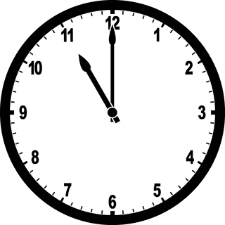

- What time is shown on the clock? _______

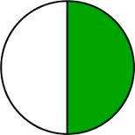
3. What fraction of the circle is shaded?______

4. Circle all numbers that are EQUAL to 54: 14 56 54 4 45 54 154

- Fill in the missing number to make the equation correct: 9= ___- 2

Mental Math ______________________
____________________________________________________________
____________________________________________________________

Math Review Week #21~Day 4 Name________________________

1. Count on and solve the problem. 6 + 15 = _______

- Use the associative property to solve:
4 + (1 + 9)= 14 so 4 + ___= 14

3. Circle the equations that don’t belong in this fact family: ( 4, 6, 10)
6+4=10 10-10=0 10-6=4 4+6=10 6+10=16

- Complete the following sentence: 77 < _______ 78 34 65 48

5. There are 3 fish. Ann is short. Kate is shorter. Mary is the shortest. Circle Kate.
Mental Math ______________________
Math Review Week #21~Friday Five Name________________________

1. Use the number line to count back and solve the problem. 20 - 7 = ______

- What fraction of the circle is shaded?______

3. Fill in the missing number to make the equation correct: 9= ___- 2

4. Circle all numbers that are EQUAL to 54: 14 56 54 4 45 54 154

5. Use the associative property to solve:
4 + (1 + 9)= 14 so 4 + ___= 14

Mental Math ______________________

Math Review Week #22~Day 1 Name________________________
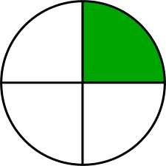
- Circle the correct fraction: 1 1 1
5 4 3

- Skip count by 10’s: ______, _______, 40, 50, _______
- John sorted these shapes:
What is his sorting rule? a. square shapes b. shapes with 4 vertices

4. How many paperclips long is the line? ________

- Write the number 365 in expanded notation: ______ + ______ + _______

Mental Math ______________________
____________________________________________________________
____________________________________________________________
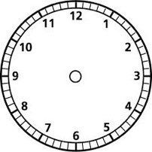
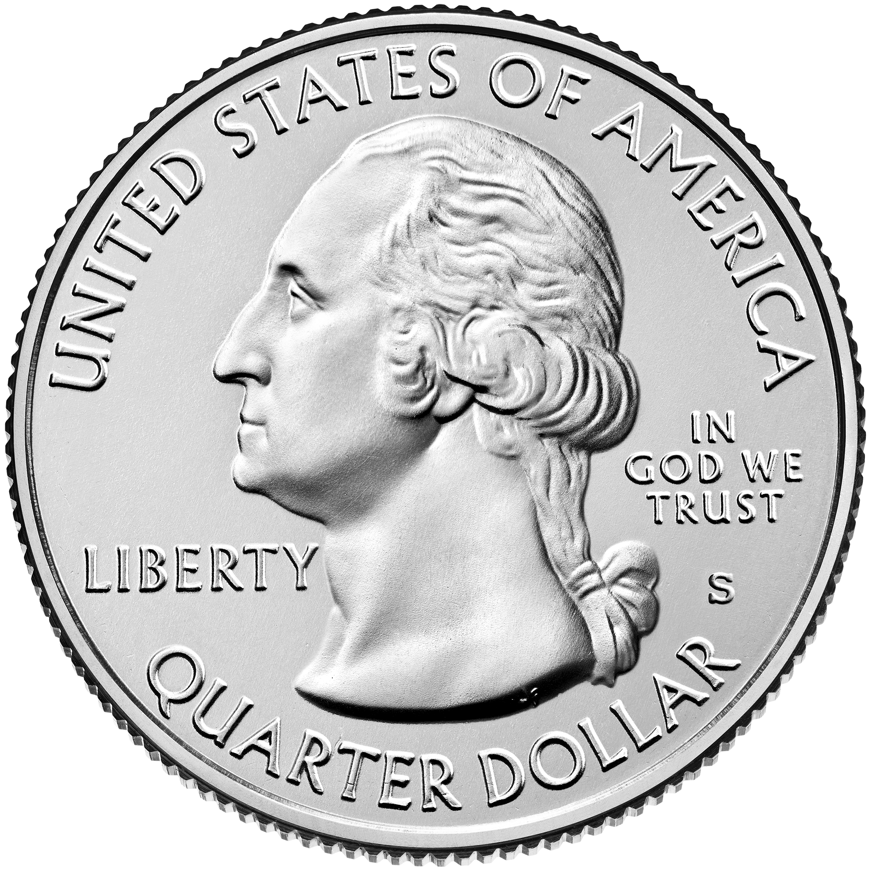
Math Review Week #22~Day 2 Name________________________

- Show 3:00 on the analog clock.
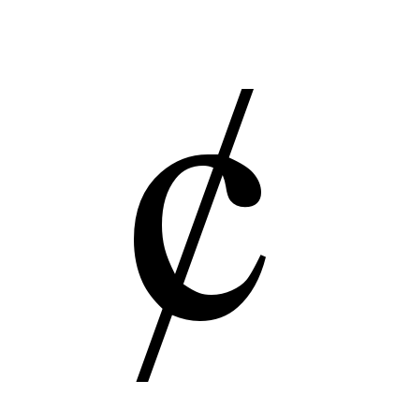
2. What is the name and value of this coin? ____________ ________

- Lydia is sorting out the shapes with 4 vertices. Circle the shapes that belong.

4. Circle the correct number for 100+40+6: 164 146 641

5. Add: 3 + 3 + 2 = ___________

Mental Math ______________________

Math Review Week #22~Day 3 Name________________________
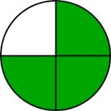
1. Circle the picture that shows 1/2:
2. Show 7:30 on the analog clock. 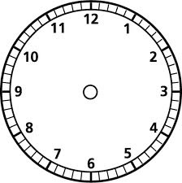

3. Count forward: 185, 186, 187, ______, ______, ______, ______, ______

4. Count back. ‘X’ the error and correct it. 147, 146, 143, 144, 143, 142

5. I am a square. Can you put an X on each of my vertices?

Mental Math ______________________
____________________________________________________________
____________________________________________________________
Math Review Week #22~Day 4 Name________________________
1. Circle one: Half of / a quarter of the circle is shaded.

2. Skip count by 2’s: _____, 12, 14, _____, _____, 20
3. John sorted these shapes:
What is his sorting rule? a. square shapes b. large shapes
4. Use the number line to count on and solve the problem. 6 + 15 = _______

- Complete the following sentence: 88 > _______

Mental Math ______________________
Math Review Week #22~Friday Five Name________________________
1. Circle the correct fraction: 1 1 1
5 4 3

2. Lydia is sorting out the shapes with 4 vertices. Circle the shapes that belong.

3. Show 7:30 on the analog clock.

4. Count back. ‘X’ the error and correct it. 147, 146, 143, 144, 143, 142

5. Use the number line to count on and solve the problem. 6 + 15 = _______

Mental Math ______________________

Math Review Week #23~Day 1 Name________________________

- If you held a ruler in your hand, would it be shorter or longer than your hand? _______

- Use the number line to count back and solve the problem.
17 - 4 = ________

- Is this equation TRUE or FALSE? _________ 7 = 9 – 1

4. Circle the correct expanded notation for 142: 100+44+2 100+40+2

- Which of the following equations are true and which are false?

6+1= 6 -1 7= 8-1 4+1= 5+2 5+2 = 2+5

Mental Math ______________________
____________________________________________________________
____________________________________________________________
Math Review Week #23~Day 2 Name________________________

- Order these numbers from least to Greatest: 14 55 87 63

_________, _________, _________, _________

2. Which coin is worth 5 cents? ______________

- True or false: 52 = 25 _________

- I have 2 HUNDREDS, 0 TENS, & 0 ONES.
What number am I? __ __ __

5. Show half past 3 on the clock:

Mental Math ______________________
Math Review Week #23~Day 3 Name________________________

- There are 3 elephants. Bob is short. Zane is shorter. Troy is the shortest.
Circle Bob.

2. Is this equation TRUE or FALSE? _________ 7 = 9 – 4

3. Subtract. 12 flowers bloomed. 9 didn’t get any water and wilted. How many are still growing strong? ______ - ______ = _______

4. Count forwards: 217, 218, ______, ______, ______, ______, ______

5. Use the number line to count on and solve the problem. 3 + 15 = _______
Mental Math ______________________
____________________________________________________________
____________________________________________________________
Math Review Week #23~Day 4 Name________________________

- Count backwards: 197, 196, 195, ______, ______, ______, ______, ______
2. Show half past 7 on the clock:

3. Circle the number: 143 118 134

- Fill in the missing number to make the equation correct: 3 + ____= 8

- I have 1 HUNDREDS, 9 TENS, & 7 ONES. What number am I? __ __ __
Mental Math ______________________
Math Review Week #23~Friday Five Name________________________

1. Is this equation TRUE or FALSE? _________ 7 = 9 – 1
2. Show half past 3 on the clock:

3. Subtract. 12 flowers bloomed. 9 didn’t get any water and wilted. How many are still growing strong? ______ - ______ = _______

4. There are 3 elephants. Bob is short. Zane is shorter. Troy is the shortest.
Circle Bob.

5. I have 1 HUNDREDS, 9 TENS, & 7 ONES. What number am I? __ __ __

Mental Math ______________________

Math Review Week #24~Day 1 Name________________________

- Circle the equations that belong in this fact family: (5, 6, 11)
11-5=6 5+5=10 5+6=11 11-6=5 11-0=11

2. Fill in the missing number to make the equation correct: 4 - _____= 4

- Which is the greatest? 123 32 132 23

4. Circle the correct expanded notation for 156: 100+50+6 100+56

- There is a tree in between two houses. Draw a house that is shorter than the tree on the left. Draw a house that is taller than the tree on the right.

Mental Math ______________________
____________________________________________________________
____________________________________________________________
Math Review Week #24~Day 2 Name________________________

1. Write the equations that belong in this fact family: (4, 5, 9)

______+______=______ ______-______=______

______+______=______ ______-______=______

2. Circle the equation that is true?
3 + (7 + 3)= 13 or (7 + 3) +2 = 13

- Choose a number to make the statement true: 46 < ____ 56 23 45

4. We go to recess at nine thirty. Which clock is correct? 9:35 9:30 9:40

5. Fill in the missing number to make the equation correct: 12= ______- 4

Mental Math ______________________
Math Review Week #24~Day 3 Name________________________

- There are 3 elephants. Bob is short. Zane is shorter. Troy is the shortest.
Circle Zane.

2. Fill in the missing number to make the equation correct: 9 + _____= 9

3. I have 9 ONES, 4 TENS, & 3 HUNDREDS. What number am I? __ __ __

- The teacher sharpened 7 pencils. Some of them broke. There are 2 sharpened pencils left. How many are broken?
7 - ______ = 2

- Is this equation TRUE or FALSE? _________ 1 + 1 + 3 =7

Mental Math ______________________
____________________________________________________________
____________________________________________________________

Math Review Week #24~Day 4 Name________________________

- Fill in the missing number to make the equation correct: 5 + _____= 16

2. Is your desk shorter or longer than the door? _______

3. Circle the correct expanded notation for 78: 100+70+8 80+7 70+8

- Joey scored 3 runs. Julie scored some more runs. They scored 7 runs all together. How many runs did Julie score? 3 + _____ = 7

5. What time does the clock show? 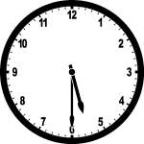 _______________

Mental Math ______________________
Math Review Week #24~Friday Five Name________________________

1. There is a tree in between two houses. Draw a house that is shorter than the tree on the left. Draw a house that is taller than the tree on the right.

2. Circle the equation that is true?
3 + (7 + 3)= 13 or (7 + 3) +2 = 13

3. The teacher sharpened 7 pencils. Some of them broke. There are 2 sharpened pencils left. How many are broken?
7 - ______ = 2

4. Is this equation TRUE or FALSE? _________ 1 + 1 + 3 =7

5. What time does the clock show? _______________

Mental Math ______________________

Math Review Week #25~Day 1 Name________________________

1. Solve: 400 - 200 = ________

- Write the number that is 10 LESS than 72. ______________
- What fraction is this? __________________

4. Use the Associative Property of Addition to complete the problem:

(3 + 4 ) + 5 = ____ + ____ + ____

5. Brian is sorting out the shapes with 0 vertices. Circle the shapes that belong.

Mental Math ______________________
____________________________________________________________
____________________________________________________________
Math Review Week #25~Day 2 Name________________________

- Solve. 21 - 5 = ______
_____ + 5 = 21

- We have school at seven o’clock. Which time is correct?
7:00 7:05 7:30
3. What number is this? _____________

4. Luke is sorting out the shapes with 3 vertices. Circle the shapes that belong.

5. Color a quarter of this rectangle:
Mental Math ______________________

Math Review Week #25~Day 3 Name________________________

1. This is an ABC pattern. Which unit is missing? Circle A. or B.
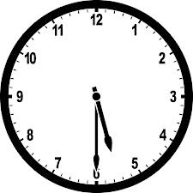
 X O S X O S _ _ _ X O S A. S O X B. X O S
- What time does this clock show?_________

3. Write the number that is 10 LESS than 95. ______________

4. Troy sorted these shapes:
What is his sorting rule? a. square shapes b. small shapes

5. Color in one-half of the rectangle:

Mental Math ______________________
____________________________________________________________
____________________________________________________________

Math Review Week #25~Day 4 Name________________________

- What pattern is this? Circle one: AABC ABBC              

- Which picture shows 1/2?

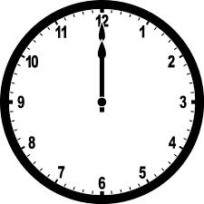

3. What time does this clock show?__________

4. Fill in the missing number to make the equation correct: 4 + _____= 17
- John sorted these shapes:
What is his sorting rule? a. shapes with straight sides b. large shapes

Mental Math ______________________

Math Review Week #25~Friday Five Name________________________

1. Brian is sorting out the shapes with 0 vertices. Circle the shapes that belong.

2. What number is this? _____________

3. Write the number that is 10 LESS than 95. ______________

- This is an ABC pattern. Which unit is missing? Circle A. or B.

 X O S X O S _ _ _ X O S A. S O X B. X O S

5. Fill in the missing number to make the equation correct: 4 + _____= 17

Mental Math ______________________

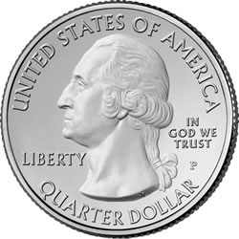
Math Review Week #26~Day 1 Name________________________

1. How much money is shown? __________

2. Circle the correct expanded notation for 243: 200+40+3 200+43

- Use the number line to count on and solve the problem. 16 + 12 = ______

4. Write the number that is 10 MORE than 132. ______________
5. What number is this?____________

Mental Math ______________________
____________________________________________________________
____________________________________________________________
Math Review Week #26~Day 2 Name________________________

1. You have 2 nickels and 10 pennies in your piggy bank. How much money do you have?_______________

- I am 238. How many do I have? ___ HUNDREDS, ___TENS, ___ONES
- What time does this clock show? 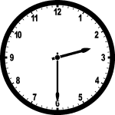_________

4. Is this equation true or false? _____________ 5 - 4 = 10

5. Circle ALL the numbers that make this equation true. 86 < _______
96 33 90 88

Mental Math ______________________
Math Review Week #26~Day 3 Name________________________

1. Solve the problem. 718 - 400 = ______

2. Finish the standard notation equation for 296: ___00 + 9___ + ____

3. What number is this?____________

4. Count forwards: 577, 578, 579, ______, ______, ______, ______, ______

5. I have 2 ONES, 0 TENS, & 3 HUNDREDS. What number am I? __ __ __

Mental Math ______________________
____________________________________________________________
____________________________________________________________

Math Review Week #26~Day 4 Name________________________

- I have 1 quarter, 2 dimes, and 4 pennies in my pocket. How much money do I have? ______________

- Circle the numbers that make the statement true: 98 > ____ 100 47 78

3. Is this equation true or false? _____________ 2 + 4 = 6

- Which group is in order from greatest to least? 98, 76, 54, 88 76, 54, 33, 21

5. What number is this?____________

Mental Math ______________________

Math Review Week #26~Friday Five Name________________________

1. Use the number line to count on and solve the problem. 16 + 12 =_______

2. What time does this clock show? _________

3. Write the number that is 10 MORE than 132. ______________

4. Which group is in order from greatest to least? 98, 76, 54, 88 76, 54, 33, 21

5. Circle the numbers that make the statement true: 98 > ____ 100 47 78

Mental Math ______________________

Math Review Week #27~Day 1 Name________________________

1. A house is (shorter, taller) than a car? ___________

2. Using the commutative property, fill in the missing number to make the equation correct:
8 + 5= ______ + 8

- Circle the equations that don’t belong in this fact family: (2, 5, 7)
7+0=7 7-5=2 5-2=3 5+2=7 7-2=5

4. Write the number 325 in expanded notation: ______ + ______ + _______

5. How much money is this?_________¢
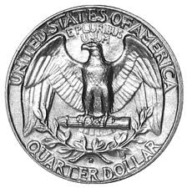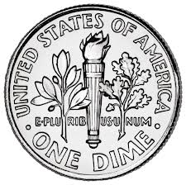
Mental Math ______________________
____________________________________________________________
____________________________________________________________
Math Review Week #27~Day 2 Name________________________
1. An elephant is (shorter, taller) than a seal.

2. Write the equations that belong in this fact family: (7, 8, 15)

______+______=______ ______-______=______

______+______=______ ______-______=______

- Fill in the missing number to make the equation correct:
7 + 3 = 10 so 3 + ____= 10
4. Fill in the correct symbol to make the sentence true: 55 _____ 55

- Put these numbers in order from GREATEST to least: 88 78 68 98

__________, __________, __________, __________
Mental Math ______________________
Math Review Week #27~Day 3 Name________________________

- 3 kids have lollipops. Lydia’s is long. Gwen’s is longer. Lily’s in the longest. Circle Lily’s lollipop.

2. How much money is this? _________¢
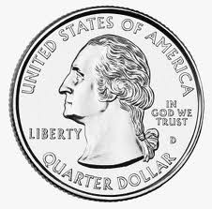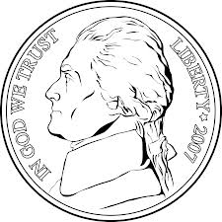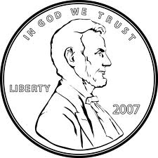
3. Skip count by 5’s: ______, 25, ______, 35, ______

4. My neighbor has 3 dogs and some cats. She has 9 pets all together. How many cats does she have? 3 + ______ = 9

5. What number is 200+90+3 in standard form? __________

Mental Math ______________________
____________________________________________________________
____________________________________________________________
Math Review Week #27~Day 4 Name________________________

- Is your shoe shorter or longer than your desk?________

2. Write the equations that belong in this fact family: (4, 7, 11)

______+______=______ ______-______=______

______+______=______ ______-______=______

3. Fill in the missing number to make the equation correct: 7= ____- 4

4. Count back. ‘X’ the error and correct it. 20, 19, 18, 14, 16, 15, 14

5. Circle all numbers that are GREATER THAN 148: 168 114 155 83

Mental Math ______________________
Math Review Week #27~Friday Five Name________________________

1. Using the commutative property, fill in the missing number to make the equation correct:

8 + 5= ______ + 8

2. Put these numbers in order from GREATEST to least: 88 78 68 98

__________, __________, __________, __________

3. How much money is this? _________¢

4. My neighbor has 3 dogs and some cats. She has 9 pets all together. How many cats does she have? 3 + ______ = 9

5. Circle all numbers that are GREATER THAN 148: 168 114 155 83

Mental Math ______________________

Math Review Week #28~Day 1 Name________________________
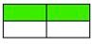
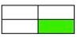
1. Circle the fractions that shows one-fourth:

2. Write the number that is 100 LESS than 132. ______________

- How much money is this? _______________¢
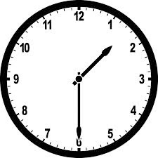
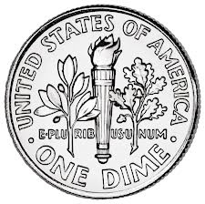

4. What time does this clock show?____________

5. Find the unknown number in the following equation: ___ + 3 = 7

Mental Math ______________________
____________________________________________________________
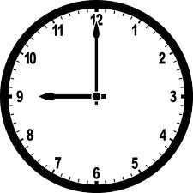
____________________________________________________________
Math Review Week #28~Day 2 Name________________________
1. Circle the fraction that shows one-half:

2. Of the following numbers, circle the one that is 10 less than 55? 65 45 75

- How much money is this? _______________¢
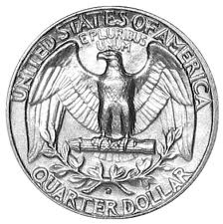

4. What time does this clock show? _______________

5. Use the Associative Property of Addition to complete the problem:

( 5 + 1 ) + 9 = ____ + ____ + ____

Mental Math ______________________
Math Review Week #28~Day 3 Name________________________

- How many people were surveyed total? ____________

- How many students chose “i”?________________

3. How many more people chose “a” than “u”? ______ - ______=_____

4. How many people chose “e”?____________________________

5. Create your own question about this graph and answer it.

Question:_____________________________________________________

____________________________________________________________

Answer:______________________________________________________

____________________________________________________________

Mental Math_________________________
Math Review Week #28~Day 4 Name________________________

Our Favorite Pizza Toppings

6
5
4
3
2
1
 | Cheese | Pepperoni | Sausage

1. How many people were surveyed total? ____________

- An equal number of people chose _____________ and _______________.

3. How many more people chose cheese than pepperoni? ____ - ____=____

4. How many people chose Sausage?____________________________

5. Create your own question about this graph and answer it.

Question:_____________________________________________________

____________________________________________________________

Answer:______________________________________________________

____________________________________________________________

Mental Math_____________________________
Math Review Week #28~Friday Five Name________________________

1. Write the number that is 100 LESS than 332. ______________

2. How much money is this? _______________¢

3. Use the Associative Property of Addition to complete the problem:

(5 + 1 ) + 9 = ____ + ____ + ____

4. Of the following numbers, circle the one that is 10 less than 55? 65 45 75

5. What time does this clock show? _______________

Mental Math ______________________

