Resiliency Reading

Story Times

Beginning in December, we will be having story times with elementary students at the LCPS elementary schools’ libraries.

These story times will teach our young students about resiliency factors such as:

* Using your imagination
* Building Self-Confidence
* Problem-Solving
* Developing Grit
* Establishing Positive Connections

December 2024’s Story

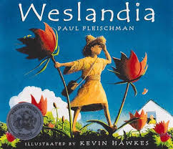

This is my favorite picture book of all time!

It tells the story of Wesley and how through his imagination and some special seeds, he is able to create his own magical world in his backyard.

In the story, Wesley overcomes bullies, creates amazing inventions, and make friends…even if he is a little different than most kids.

Click the link below to be taken to the Read Aloud

<https://youtu.be/j7UwdPJL8MQ?si=gc0JfXBgoqBJi_ll>

January 2025’s Story

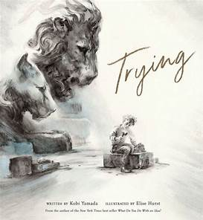

Have you ever tried to do something and found out it was just too difficult?

The boy in this story has.

With great images and a wonderful tone, this book will inspire readers to keep trying even when things seem impossible.

Click the link below to be taken to the Read Aloud

<https://youtu.be/Cy5B3dzJFg8>