Classroom Wish List

Copy Paper

Trash Bags

Swiffer Mop Refills

Individually Wrapped Candy

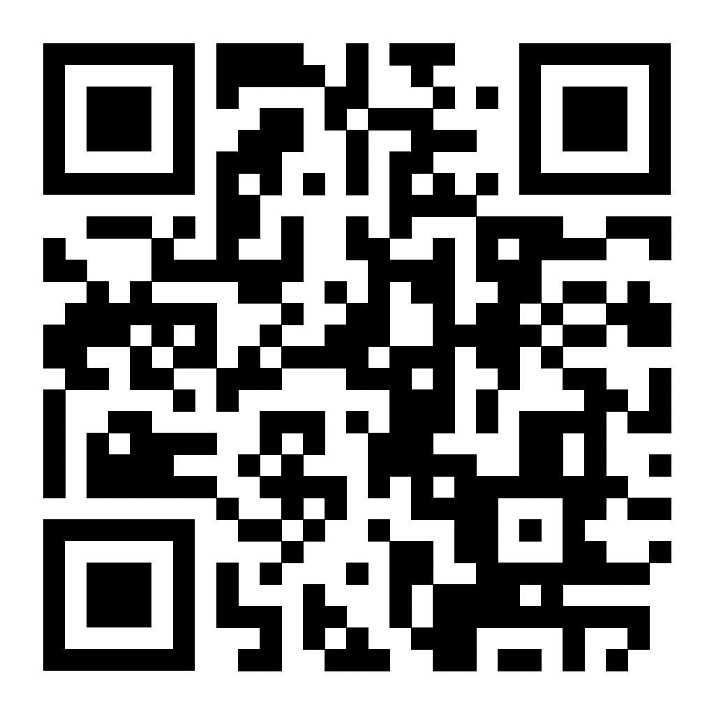

Scan for my Amazon wish list:

[Click Here for Amazon Wish List Link](https://www.amazon.com/hz/wishlist/ls/BT3ZJ23XZQ7V?ref_=wl_share)