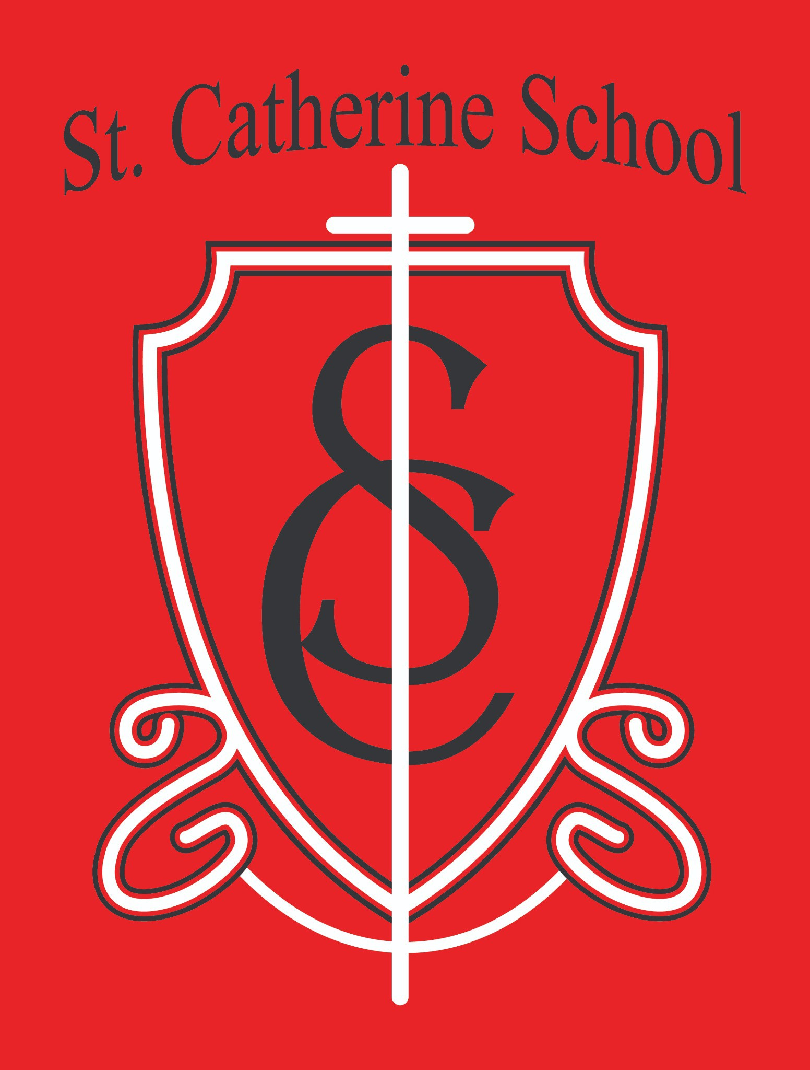

**St. Catherine School Weekly Newsletter** [**https://www.stcatherine.k12.nd.us/parents**](https://nam02.safelinks.protection.outlook.com/?url=https%3A%2F%2Fwww.stcatherine.k12.nd.us%2Fparents&amp;data=05%7C02%7CTerra.Giesen%40k12.nd.us%7C1a20ffe06f124ecb059708dd3cb52ec1%7Cdbbf782acef14af186c81f9201061db6%7C0%7C0%7C638733471056085615%7CUnknown%7CTWFpbGZsb3d8eyJFbXB0eU1hcGkiOnRydWUsIlYiOiIwLjAuMDAwMCIsIlAiOiJXaW4zMiIsIkFOIjoiTWFpbCIsIldUIjoyfQ%3D%3D%7C0%7C%7C%7C&amp;sdata=rJIvMlI7HZB4N6MKonXIFAtFa17s7URa1YeY514%2F0%2B8%3D&amp;reserved=0)

# Principal's Message

**United Through Faith and Community**

The theme for this year’s Catholic Schools Week is **“United In Faith and Community,”** which perfectly reflects our St. Catherine School family. I truly see each of you—students, parents, and staff—as an extension of my own family, and I’m incredibly grateful for the opportunity to serve as your principal. Helping each child grow and supporting every family is an honor and a blessing.

Which brings me to the exciting developments at St. Catherine School. This year, we are investing not just in our buildings but in our future. With the support of our Parish Council and Finance Council, we are moving forward with plans to open a school-owned and operated daycare facility. This is an incredible opportunity to serve our parish and community in a very real and impactful way. By opening our doors to families seeking childcare, we open their hearts to a faith-filled environment where Christ’s love is present in all we do. We aim to be ready by June 1st, with a daycare director in place by April 1st.

Thank you for your continued commitment and support of St. Catherine School. We have so much to celebrate this week and beyond!

# Reminders

* **Winter Weather Gear**

Please make sure your child comes to school every day with **snow pants, boots, coat, hat, and gloves**. We decide on indoor or outdoor recess each morning based on the weather. Being prepared ensures your child is comfortable and safe when we do go outside.

* **Quarter 2 Report Cards**

If you haven’t already, please **sign and return** your child’s report card. If you’ve misplaced it, contact **Ms. Giesen** in the office at **701-845-1453** for a new copy.

* **No Counseling Next Week**

Due to our busy Catholic Schools Week activities, there will be **no counseling sessions** at school next week.

* **Upcoming Parent-Teacher Conferences – February 6**

Parent-teacher conferences will be held on **February 6**. Be on the lookout for any sign-up sheets or scheduling information so that you can meet with your child’s teacher and discuss progress, goals, and any questions you may have.

* **Book Fair (February 3–7)**

We’re excited to host our annual book fair from **February 3–7** in the school library. Students may bring cash to browse and shop **before school** if they’d like.

The book fair will also be open during **parent-teacher conferences**.

As in previous years, you’ll have the option to purchase books for your child’s teacher’s **classroom library wishlist**.

# Catholic Schools Week Schedule (January 26 – February 1)

**Theme:** *“Catholic Schools United in Faith and Community”*

* 1. **Sunday, January 26 – PTO Breakfast (9 AM–Noon)**

Everyone is welcome—parishioners and non-parishioners alike. Please make plans to attend and bring the family.

Freewill offering benefits St. Catherine School PTO.

* 1. **Monday, January 27 – Veterans Program (11 AM)**

Veterans and active-duty military are invited to join us.

If you have photos of veterans to share, please send them to **Ms. Busch (**[alexis.a.busch@k12.nd.us](mailto:alexis.a.busch@k12.nd.us)**)** with the veteran’s name, branch, and years of service if known.

Lunch invitation follows for all veterans and military in attendance—RSVP by calling the school office (spouses welcome)

* 1. **Thursday, January 30 – Bingo (2 PM)**

Families and parishioners are welcome to join us in the church hall for an afternoon of Bingo fun.

* 1. **Friday, January 31 – All School Mass (11 AM) & Early Dismissal**

We’ll celebrate Mass at 11 AM.

Students will return to their classrooms after Mass, with an **early dismissal** to follow.

If you are **not** attending Mass, please pick up students **between 12:10 PM and 12:15 PM**, following our usual early dismissal process.

* 1. **Other Special Events**

We have a number of **fun activities** and **surprises** planned, including one

**top-secret event**.

We can’t wait to celebrate the importance and joy of Catholic education together. If you have any questions about the week’s events, feel free to reach out to the school office at **701-845- 1453**.

# St. Catherine Spotlight



* **Chess Club Fun**

Our 4th, 5th, and 6th graders are showing great enthusiasm (and impressive skills!) in Chess Club. Mr. Benner, our new custodian, took on a 5th grader in an intense match, and I was personally bested by a 6th grader in a *shockingly* short amount of time! My own personal embarrassment aside, it’s wonderful to see this spirit of fellowship and friendly competition among our students.

* **Preparing for Catholic Schools Week**

Our teachers have done a **tremendous** amount of work in getting ready for Catholic Schools Week, remaining flexible with any last-minute changes. We also have **alumni parents** bringing their former students for Bingo—what a joy to see how connected they remain to our community. And a special thank-you goes out to a supportive parishioner, whose children are all in their 30s, for offering to help with next week’s festivities. This generosity reminds us how blessed we are to be part of such a giving faith family.

* **Bright Moments**

Finally, a conversation with one of our Kindergarteners truly made my day—never underestimate the joy and perspective our youngest students bring to the school!

Stay Connected with St. Catherine School

📍 **Address:** 540 3rd Ave. NE, Valley City, ND 58072

**Email:** [nicholas.lee1@k12.nd.us](mailto:nicholas.lee1@k12.nd.us)

📧

**Phone:** 1-701-845-1453

📞

**Website:** [www.stcatherine.k12.nd.us](https://nam02.safelinks.protection.outlook.com/?url=https%3A%2F%2Fwww.stcatherine.k12.nd.us%2F&amp;data=05%7C02%7CTerra.Giesen%40k12.nd.us%7C1a20ffe06f124ecb059708dd3cb52ec1%7Cdbbf782acef14af186c81f9201061db6%7C0%7C0%7C638733471056107250%7CUnknown%7CTWFpbGZsb3d8eyJFbXB0eU1hcGkiOnRydWUsIlYiOiIwLjAuMDAwMCIsIlAiOiJXaW4zMiIsIkFOIjoiTWFpbCIsIldUIjoyfQ%3D%3D%7C0%7C%7C%7C&amp;sdata=3Hl3RQLtx1mZa%2Femhg6AhaYrM6%2BoxneJUR3FbEvWEi4%3D&amp;reserved=0)

🌐

📘 **Follow Us on Facebook:** [St. Catherine School on Facebook](https://nam02.safelinks.protection.outlook.com/?url=https%3A%2F%2Fwww.facebook.com%2Fst.catherineschoolvc%2F&amp;data=05%7C02%7CTerra.Giesen%40k12.nd.us%7C1a20ffe06f124ecb059708dd3cb52ec1%7Cdbbf782acef14af186c81f9201061db6%7C0%7C0%7C638733471056123285%7CUnknown%7CTWFpbGZsb3d8eyJFbXB0eU1hcGkiOnRydWUsIlYiOiIwLjAuMDAwMCIsIlAiOiJXaW4zMiIsIkFOIjoiTWFpbCIsIldUIjoyfQ%3D%3D%7C0%7C%7C%7C&amp;sdata=J11%2BQIhbsNZ6rFz8eB76pOSrPkiPwdG7IWntIYSEIwY%3D&amp;reserved=0)

*“Inspiring excellence through faith, learning, and service.”*