Dear Students, Parents and Guardians,

I would like to take this opportunity to welcome you to 7th grade Life Science for the fourth school year of the newly renovated Barton Academy! Student learning will be based on the Alabama Science Standards life science curriculum. The curriculum includes the ***Cell, Biodiversity and Ecosystems, Body Systems, Cellular Respiration and Photosynthesis, & Genetics.*** Students will be exposed to the scientific concepts and activities that will ensure success at the high school level and beyond. This class is designed for the student to enjoy and participate in, but will be what the student makes of it. Engagement = success!

**Our learning resources include (but are not limited to)**: Schoology (all daily assignments will be posted here), Gizmo’s, Newsela, Nearpod, Amoeba Sisters, Alabama Math and Science Teaching Initiative (AMSTI) resources, Harvard Science and Cooking, and field trips

## Materials needed each day:

Pen or pencil

PLANNER

Composition Notebook

Chromebook

## Requested for class donation:

Kleenex or Paper Towels

STAY IN TOUCH **JOIN OUR 7th GRADE REMIND.** TEXT the following “@6k27f6” to 81010

Megan O. McCALL, Phd 2024-2025

Life Science Syllabus

7th grade Barton Academy for Advanced World Studies

**Project Based Learning** is our school-wide focus and will be guided by our quotes each quarter.

***Grading***

**Students will be graded daily on material in each unit. These grades are obtained as a result of group and individual participation.**

**\*\*Grades will consist of the following (all assignments are opportunities to succeed during each quarter! No extra credit assignments will be offered)**

40% Minor Assignments (Classwork, Bellringers, Exit Tickets)

60% Major Assignments (Quizzes, Tests, Major Labs and Projects)

**Cell phones *only*** when instructed and otherwise will be put away in the locked box during each class period per the MCPSS guidelines. Technology is a great tool, but does not need to be a distraction to our learning process :)

**Bathroom passes** should not be a distraction to class time - use transition times and lunch - you will sign out using your planners

Classroom Norms

# Be responsible

# Be great listeners

# Be KIND

# Do our BEST work

See the Barton Planner for School Norms, Expectations, Uniform Policy and Discipline Procedures, AND Remember….

SCIENCE ROCKS!!!!!!!!!

### Makeup Work Policy:

If an assignment was assigned before your absence, the assignment is due the day you return. If an assignment was assigned during your absence, you will have three days from your return to make up the missed work. You will need to contact me if more time is needed. I value flexibility IF you communicate with me *BEFORE* deadlines. All daily assignments are posted on Schoology and you have access any time. Each day an assignment is late 10% will be deducted and will be capped at 50% (5 days) minus missed items on the assignment.

Life Science Syllabus 2024-2025

#### I have read and understand the expectations of the Life science syllabus:

______________________________________ _________________

Student Printed Name Date

______________________________________ ___________________

Parent Signature Date

Please return this to Dr. McCall by Friday, August 9, 2024

***Cheating/Plagiarism***is never allowed and will be an automatic zero - INTEGRITY is critical for you and your school.

I am here for YOU!

[momccall@mcpss.com](mailto:momccall@mcpss.com)[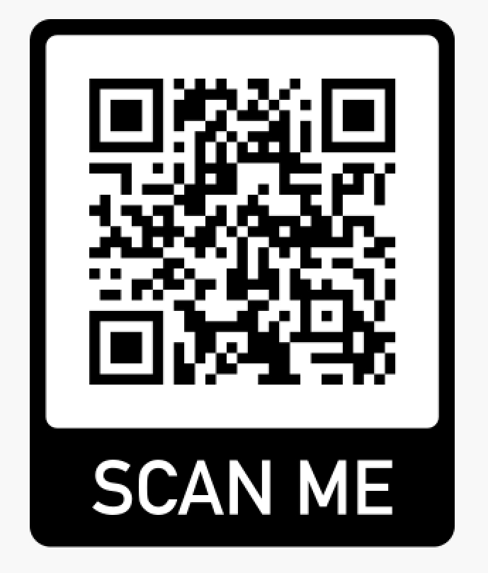](http://www.apple.com)