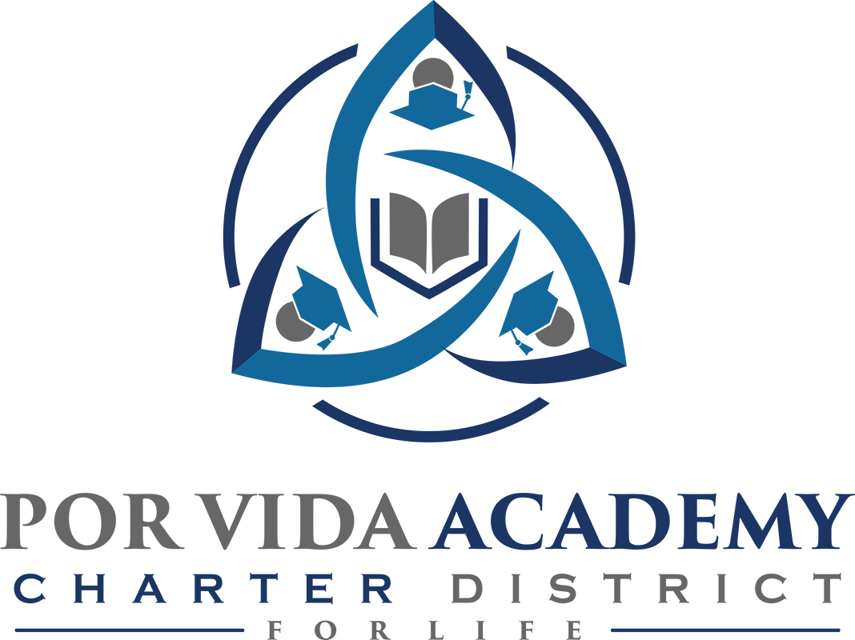

Return to In-Person Instruction & Continuity of Services Plan

Contents
Contents 2
Student & Staff Safety Protocols 2
Protocols for Screening and Isolation 2
General 2
Health Screenings for Students 3
Health Screenings for Staff 3
Isolation Protocols 3
Protocols for Face Coverings 4
Protective Measures 4
General 4
Special Education 4
Athletics, PE, & Recess / Electives / Assemblies 5
Protocols for Campus Visitors 5
Visitor Screening 5
Protocols for Disinfecting, Hand Sanitizing, and Campus Cleaning 5
General 5
Hand Washing/Sanitizing Expectations 5
Disinfecting Expectations 5
Daily Campus Cleaning 6
Work and Learning Environments 6
Classroom Configuration 6
Specialized Classrooms 6
Physical Activity Classroom Protocols 6
Common Areas 6
Restrooms 7
Outdoor & Off-Campus Student Activities 7
Campus Events 7
Instructional Delivery 7

Student & Staff Safety Protocols

Protocols for Screening and Isolation

General
All students and staff will be screened for COVID-19 symptoms regularly and individuals who present with symptoms will be separated and sent home.

Health Screenings for Students
- Parents/guardians are expected to screen their students for COVID-19 symptoms each day prior to sending their student to school.
- Teachers will observe students and refer to the nurse if symptoms are present.
When screening whether an individual has symptoms consistent with Covid-19, we will consider the following question:
Has the individual recently begun experiencing any of the following in a way that is not normal for them?
- Feeling feverish or a measured temperature greater than or equal to 100.0 degrees
- Loss of taste or smell
- Cough
- Difficulty Breathing
- Shortness of Breath
- Headache
- Chills
- Sore throat
- Congestion or runny nose
- Shaking or exaggerated Shivering
- Significant muscle pain or ache
- Diarrhea
- Nausea or vomiting

Health Screenings for Staff
- Each staff member will self-screen prior to reporting for duty each day.
- Any staff member displaying Covid-19 symptoms will be asked to immediately notify their supervisor and stay home.

Isolation Protocols
Student or Staff Displaying COVID-19 Symptoms
- When a student displays symptoms of COVID-19, a front office staff member will provide an assessment to determine if and when a student needs to be sent home.
- Students who are ill will be separated from their peers and should be picked up no later than 1 hour from the time the campus contacted the student’s parent/guardian.
- Other students will be removed from the classroom and taken to an alternate location on campus (e.g. go on a walk outside, move to a different classroom, etc.) so that the classroom can be disinfected.
- District communication will be provided to staff and the parents of students when a test confirmed COVID-19 positive student or staff member occurs on campus via a schoolwide call.
- Staff members displaying COVID-19 symptoms will follow district protocols including isolation from students and other staff members.
- For staff who meet the close contact threshold with a COVID-19 positive individual, rapid testing must be performed at the start of the day, at least once every other day until the end of day 10.
- Students and staff who are test-confirmed with COVID-19 will be unable to return to campus until all of all of the following conditions for campus re-entry have been met:
- At least one day (24 hours) have passed since recovery (resolution of fever without the use of fever-reducing medications);
- The individual has improvement in symptoms; and
- At least 10 days have passed since symptom onset or positive test result.

Close Contact
”Close contact” with an individual who is test-confirmed to have COVID-19 is defined as:
Someone who was within 6 feet of an infected person for a cumulative total of 15 minutes or more over a 24-hour period (for example, three individual 5-minute exposures for a total of 15 minutes).

Immunizations

Por Vida Academy will coordinate safety efforts with state and local health officials when the opportunity arises to include opportunities to provide vaccinations to school communities.

Protocols for Face Coverings
Per GA-38, school systems cannot require students or staff to wear a mask. However, students and staff have the option to wear a mask if they so choose. Por Vida Academy will continue to follow guidance issued by the Texas Education Agency. Please note, mask provisions of GA-38 are not being enforced as the result of ongoing litigation. Further guidance will be made available after the court issues are resolved.
Due to the circulating and highly contagious Delta variant, CDC recommends universal indoor masking by all students (age 2 and older), staff, teachers, and visitors to K-12 schools, regardless of vaccination status. Therefore, the use of masks is encouraged but remains an individual choice.

Protective Measures

General
In addition to the daily screening of all staff and students for COVID-19 symptoms, students and staff will be encouraged to:
- Use hand sanitizer frequently
- Increase hygiene awareness and handwashing during the school day
- Limit sharing (when feasible)

Special Education
- Por Vida Academy ensures that students with disabilities have equal access to educational opportunities during on-campus or remote learning when needed due to a positive COVID-19 test
- Special Education personnel will make every effort to ensure all Por Vida Academy special education students are provided the necessary supports to be successful during any campus or district closure
- Other mitigations may occur in life skills classrooms based on student needs
- School personnel will work closely with families of students who are immunocompromised regarding specific needs

Athletics, PE, & Recess / Electives / Assemblies
We will continue important activities related to electives, athletics, PE, and recess.
When not actively participating in an activity which requires close proximity to other individuals, students are encouraged to keep their individual space to help protect their health.

Protocols for Campus Visitors
Parents are valued partners in education. Parents needing to visit a campus are asked to monitor their health with regards to COVID-19 symptoms. Parents who have tested positive within the last ten days are asked to refrain from visiting any campus until the quarantine period is over and symptoms have resolved.

Visitor Screening
All campus visitors wishing to come on-site will be asked to self-screen for COVID-19 symptoms and refrain from visiting the campus if experiencing any COVID-19 symptoms.
- All visitors will be screened for COVID-19 symptoms by way of a screening questionnaire
- Visitors and staff will maintain physical distancing for any on campus meetings
- Parents/guardians will not be allowed to eat breakfast or lunch with their children until further notice.
- Food drop off and food delivery will not be permitted until further notice.

Protocols for Disinfecting, Hand Sanitizing, and Campus Cleaning

General
Frequent cleaning and disinfecting will promote a healthy learning and work environment for students and staff. Instructional and awareness posters will be posted around the school.

Hand Washing/Sanitizing Expectations
Alcohol-based hand sanitizer will be available at the main entry to the campus, in classrooms, in the cafeteria and in common areas throughout the campus. Staff and students will be encouraged to regularly wash or sanitize their hands.

Disinfecting Expectations
- Custodians will sanitize high-touch surfaces routinely throughout the day.
- Staff will limit the use of shared supplies when possible.
- Staff will be provided disinfectant cleaners to sanitize high-touch surfaces routinely throughout the day.
- Staff will be provided disinfectant cleaners to sanitize working surfaces and shared objects after each use and during breaks in instruction.

Daily Campus Cleaning
All high touch areas will be disinfected daily.
- Each classroom and restroom will be disinfected daily with CDC recommended disinfectants that are certified safe for schools and public spaces.

Additional Cleaning Measure for Covid-19 Positive Cases on Campus
- If a classroom or facility is closed due to COVID-19 spread, quaternary disinfectant, which is recommended for use on the virus that causes COVID-19, will be used to defog and disinfect.
- Custodial staff will defog and disinfect classrooms, restrooms, and all additional areas in the entire building.

Work and Learning Environments

Classroom Configuration
Recommended procedures will be applied to all classroom settings, including special education service locations when possible and appropriate. Students’ individual needs will be addressed on a case-by-case basis.
In effort to provide continuous, uninterrupted on-campus instruction to our students, teachers are asked to maintain a classroom configuration that allows students individual space. Likewise, when not actively participating in an activity that requires close proximity, students are asked to protect their health by maintaining their individual space as much as possible.

Specialized Classrooms
- Specialized equipment will be sanitized frequently.
- Procedures and protocols will be put into place to address locker rooms.
- Protocols will be in place for disinfecting equipment, students changing clothes, students showering, etc.
- Career and Technical Education classes will follow industry-based safety guidelines as appropriate to the equipment and course content.
- Special education classrooms and service locations may have additional protective barriers in place to support a safe environment for our students.
- Music equipment will be sanitized and wiped down frequently.

Physical Activity Classroom Protocols
- Equipment will be disinfected frequently.
- Sanitizing areas and access to handwashing will be provided.

Common Areas
Common areas include spaces that are used for meetings and collaboration. This includes computer labs, flexible spaces, campus libraries, conference rooms and other meeting rooms. In order to provide the safest environment possible in our common/collaborative spaces, while promoting disease prevention and mitigation, the following guidelines will be implemented:
- Common areas will be sanitized frequently
- Limit the sharing of materials/supplies

Restrooms
- Proper handwashing technique will be taught to all students and consistently reinforced.
- Students will be encouraged to wash hands and then use hand sanitizer frequently.
- Increased disinfecting will occur throughout the school day. Each campus will comply with health agency recommendations.

Outdoor & Off-Campus Student Activities
- Student participation in athletic will follow specific guidance provided by the authorized entity
- Special Education guidance will be followed to ensure these learning environments are available to our students per ARD/IEP recommendations.
- Off-campus field trips will be scheduled as appropriate to meet curricular needs while maintaining proper social distancing requirements.

Campus Events
Any school wide events will adhere to requirements outlined by Por Vida Academy, TEA, DSHS and UIL. (Examples: grade level pep rallies, assemblies, performances, etc.)

Instructional Delivery
Por Vida Academy has returned to fully on-campus instruction with the exception of students who have received a positive test result for COVID-19.
Remote conferencing will be available to COVID-19 positive students as well as students who have a person who has tested positive in their home. Contact your child’s campus to be provided with the implementation plan and necessary devices and materials.

Academics and Supports

- A school social worker was hired has been hired to assist with both financial resources and emotional and social supports.
- A male and female character development program has been expanded to include more students
- A calming center was created in an available space on campus to support students experiencing high anxiety and allows them to work on a computer in a quiet zone
- An after school tutoring program was implemented to address not only academic but also social and emotional needs.
- Weekly staff circulos where our character development program is implemented for staff using the same concepts and process as what is used for students and to allow a safe space to decompress and gain strength and support.

PLEASE NOTE:
The details in this document are subject to change as directives are provided by governing authorities and/or health officials or as environmental conditions change. Please check back regularly for updates. The date of the update is stated below.

