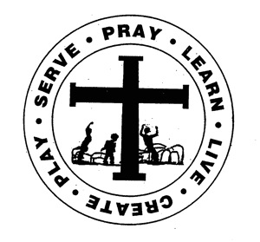
Fr. Todd Petersen, Pastor * Jaci Garvey, Principal
210 W. 4th Street * Minneota, Minnesota 56264
Phone:(507) 872-6391 * Fax: (507) 872-5263
Email: jgarveysteds@hotmail.com
Website: www.stedscatholicschool.com

January 6, 2022

One of the things I love about Minnesota is that we can have a snow day one day and beautiful sunshine the next! I hope everyone enjoyed their Christmas break. It is good to have everyone back in the building!

Our next School Mass will be Wednesday, January 12th and will be led by the 5th and 6th grades. All are welcome to celebrate the Mass with us!

We will be having a dress-up day on Friday, January 14th. It will be “Fake Injury Day”.

There will be no school for St. Edward School on Monday, January 17th. The staff will be holding inservices.

The Diocese has asked that all Catholic Schools within the Diocese conduct Winter NWEA testing. We will be testing Math and Reading beginning Tuesday, January 18th. A schedule will be posted on the school calendar on the website.

Catholic Schools Week plans are underway. As I mentioned last week, we are looking for volunteers to help share their talents during mini sessions or visit with the students regarding their careers. We have had some volunteers come forward with some very interesting ideas!

We are in need of small, medium and large prizes for the games at Mardi Gras. These prizes can be new or gently used. Look through your toy closets and send us what your children no longer treasure.

As of yesterday we had collected $53,255.74 toward our Challenge Grant. That plus the $25,000 from the Schulze Family Foundation gives us $78,255.74 to make the upgrades to our building. We are in need of just over $10,000 to do everything on our list.

Speaking of upgrades, our new bleachers were installed yesterday and today. They look fantastic! Thank you to Adam and Colton DeRoode for taking the old ones out!

May God Bless,

Mrs. Garvey

