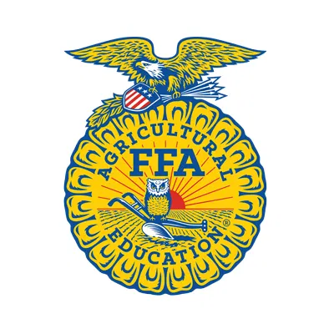
Environmental and Natural Resources I

Course Description & Grading Procedures

Trinity High School

Instructor: Ms. Caroline McKee Telephone: 336-861-6870
E-mail: cmckee@randolph.k12.nc.us Classroom: G 82
Available Hours: Daily 7:15-7:45am, After School with notice.

Course Description: Within this class, students will cover the following topics in detail so that they have a full understanding of environmental and natural resources: Leadership Development, Employability Skills, Environmental Studies, Science and Technology in the Environment, Natural Resources, Management of Fish Environments, Management of Wildlife, and the Role of Forests in the Environment. Students will also have a sound knowledge of Tree Identification within North Carolina as well as attain their Hunter Safety certification.

Required Materials: All students in Natural Resources I must bring with them a pencil, a three-ring binder OR a tab for this class only that will be in a binder that they use for other classes. These items need to be brought every day to class.

Instructor Expectations: In general homework will consist of reviewing activities and information from recent lessons or preparing for upcoming topics. You will also be asked to complete small projects in each class. When a project, paper, or speech is assigned I expect that you will come to class ready to present or turn in your assignment on the due date.

Safety Info: This class is likely different from anything else you have done in school. Safety comes first. I will not make you do anything you are uncomfortable with, but it is important that you take all equipment and procedures seriously! IF YOU HAVE TO THINK ABOUT WHETHER IT IS A GOOD IDEA, IT MOST LIKELY IS NOT.

How I will be Grading:

O SAE/FFA: 30%
Every student who is in an agricultural class is required to have an SAE. (More information on this will be presented to the student by the second day of the class.) Students are also highly encouraged to join the FFA that is associated with all agriculture classes. Students will complete each 9-weeks a detailed account of how they are participating in the FFA. If they choose not to, there are alternative assignments that students can accomplish..

o Celebration of Knowledge: 35%
We will have quizzes over each section throughout the term of this course breaking up each of the major topics in the course. For some quizzes, students will be able to use their notes and for other quizzes, students will rely on their study skills.

o Class Work 35%
Students are expected to participate in the class to its fullest. The course will require significant “lab” and outside work. Agricultural education is based on experiential learning, which means you learn it by doing it. You will also be graded on involvement and completion in several small class projects throughout the semester. I will also be grading students on how well they keep up with their notebooks and I will show students what I expect on the first day of school.

Final Exam- The final exam is a required state exam that will be worth 25% of your final grade.

Phones- Every student who has a cell phone will be asked to put their phone in the “Phone Pocket” that is located in the room. Students are not allowed to have phones on them during class unless the teacher permits it. If the student is caught on their phone without permission, the parent will be contacted and school administration will be notified as Insubordination/Defiance of Authority.

Make-Up Work / Absences- I encourage you to have a study buddy to help with missed work. If you anticipate being absent, see me for work before you leave. There is also a “Ketchup” folder located in the room for missed worksheets or notes.

Late Work: Respect your time and my time and turn your work in on time! As a high school student, you are expected to turn in the work by the due date. If there is a reason you cannot turn it in on time, please see me and we can work something out.

FFA Dues- If you are interested in becoming a member of the Trinity High School FFA, dues are $15 through August 2022. You will have the opportunity to go on trips, attend meetings, have fun, make awesome friends, and of course eat some delicious food! Mr. Harmon, Mr. Fowler and myself want to continue building the program and this chapter has the potential of being one of the best in the state and possibly the nation. Cash or check will be accepted and please make all checks out to THS FFA.

Best wishes for a great semester!

Caroline McKee

