
Election Precincts 1
2 3 4 5 6 7 8 9 10 11 12 13 14 15 16 17 18 19 20 22 23 24 25 27 28 29
30

10

9

11 4

8 3 12

18

19 28 1 29 7

15 13 2

14 5

22

17

Ü

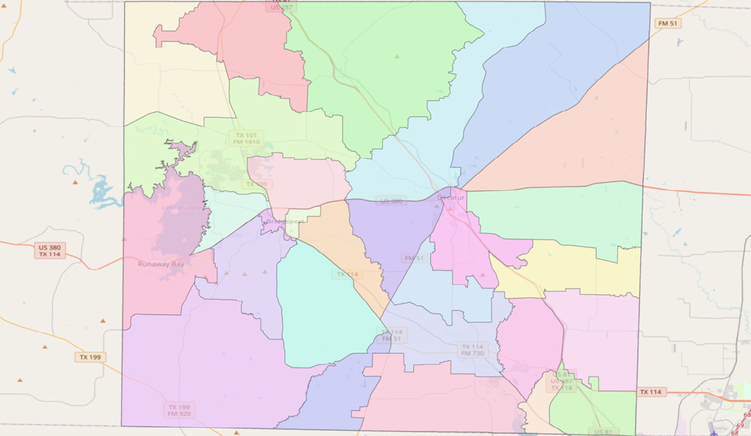
23 25 6

16

20 27 24 30

© OpenStreetMap (and) contributors, CC-BY-SA

0 2.25 4.5 6.75 9 Miles

Created: 12/8/2021
Wise County Election Precincts Draft Plan A
Adopted December 13, 2021

© 2021 Bickerstaff Heath Delgado Acosta LLP Data Source: Roads, Water and other
features obtained from the 2020 Tiger/line files, U.S. Census Bureau

