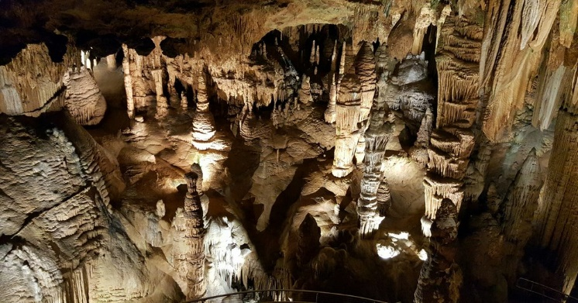

**Reading News**

**Mrs. Williams**

**Date: May 5, 2025**

**Story:** Magic Tree House: Day of the Dragon King

**Word Study:**

-Greek unusual spellings

**Vocabulary:**

**prologue** – type of introduction

**weave** – lace threads together to make cloth

**force** – to make someone do something

**scholar** – a person who studies something

**ancestors** – people who lived before in same family, not have died now

**bury** – to put underground, to cover with dirt

**panic** – to get very scared

**solutions** – problems in stories that get solved

**legend** – a traditional story people tell, but it may not be true; people told legends to explain things around them