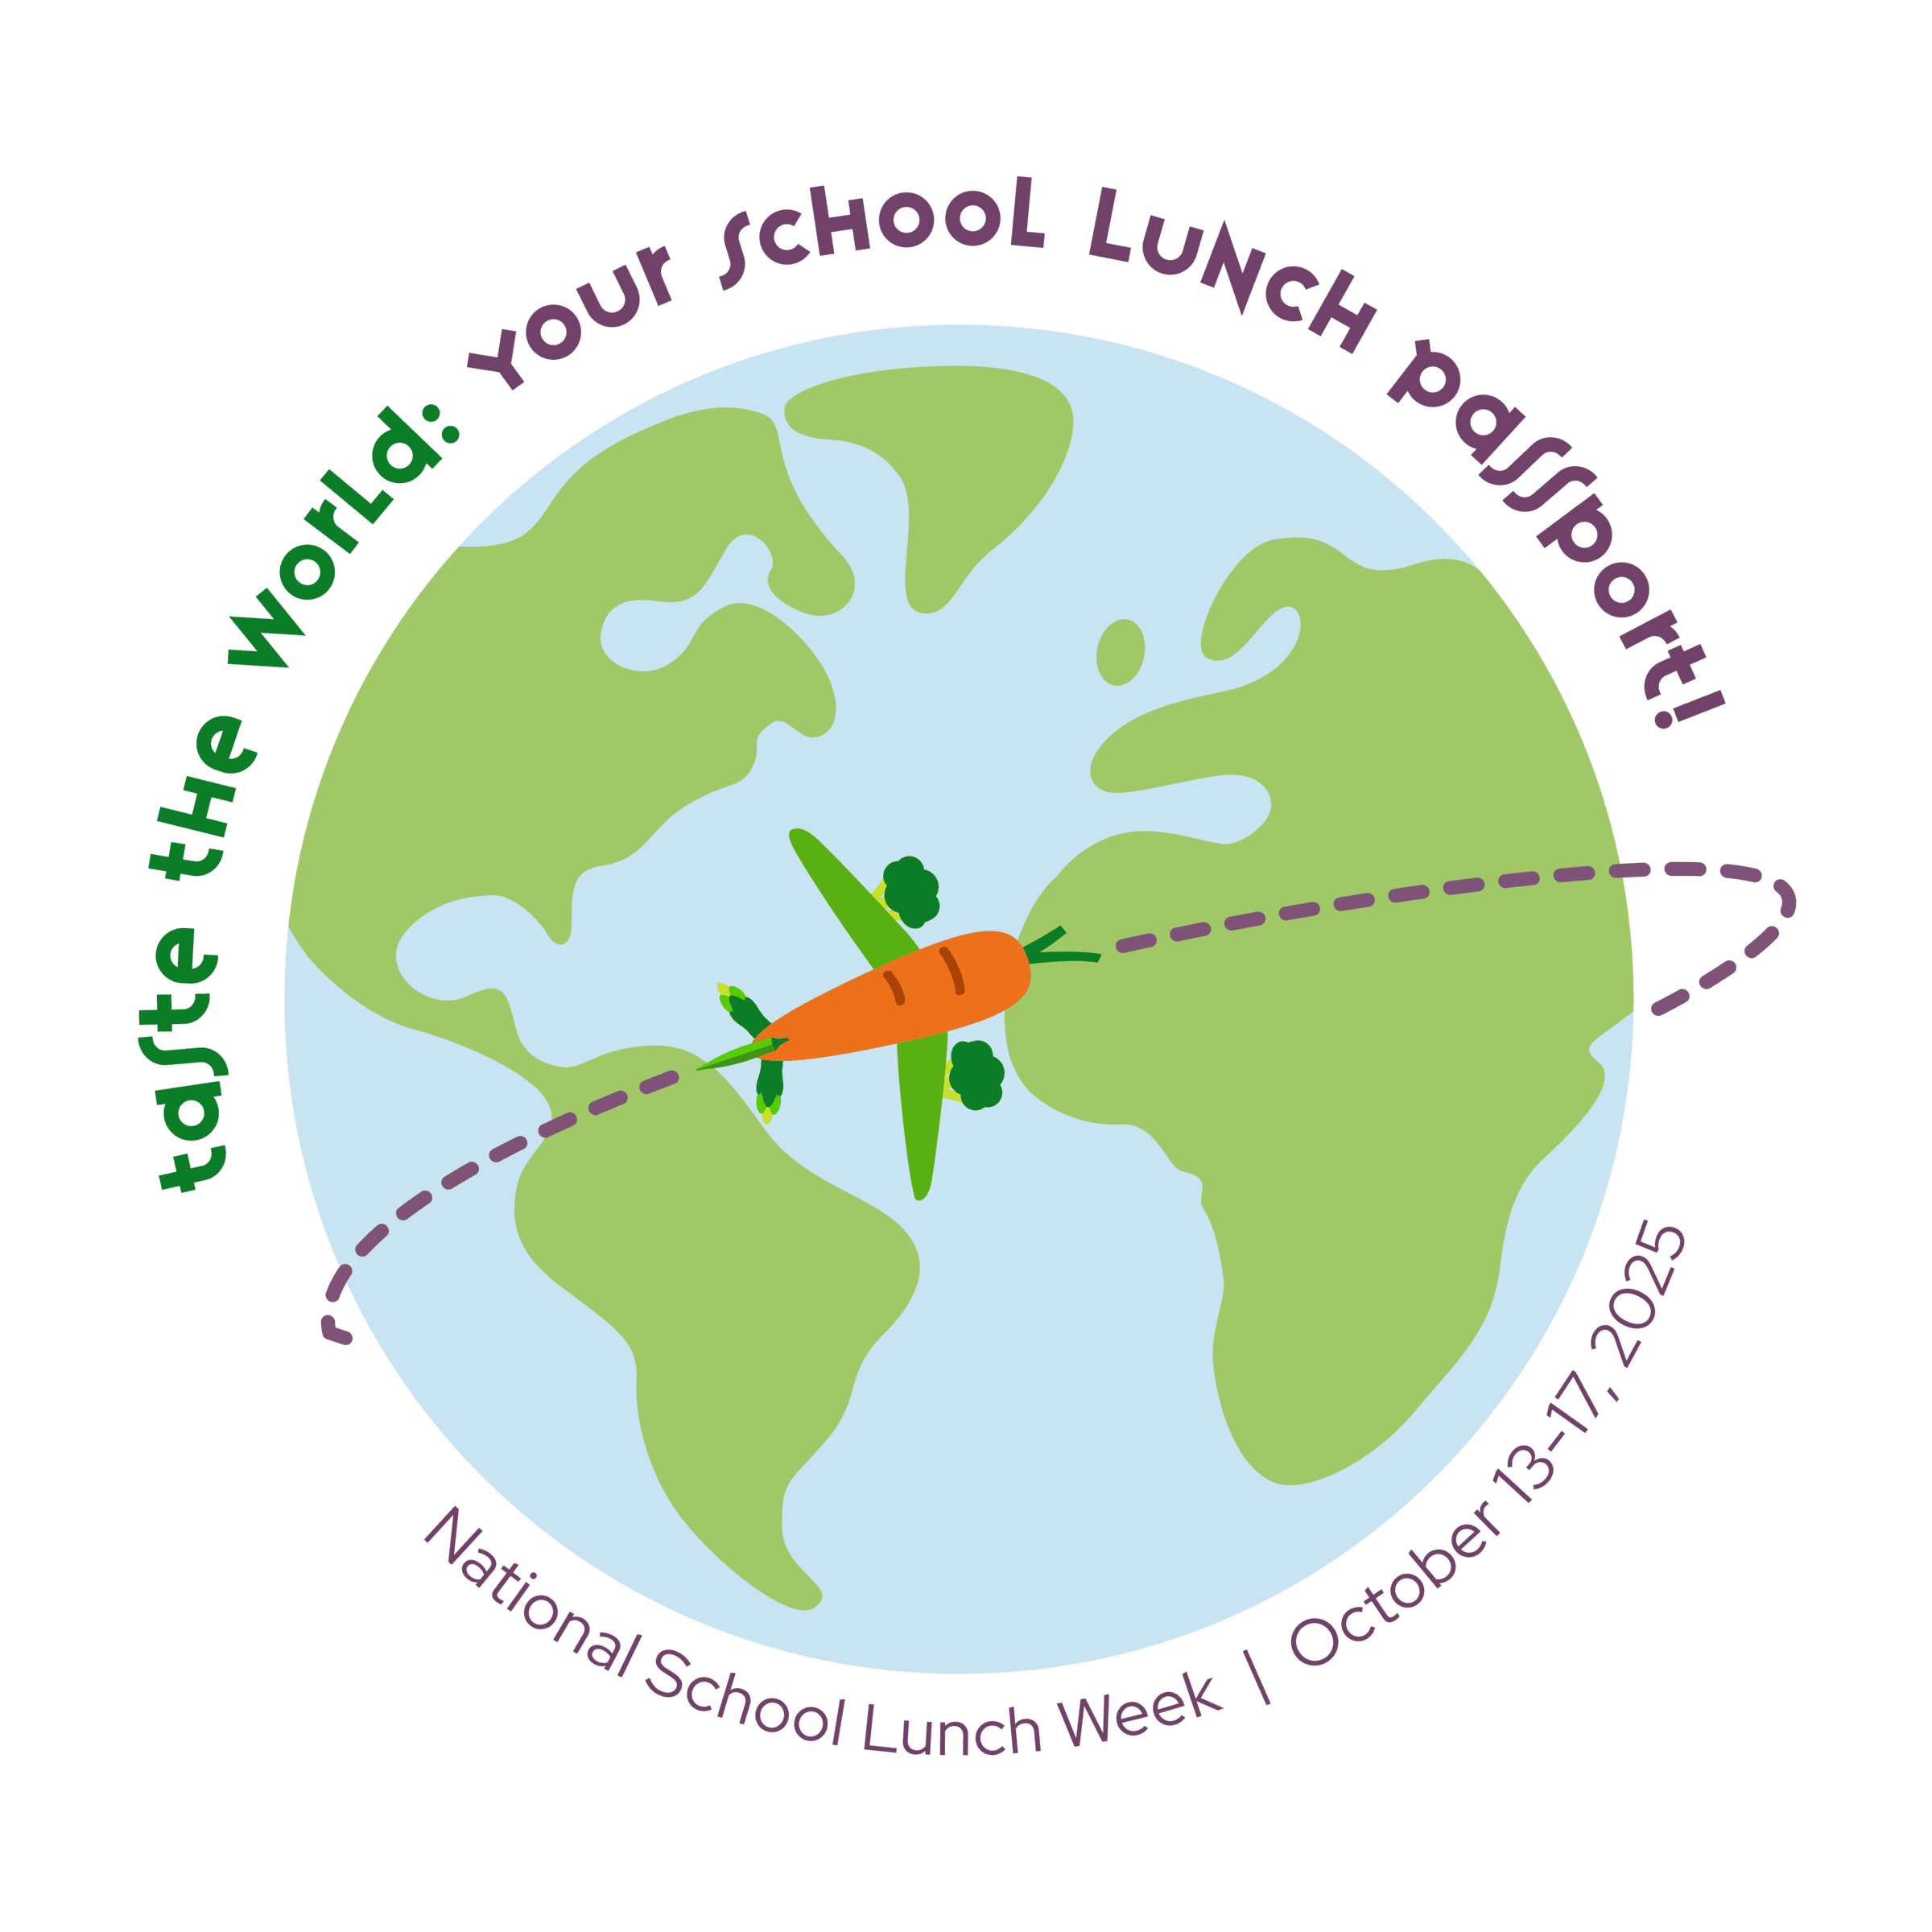
Fall Break

Boomin’ “Boo” Wings & Rings
Veggie Sticks
Ranch Dip
Roll
Fruit/Milk
Halloween Cookie

Water made available daily
Hamburger
Tossed Salad
Baked French Fries
Frozen Fruit
Milk

Hot Wings
Cinnamon Fries
Veggie Sticks
Ranch Dip
Toast
Fruit/Milk

Pepperoni Pizza Pocket
Marinara Sauce
Broccoli w/ Cheese Sauce
Fruit
Frozen Juice Cup
Milk

Hamburger Steak
Mashed Potatoes
Blackeye Peas
Cornbread
Fruit
Milk

Chicken Sandwich
Tossed Salad
California Vegetables
Fresh Fruit
Milk

Hot Dog
Tater Tots
Baked Beans
Frozen Fruit/Milk

Sumter County Schools, Lunch, K-8
Beefy Nachos
Cheese Sauce
Jalapeno Peppers
Tossed Salad
Fruit
Milk

Fall Break

Chicken Nuggets
Waffle Fries
Veggie Sticks
Ranch Dip
Roll
Fruit/Milk

Chicken Tenders
Mashed Potatoes
Brown Gravy
Steamed Carrots
Roll
Frozen Fruit/Milk

Beefaroni
Green Beans
Corn on the Cobb
Fruit
Cookie/Breadstick
Milk

Fall Break

Corndog
Spiral Fries
Baked Beans
Frozen Fruit
Milk

General Tso’s Chicken
Fried Rice
Mixed Vegetables
Egg Roll
Fruit
Milk

Oven Roasted Chicken
Baby Bakers
Turnip Greens
Cornbread
Fruit
Vanilla Pudding/Milk

Spaghetti w/ Meatballs
Tossed Salad
Fruit
Garlic Knot
Milk

Fall Break
Pizza
Tossed Salad
Crinkle Cut French Fries
Fruit
Milk

Professional Development
Hot Turkey and Cheese Sub
Lettuce/Tomato
Veggie Sticks
Ranch Dip
Fresh Fruit
Milk

Taco Salad
Salsa/Sour Cream
Whole Kernel Corn
Fresh Fruit
Cheez-it Crackers
Milk

