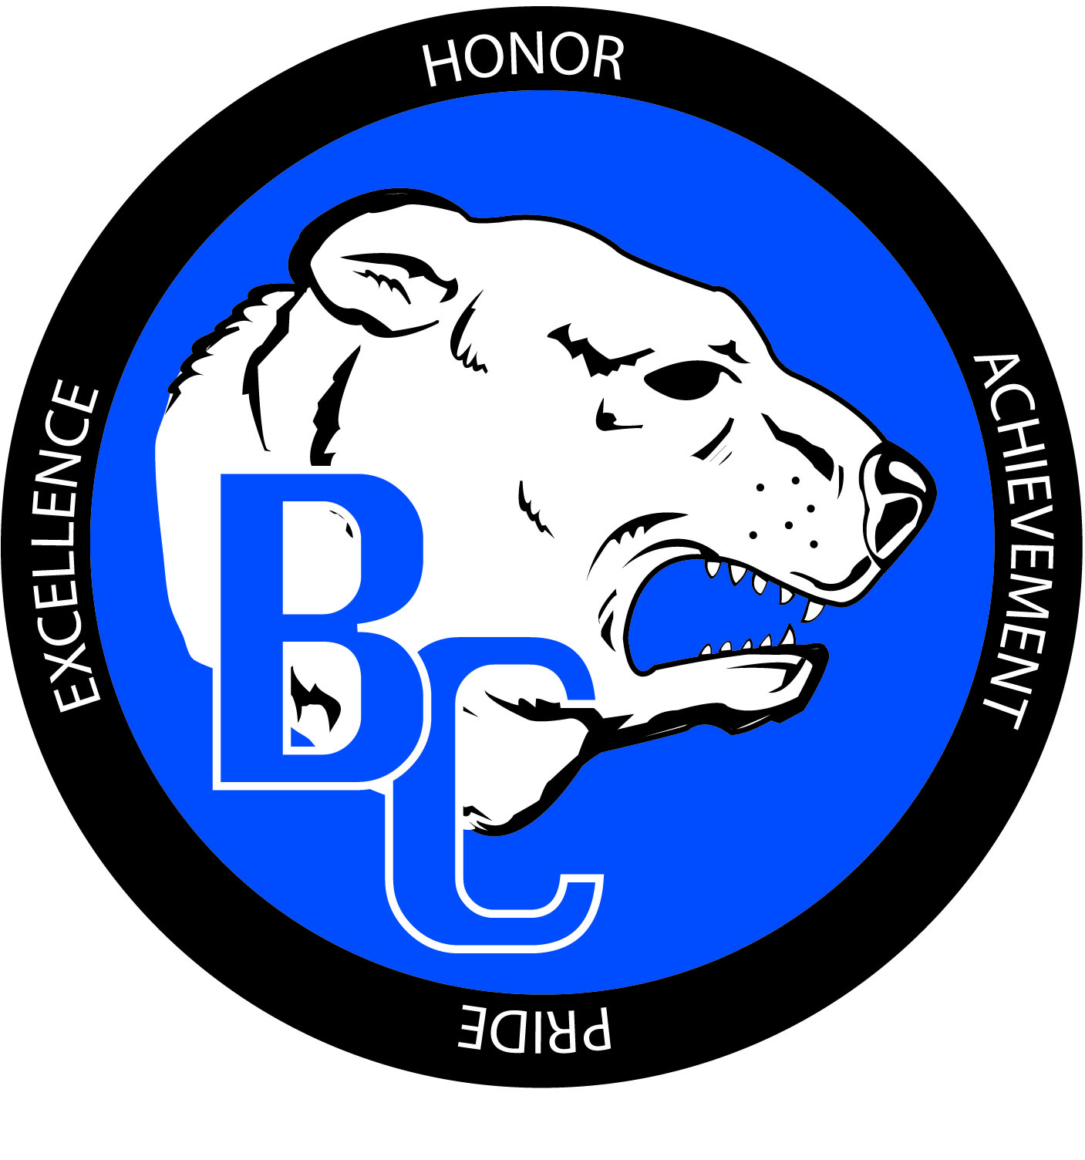
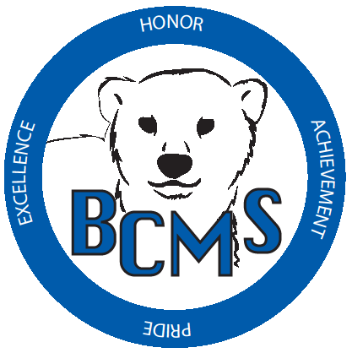
Bracken County Schools
348 West Miami Street

Brooksville, KY 41004
606-735-2523- phone 606-735-3640- fax
“Changing the world, one student at a time.”

Bracken Co. Schools Gifted and Talented Instructor Checklist & Recommendation

Student Name: ____________________________ Grade: ___________ Date: ______________
Name of Instructor completing checklist: _______________________________________
Signature: ______________________________________ Contact Phone #: ______________

VISUAL AND PERFORMING ARTS: VISUAL ARTS
A. Indications (check all that apply):
- Observed strengths in the area of visual arts
Explain: _________________________________________________________________
- Has won an award in visual arts(in or out of school)
Award: _________________________________________________________________
B. Submit samples of student work.
C. Additional information that you believe is relevant. (Please Attach)
D. Visual Arts Checklist (Please complete below)

(MUST BE COMPLETED FOR RECOMMENDED STUDENTS)
Please check the characteristics which accurately describe the TYPICAL behavior of this student.

☐ May be asked by others to do artwork
☐ Likes to comment on colors, shapes, and structure of things
☐ Enjoys and appreciates or may be critical of own artwork and work of others
☐ Takes pride in doing things well
☐ Draws or doodles a lot in school/home
☐ Does outstanding original artwork
☐ Likes to use many different materials
☐ Enjoys talking about, collecting, and/or looking at works of art
☐ Masters basic art skills quickly and easily
☐ Has a keen sense of humor/makes unusual connections with drawing
☐ Concentrates on art projects for long periods of time
☐ May shut out other things going on around him/her
☐ Creates exceptional charts, graphs, models, or other visuals when given the opportunity
☐ Demonstrates elaboration in artwork
☐ Has a sensitive use of line/color/texture
☐ Enjoys open-ended art activities
- Has an appreciation of beautiful objects.
- Capable of “finding” or “making” art.

Additional Comments- See Back:

Bracken County Schools
348 West Miami Street

Brooksville, KY 41004
606-735-2523- phone 606-735-3640- fax
“Changing the world, one student at a time.”

Bracken Co. Schools Gifted and Talented Instructor Checklist & Recommendation (Continued)

Level of performance:

Special strengths and weaknesses:

Needs caused by giftedness:

Ability to work independently and focus responsibility on specific area:

Other comments:

