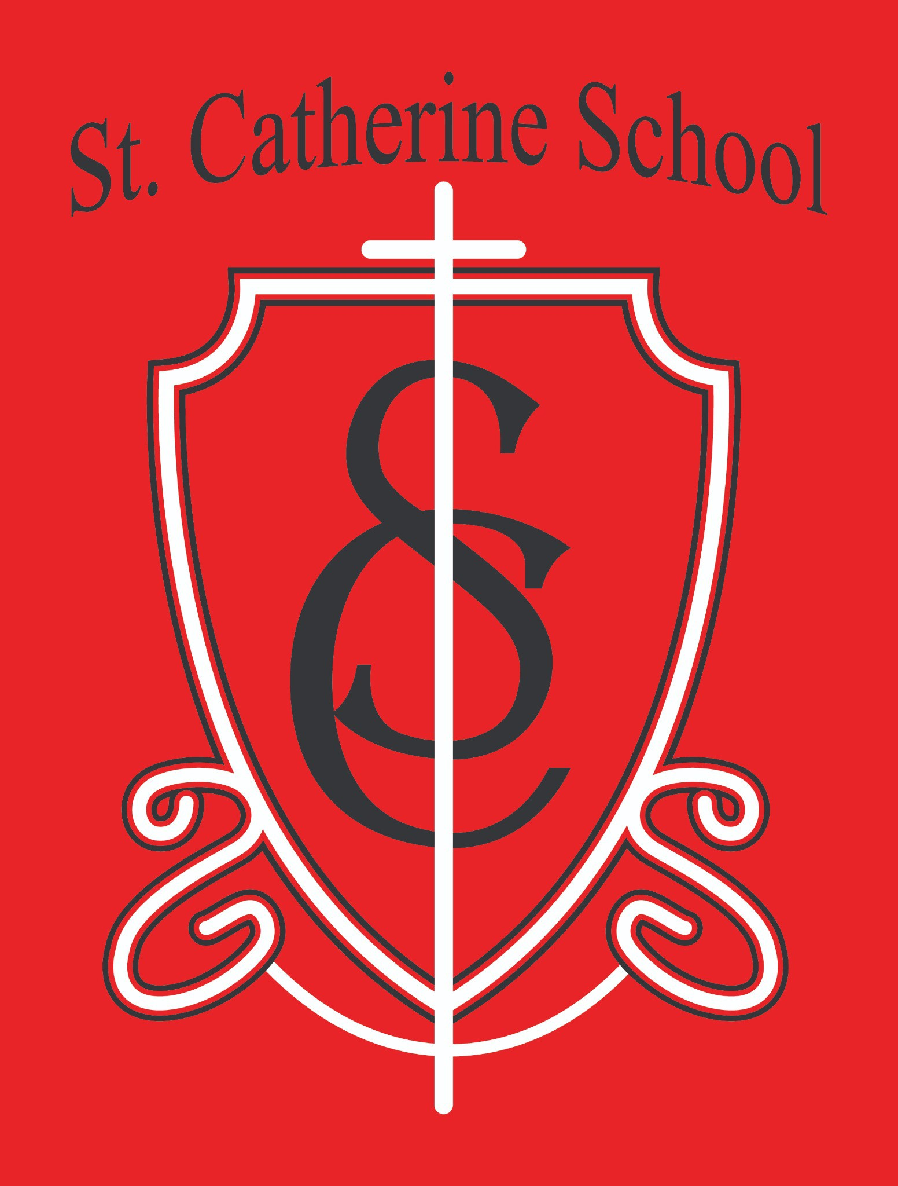

**St. Catherine School Weekly Newsletter**

Week of August 19-22 (First Week of School)

[https://www.stcatherine.k12.nd.us/parents](https://nam02.safelinks.protection.outlook.com/?url=https%3A%2F%2Fwww.stcatherine.k12.nd.us%2Fparents&amp;data=05%7C02%7CTerra.Giesen%40k12.nd.us%7Ce452e2f300db4d04298f08dde1d2889d%7Cdbbf782acef14af186c81f9201061db6%7C0%7C0%7C638915016565225799%7CUnknown%7CTWFpbGZsb3d8eyJFbXB0eU1hcGkiOnRydWUsIlYiOiIwLjAuMDAwMCIsIlAiOiJXaW4zMiIsIkFOIjoiTWFpbCIsIldUIjoyfQ%3D%3D%7C0%7C%7C%7C&amp;sdata=UjPNJJShu6pmT27btN90U8L2z%2FG8i%2BBUS8yEI%2FB4cq0%3D&amp;reserved=0)

# Principal's Message

#### All Things Through Christ

This first week of school has been a powerful reminder of how good God truly is.

I saw His goodness in a family taking the next step in their faith, in a student’s joy for Adoration, in our school Mass, in the projects nearing completion, and in new families walking through our doors and commenting on how beautiful the space has become. These are visible signs of God’s hand at work.

There is genuine joy in our teachers and staff, and I could feel the energy in the building. Our children returned eager to learn, and families—new and returning—brought a strong sense of trust in our mission. As principal, I cannot ask for more.

I often say, “I get to do this.” But the deeper truth is: “I was granted the opportunity to serve as the leader of St. Catherine School.” This role is a gift entrusted to me by God, and I trust He will continue to guide us forward.

“I can do all things through Christ who strengthens me.”

— Philippians 4:13

Christ is the true leader of our school. May He continue to strengthen us as we teach, learn, and grow together.

**Fall Auction – Planning Meetings Begin Soon! —** A note from Auction Chair, Alison Kasowski:

Hello St. Catherine parents!

It is a pleasure to chair the 53rd Annual St. Catherine School Auction, coming up on Friday, November 7th. There is a lot to be done in the next 11 weeks, but with many hands it is light work, a lot of fun and a great opportunity to get to know your fellow school families and supporters.

We will start the auction planning meetings on Wednesday, September 3rd at 6:30pm in the Sacred Heart Room, which is in the north side of the church basement. We will meet every other week until the event, and these meetings will not be any longer than an hour. If you are able, please come to learn more about the auction and/or volunteer your time and talent in some capacity. Also, we love new ideas! If you aren’t able to attend the meetings but have ideas of how to improve the auction or how you would like to help, just reach out to me via e-mail, text or call (my cell number is below). I hope to see you there.

**Auction Meeting Dates** September 3rd September 17th October 1st

## October 15th October 29th

Cell: 701-840-5460

[Email: alison@ivyrealestategroup.com](mailto:alison@ivyrealestategroup.com)

**Reminders**

#### Free & Reduced Meal Applications

* Available on our website or in the school office.
* The income eligibility guidelines have changed this year, so please review even if you think you may not qualify.

#### Meal Prices

* We expect to finalize pricing next week now that the USDA and state reimbursement rates have been released.

#### Specials Staffing Update

* For the first six weeks of school:
* Mrs. Nichola Kjelland will teach **music**
* Mrs. Deb Gulmon will teach **physical education**
* Ms. Busch is completing her high school student teaching during this time. We are grateful for these wonderful subs!

#### Band – 5th & 6th Grade

* Band is a required part of the curriculum.
* If your child needs an instrument or you are unsure about renting, contact Mr. Kjelland or the school office.
* **Instrument Rental Night**: Wednesday, September 3rd from 3:30–5:30 PM at the HAC

#### Parking Lot Safety

* Students should use **sidewalks** during drop-off and pick-up whenever possible.
* Please **park in a spot**—we do not have room for a pull-through drop-off loop.
* Monday will be a **busy day**, so remind any other drivers of our procedures. Let’s keep all kids safe!

#### Attendance Communication

* + Please report **absences, tardies, appointments, and student-related info** directly to the school office.
  + We’ll ensure it reaches the right staff member or teacher.

#### Welcome, Mr. Marker!

* + We are happy to welcome **Mr. Russell Marker** as our new **custodian and maintenance professional**.
  + He is a long-time Valley City resident and is excited to grow in his faith and help our school shine.

# St. Catherine Spotlight



During physical education this week with Mrs. Gulmon, one of our students lost an item that was deeply important and sentimental. Even though Phy Ed is a favorite time for many, the 5th and 6th grade students didn’t hesitate—they immediately stopped what they were doing to help look.

Mrs. Gulmon gently encouraged them to offer a prayer to **Saint Anthony**, the patron saint of lost items, asking for his intercession. After several minutes with no luck and the group beginning to lose hope, one student found the lost item. A quick prayer of thanksgiving followed—and a beautiful reminder that God hears even the smallest prayers.

This moment stands out as my favorite story of the week. It was an act of **selflessness**, of students putting a friend’s needs above their own fun. There was no hesitation—they knew it mattered to their classmate, and they responded with kindness and unity.

**Great job, 5th and 6th grade!** You were a bright example for our school this week, and your leadership made a lasting impact.

Stay Connected with St. Catherine School

📍 **Address:** 540 3rd Ave. NE, Valley City, ND 58072

**Email:** [nicholas.lee1@k12.nd.us](mailto:nicholas.lee1@k12.nd.us)

📧

**Phone:** 1-701-845-1453

### 📞

**Website:** [www.stcatherine.k12.nd.us](https://nam02.safelinks.protection.outlook.com/?url=https%3A%2F%2Fwww.stcatherine.k12.nd.us%2F&amp;data=05%7C02%7CTerra.Giesen%40k12.nd.us%7Ce452e2f300db4d04298f08dde1d2889d%7Cdbbf782acef14af186c81f9201061db6%7C0%7C0%7C638915016565255891%7CUnknown%7CTWFpbGZsb3d8eyJFbXB0eU1hcGkiOnRydWUsIlYiOiIwLjAuMDAwMCIsIlAiOiJXaW4zMiIsIkFOIjoiTWFpbCIsIldUIjoyfQ%3D%3D%7C0%7C%7C%7C&amp;sdata=NHkx3TWl6JEEmzJM6zYNZQsW6lPSObj6pFW12JaNldc%3D&amp;reserved=0)

### 🌐

📘 **Follow Us on Facebook:** [St. Catherine School on Facebook](https://nam02.safelinks.protection.outlook.com/?url=https%3A%2F%2Fwww.facebook.com%2Fst.catherineschoolvc%2F&amp;data=05%7C02%7CTerra.Giesen%40k12.nd.us%7Ce452e2f300db4d04298f08dde1d2889d%7Cdbbf782acef14af186c81f9201061db6%7C0%7C0%7C638915016565272980%7CUnknown%7CTWFpbGZsb3d8eyJFbXB0eU1hcGkiOnRydWUsIlYiOiIwLjAuMDAwMCIsIlAiOiJXaW4zMiIsIkFOIjoiTWFpbCIsIldUIjoyfQ%3D%3D%7C0%7C%7C%7C&amp;sdata=LwDPLQA%2FJ8NJLwYY2F0jGJR4l0C9RE%2BxkyARRVKQWbg%3D&amp;reserved=0)

*“Inspiring excellence through faith, learning, and service.”*