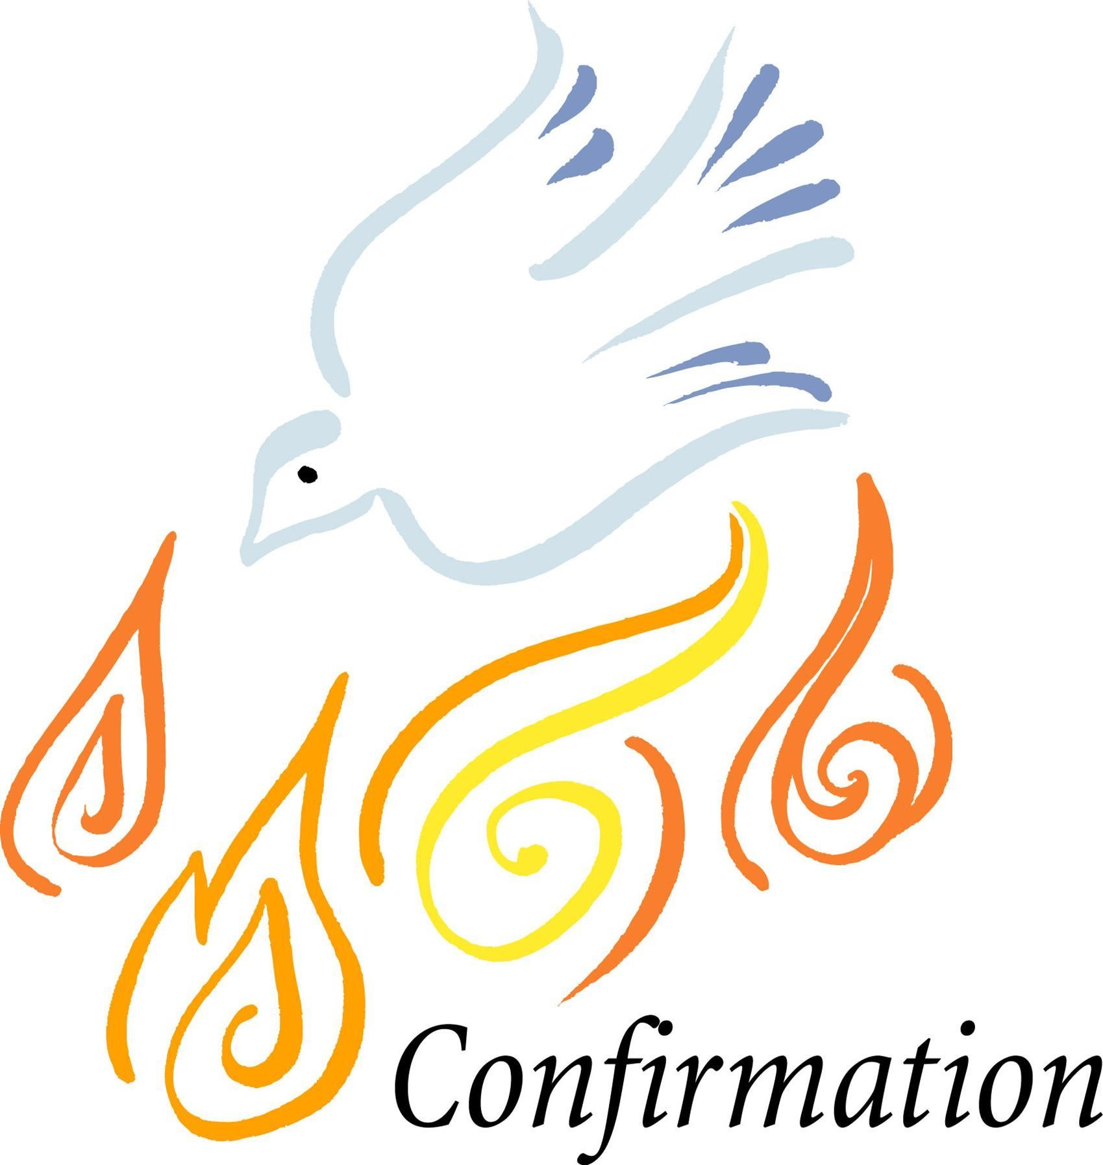

Program Handbook 2023-2024
Parishes of St. Edward & St. Eloi

Name of Candidate / Confirmation Saint Name

Churches of St. Edward & St. Eloi
408 N. Washington
Minneota, MN 56264
507-872-6346 (Office)

Religious Ed (RE) website: www.goodteacherafc.org

Greetings to Parents/Guardians of Confirmation Candidates!

Blessings to you as your son or daughter prepares for the Sacrament of Confirmation. Confirmation continues the Sacraments of Initiation, which began with Baptism and was continued through the Eucharist. Confirmation is the final Sacrament of Initiation where your young adult becomes a fully initiated member of the Church. It is initiation, but NOT graduation. Continuing Religious Education and growing deeper in faith life are life-long learning processes for both you and your child.

The Confirmation program will allow your son or daughter to grow closer to Christ through educational sessions, retreats, and experiences that we hope will transform their hearts and change their lives. The best preparation that you, as a parent, can give your son or daughter is to practice and live your Catholic faith through word and deed.

Each of us has been called to witness Christ’s love for our children and each other. May these blessings be a continuous faith journey, guided by the Holy Spirit to follow Christ and become Disciples of Jesus.

Again, blessings to you as you begin the journey with your son or daughter to the Sacrament of Confirmation.

In Christ,

Father Todd Petersen - Pastor
Deacon Travis Welsh & Jessica Welsh - Confirmation Catechists
Corissa Van Keulen – Religious Education Director

What is Confirmation?

Confirmation is one of the three Sacraments of Initiation (Baptism, Eucharist
& Confirmation). The Sacrament of Confirmation strengthens the gifts of the Holy Spirit already received in Baptism. The Spirit empowers us to go forth, acts in us, urges us to move beyond our individual selves into our greater community as Disciples: to a greater participate in the mission of the Church. Through Confirmation, we become witnesses of Christ and are invited to spread The Good News to all.

Knowledge of the Catholic Faith
Candidates should have a basic knowledge of the Catholic faith including the Creed and its meaning, an understanding of the Mass and the Sacraments, what it means to live in Christ, and have grounding in Christian prayer. Attendance at Wednesday night Religious Education classes/Confirmation preparation is the usual expectation along with any homework assigned. If a candidate misses more than three classes, they will need to meet with RE
Coordinator/Priest and they will may be asked to delay
Confirmation. Absences will have a makeup assignment.

Spiritual Growth in the Catholic Church
The Catholic Church requires that a person achieves certain amount of spiritual growth or be in a certain state of readiness before they receive the Sacrament of Confirmation. These are stated in the Code of Canon Law §§ 889-891 and the Catechism of the Catholic Church (CCC) 1306-1311. They are:
Faith: The person must be baptized. Candidates for Confirmation must profess their faith with the Church by believing the Catholic faith and practicing it in their lives.
Grace: Candidates must be in the state of grace when receiving the Sacrament of Confirmation. (This means one must seek the Love and Mercy of God through Confession and commit to change if one is in the state of mortal sin.)
Will or Choice: The candidate needs to have a clear and deliberate intention to receive the Holy Spirit. They must be open to accept the responsibilities of being a public witness for Christ.
Sponsor: Candidates are to seek the spiritual help of a sponsor. (See sponsor requirements).

Please take some time to reflect on these questions. This will help you decide if you are ready for Confirmation or not:
- Approach the Confirmation journey with an open mind and heart?
- Willing to accept more responsibility in your family, parish & community?
- Does your behavior reflect developing maturity in your faith?
- Attend Sunday Mass and Holy Days of Obligation, and fully participate in all Confirmation classes and activities?
- Is it your desire to live a life that is committed to daily prayer, especially for growth in your Catholic faith, hope, and love by following the teachings of Jesus in your personal life and in your relationships (family, friends, romantic)?
If these reflect your desire to be Confirmed, then the following will help guide you in the journey towards fulfilling your role as an adult in the Church.

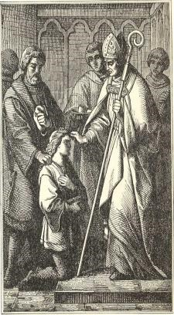
The Goal of our Confirmation Program:
To form disciples by leading teens to:

- Develop a personal relationship with Jesus Christ
- Experience the power of the Holy Spirit
- Awaken a sense of belonging to the Church
- Encourage a sense of belonging by developing a fellowship among the youth of the parish

Confirmation Saint Name

One of the traditional practices in the Church at the time of Confirmation is choosing a Saint name to inspire us on our Christian journey. Your prayerful reflection will help you determine that name. Choose the name of a Saint to serve as a model and guide. This will be your Confirmation name.

Information on Saints can be found in Lives of Saints books, and websites available are www.AmericanCatholic.org and www.catholic.org/saints.

Confirmation Sponsor Requirements

Sponsors at Confirmation represent the Catholic Church Community. Thus, it is necessary that they be a practicing Catholic in good standing with the Church, who, have themselves received the Sacraments of Initiation, which are Baptism, Holy Eucharist and Confirmation. Sponsor must have been confirmed for at least 2 years and is the age of 18 or older.

If they are married, they must have been validly married in the Church. They cannot be in a cohabiting relationship. The Code of Canon Law states they must lead... “a life in harmony with faith and the role to be undertaken....and will help the baptized to lead a Christian life in harmony with Baptism, and to fulfill faithfully the obligations connected with it.”

An ideal sponsor is someone who not only meets the requirements listed for Confirmation, but has matured in his/her faith by participating in ongoing faith opportunities in his/her parish, on retreats, etc. If a person does not actively practice their Catholic faith in these ways, the role of representative of the Catholic Church would be inappropriate for them. A sponsor can be a godparent, family member, or any other Catholic person with whom the candidate would be comfortable talking about his/her faith honestly and openly. Candidates can avoid hurting the feelings of family and friends by not choosing a sponsor who is unable to fulfill these basic requirements.
*Parents cannot serve as sponsors for their children. (Canon 874, 5)

Sponsor Responsibilities
All sponsors will receive a sponsor booklet to help them in their Candidate’s preparation. Candidates should try to meet with their sponsor a minimum of two times to give the sponsor an opportunity to share their faith and assist the candidate in their preparation for the Sacrament. (One of those meetings will include an interview to complete with the Candidate.)

Mass Attendance
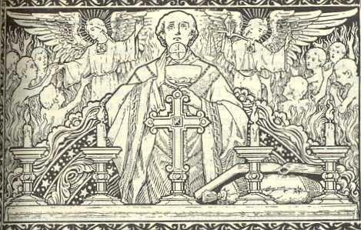
In fulfilling the Third Commandment, we expect all of our Candidates to understand, accept, and adhere to this teaching and ask that students make every attempt to attend Mass each week. Your weekly encounter with The Living God helps you to grow in your knowledge of Him.

The Mass and the Eucharist are the very center of our Catholic faith. The obligation to attend Sunday and Holy Day Masses is a response to the gift of Christ’s Sacrifice and love for us. We return this love to God by attending a banquet in His honor. This necessary opportunity of spiritual growth, for the candidate desiring to be confirmed, must not be taken lightly. It is in the repetitive contact with someone that we grow in love and understanding of them and the same is true of our Lord.
(And now that you are becoming a fully initiated member of the Church, you should know if a person intentionally misses Mass on Sunday or a Holy Day of Obligation it is a mortal sin and that person is required to go to confession before they can receive Holy Communion again. A person can attend Mass without receiving Holy Communion if they were not able to go to confession before Mass.)
Holy Days of Obligation: Mary, Mother of God (Jan 1); Assumption of Mary (Aug 15); All Saints’ Day (Nov 1); Immaculate Conception (Dec 8); Christmas (Dec 25)

Mass Notes
We ask that each candidate fill out a Mass Note entry for every Mass attended during the years of preparation. Filling these out is a helpful way to enter more fully into the experience of the Mass, grow in one's personal reflection of what is happening during Mass, gives accountability, and is a great help to personal prayer and an introduction to prayer journaling. Mass note pages are found in both church entryways, on the AFC website, and included with this handbook.
These pages will be checked monthly by the RE Director. Please keep them in your handbook and bring it to class.

Faith Enrichment
All Confirmation candidates need to make time to spend with our Lord during this year of Spiritual Growth by attending faith enrichment opportunities. If the candidate cannot attend these events for a serious reason, they will be given the opportunity to make it up by attending another retreat/event.
Adoration Holy Hours: Young people typically have a very positive experience during these and report that they are very helpful in their preparation for Confirmation. These are mandatory when offered.
Totus Tuus: A 5-day nightly youth event where 4 young adult missionaries come to enrich the faith lives of those attending. Must be attended at least one year as offered during the preparation period.
*Retreat: There are several options to choose from, but the chosen retreat must be approved by the RE Coordinator or Fr. Todd BEFORE the event takes place.
Some of the approved retreats available – (Choose one or another approved retreat – see website for more events and details)
- Broom Tree Retreat: Irene, SD
- Steubenville:
- Camp Beloved (girls): Schoenstatt - Sleepy Eye
Camp Greatness (boys): Schoenstatt - Sleepy Eye
- Teen Talk Retreat (TBA)
- Catholic Heart Work Camp: various dates & locations during summer

*Submit “Faith Enrichment Reflection” for each event attended. "We Are Called to Serve” Confirmation Service Project Information

Service projects enable each Confirmation Candidate to identify personal gifts and use them for the benefit of the others within the life of their faith and surrounding community. Candidates are asked to complete two items each of service each year from the following areas: Family, Parish &
Community

*Below are examples of service in each area, but are not limited to these:

Family
- Visiting a sick relative; sending flowers; writing letters
- Preparing and serving a special meal for your family
- Helping grand/parents or siblings with jobs they may have a hard time doing

Parish - Assist within your parish
- Altar server, lector, usher, greeter, and gift bearer. Contact Caren at parish office 872-6346
- Share music at Mass by singing or playing an instrument
- Monthly church cleaning
- Work at Parish Festivals
- Help at Parish Events: Work at a breakfast or other event, help decorate or take down decorations for Christmas, help with CCW or KC’s events. See Sunday Bulletin for dates/times. RE Director will also inform of upcoming opportunities.

Community
- Help a neighbor with chores without being paid
- Work at the local Food Shelf or food kitchens for homeless
- Babysit for free
- Meals on Wheels – Contact Alice Bot 872-6648
- Visit or entertain the elderly at the Manor or other nursing homes
- Help with various activities going on in school or community. (You can use service you also do for another organization (i.e. NHS)

NOTE: Candidate must fulfill these obligations respectfully and with dignity as any Christian should.

Letter to Bishop/Father
Towards the end of their final preparation year, Candidates will be asked to write one letter addressed to the Bishop telling him of their desire to be confirmed in the Catholic Church. This letter should include reflections on their faith journey and preparation for the Sacrament, a statement of their beliefs and understanding of the Catholic Church, and some ideas about the gifts and talents they bring to their faith community. (More information will be provided when the time comes.)

Sacrament of Reconciliation
“To receive Confirmation, you must be in a state of grace. You should receive the Sacrament of Reconciliation in order to be cleansed for the gift of the Holy Spirit” - CCC 1310. Monthly reception of this sacrament is encouraged. Through the Confirmation Preparation Program, the Sacrament of
Reconciliation will be offered to students during Religious Ed, during the Holy Hours at St. Eloi in Ghent, and will be offered within a week before receiving Confirmation.

Discipline
The Sacrament of Confirmation is a gift given to those that are truly prepared to fulfill the obligation of what it means to receive this gift and should not be taken lightly. If a candidate is not partaking in the above necessary opportunities of spiritual growth, the RE Coordinator will discuss with them to understand why these are not being met. Upon further neglect to fulfill these spiritual growths, Father will be notified along with parents to ensure the sanctity of this Sacrament. Those unable to complete these spiritual growths as well upon these discussions will need to postpone the reception of this Sacrament.

Confirmation Checklist

Confirmation Class: Plan to attend all Confirmation Classes. From preparation, to large and small group lessons, every class is designed to help strengthen the students’ relationship with Jesus. In addition, we will be working on prayers and Catholic doctrine. Absences will have a makeup assignment. IF A STUDENT
MISSES MORE THAN THREE CLASSES, THEY MAY BE ASKED TO DELAY CONFIRMATION. Extreme cases will be looked at individually.

Refer to this page and mark off completion of these requirements:

Required Events and to do list:

□ Confirmation meeting with parent(s)
□ Weekly and Holy Days of Obligation Masses
□ Weds night classes
□ Adoration Holy Hours
□ Confirmation Saint Name
□ Sponsor Chosen
□ Totus Tuus week, when offered (at least one in your 2 years)
□ A Catholic Retreat
□ Reconciliation before Confirmation

Completion of Forms or Reports:

□ Mass notes pages (turn in monthly during class)
□ Parish Information Form
□ Baptismal certificate (if not baptized at St. Ed’s or St. Eloi)
□ Application for Confirmation
□ Saint Paper & Name Paper
□ Faith Enrichment Reflection(s) – for retreat and Totus Tuus □ Project Service - at least 2 items from each:
o Family o Church o Community
□ Candidate/Sponsor interview
□ Letter to Bishop/Father

Service Project Form

Due Dates: Year 1-turned in by April 2022; Year 2-turned in by Jan. 2023

Candidate: _________________________________________

Service Projects- 6 services from these 3 areas, 2 from each per year: (see p. 8 in handbook for more details)

Family:

- I served by: ___________________________________________________
Date: ______________
Parent/Family Signature: _________________________________________

- I served by: ___________________________________________________
Date: ______________
Parent/Family Signature: _________________________________________

Church:

- Church Event: _________________________________________________ Date: ______________
Signature of person who can verify: ________________________________

- Church Event: _________________________________________________ Date: ______________
Signature of person who can verify: ________________________________

Community:

- Community Event: ______________________________________________
Date: ______________
Signature of person who can verify: ________________________________

- Community Event: ______________________________________________ Date: ______________
Signature of person who can verify: __________________________________________

