**April 2024**

**Greenville State Preschool 284-7195x2711**

# Bubble Fun!

¼ cup KARO light syrup

½ cup dish soap

1 gallon water

Pour in dish soap and syrup, add water slowly. Do Not Shake.

Best if left to sit for 24-48 hours.

This recipe makes bubbles that last a bit longer than the commercial bubble solutions and is less expensive. It works very well with the large bubble wands.

The mixture can be stored indefinitely in cool dry place.

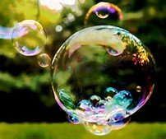

**Important Dates:**

**April 1-5 Closed for Spring Break**

**We Return Tuesday, April 9**

**Curriculum Focus for April: Science & Technology**

**Please check your Ready Rosie App!**

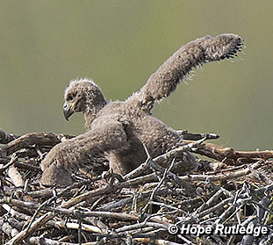

**The Eagles have hatched!!!**

Watch the Eagles from home!

**YouTube: Decorah Eagles Live**