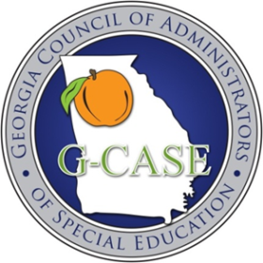G-CASE

*Georgia Council of Administrators of Special Education*

**REGISTRATION IS NOW OPEN FOR THE 2025 G-CASE FALL CONFERENCE!**

***EDUCATION: The Greatest Show on Earth — Balancing Compliance and Instruction under the Big Top!***

You will be inspired by nationally acclaimed presenters while sharpening your skills as an educational leader – and more specifically, a leader for our students with disabilities!  Plans currently include an inspiring three-day conference, live in Savannah.  An array of excellent keynote presenters; timely and informative breakout sessions highlighting exemplary practices, GaDOE initiatives, and trending legal issues -- along with high-quality exhibitors, an exciting FREE Carnival, social events, awards, BIG door prizes, and a Silent Auction-- has been planned to give you the opportunity to network, learn, and leave refreshed and ready!  This conference has been designed specifically for you and your team.

Because of the uncertain times regarding Professional Learning funding, G-CASE will not be raising prices on ANY of our activities or membership this year! Additionally, we will be hosting even more exciting events throughout the year!  We know you need high-level Professional Learning to stay current and remain compliant, in order to continue to improve outcomes for our students with disabilities.

RFPs for Breakout Sessions will be sent out in early September.

Bring your team and come join us in Savannah at the Hyatt Regency on the River, November 12-14, 2025.

A DRAFT Agenda is attached for your planning purposes.

[**REGISTRATION FOR THE 2025 G-CASE FALL CONFERENCE**](https://gael.ps.membersuite.com/events/ViewEvent.aspx?contextID=e386dc0a-0078-c8eb-80e6-0b489aa923dd.)

[**HOTEL LINK FOR THE HYATT**](https://www.hyatt.com/en-US/group-booking/SAVRS/G-GCAE)

[**OVERFLOW HOTEL LINK AT THE ANDAZ**](https://www.hyatt.com/en-US/group-booking/SAVRD/G-GCAS)**(*one block from the Hyatt)***

