Ms. Shonda Knighton
Sumter Central High School
5th /6th Grade English Language Arts Syllabus

Course Description:
In this course, fifth graders will deepen their understanding of concepts
about text and comprehension strategies. They will have many opportunities to apply what
they have learned through integration of language arts with other subjects. Students will use
writing as a tool for learning, and they will write for a variety of purposes and audiences. They
will write in a variety of genres. They will apply what they have learned about author’s craft to
their own pieces. Fifth graders will increase their vocabulary by being involved in classroom
discussion and word study. They will participate in oral discourse about a variety of topics,
concepts, and texts.
Instructional Philosophy:
I believe in teaching the whole child, that all students can learn and deserve a quality education
in a safe, supportive and caring learning environment with high expectations for academic
achievement.

Classroom Instruction:
Instruction focuses on building knowledge through content rich
nonfiction, reading, writing and speaking grounded in evidence from the text, both literary and
informational; and regular practice with complex text and academic language.

Course Assessment Plan:
All assignments are due on the due date. Points will be deducted
from assignments turned in late. Students will be assessed using the following:
1. Classwork
2. Quizzes
3. Projects
4. End of the Unit Tests
5. Pre/Post Tests
6. I-Ready Assessments

Homework Policy
Students will be assigned homework on a daily basis except Friday. (This does not include
projects and special assignments.) All homework assignments are to be completed and turned
in on the due date.

Attendance Policy
(please also refer to Student Code of Conduct)
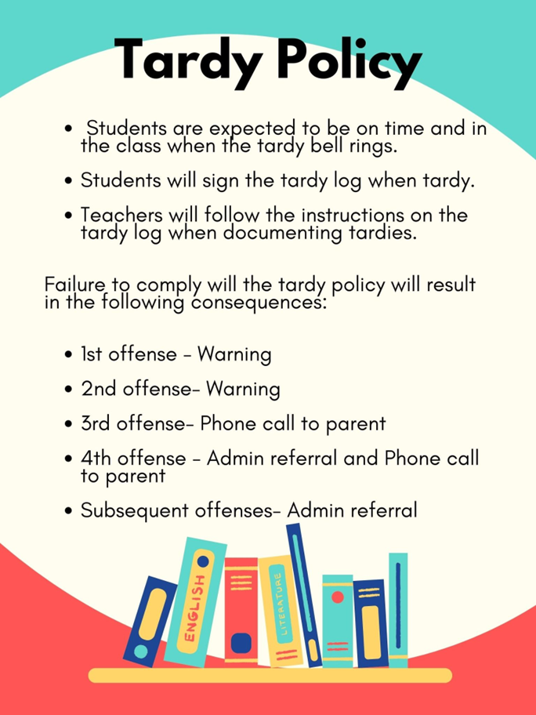

Classroom Expectations:
In order for students to learn in a safe environment conducive to optimum teaching and
learning, the following is expected. Students will…
Respect Self
1. Listen and follow directions the first time they are given.
2. Come to class prepared and on time.
3. Complete all assignments.
4. Use language appropriate for school.
Respect Others
5. Keep your hands, feet and objects to yourself.
6. Raise your hand and wait for permission to speak or leave your seat.
Respect Property
7. Handle all school and classroom equipment with care.

Positive behavior incentives include, but are not limited to:

*Praise *Token system *Positive phone calls home *Special privileges
*Lunch Bunch *Positive notes * School wide event *Preferred Activity Time
Student misbehavior will be followed by consequences and remedial measures, which will
include the following:
*Verbal Warning *Loss of privileges *Sent to buddy room *Seat change
*Reflective essay *Parent contact *Behavior contract *Guidance referral
*Think time sheet *In school suspension*Office referral

Materials/Supplies Needed:
Open Court Reading Book
Practice Skill Book 1 & 2
Language Arts Handbook

Parent-Teacher Communication:
Most communication from school will be via the “school cast”, phone calls home and text
messages using the Remind App.

Extra Help/Tutoring
After-school tutoring will be offered. The dates and times will be announced at a later date.

Contact:
Email: ssilliman@sumter.k12.al.us
Text Message: Remind
If you would like to set up a conference, please feel free to call me and we can set this up at a
time that works with your schedule.

