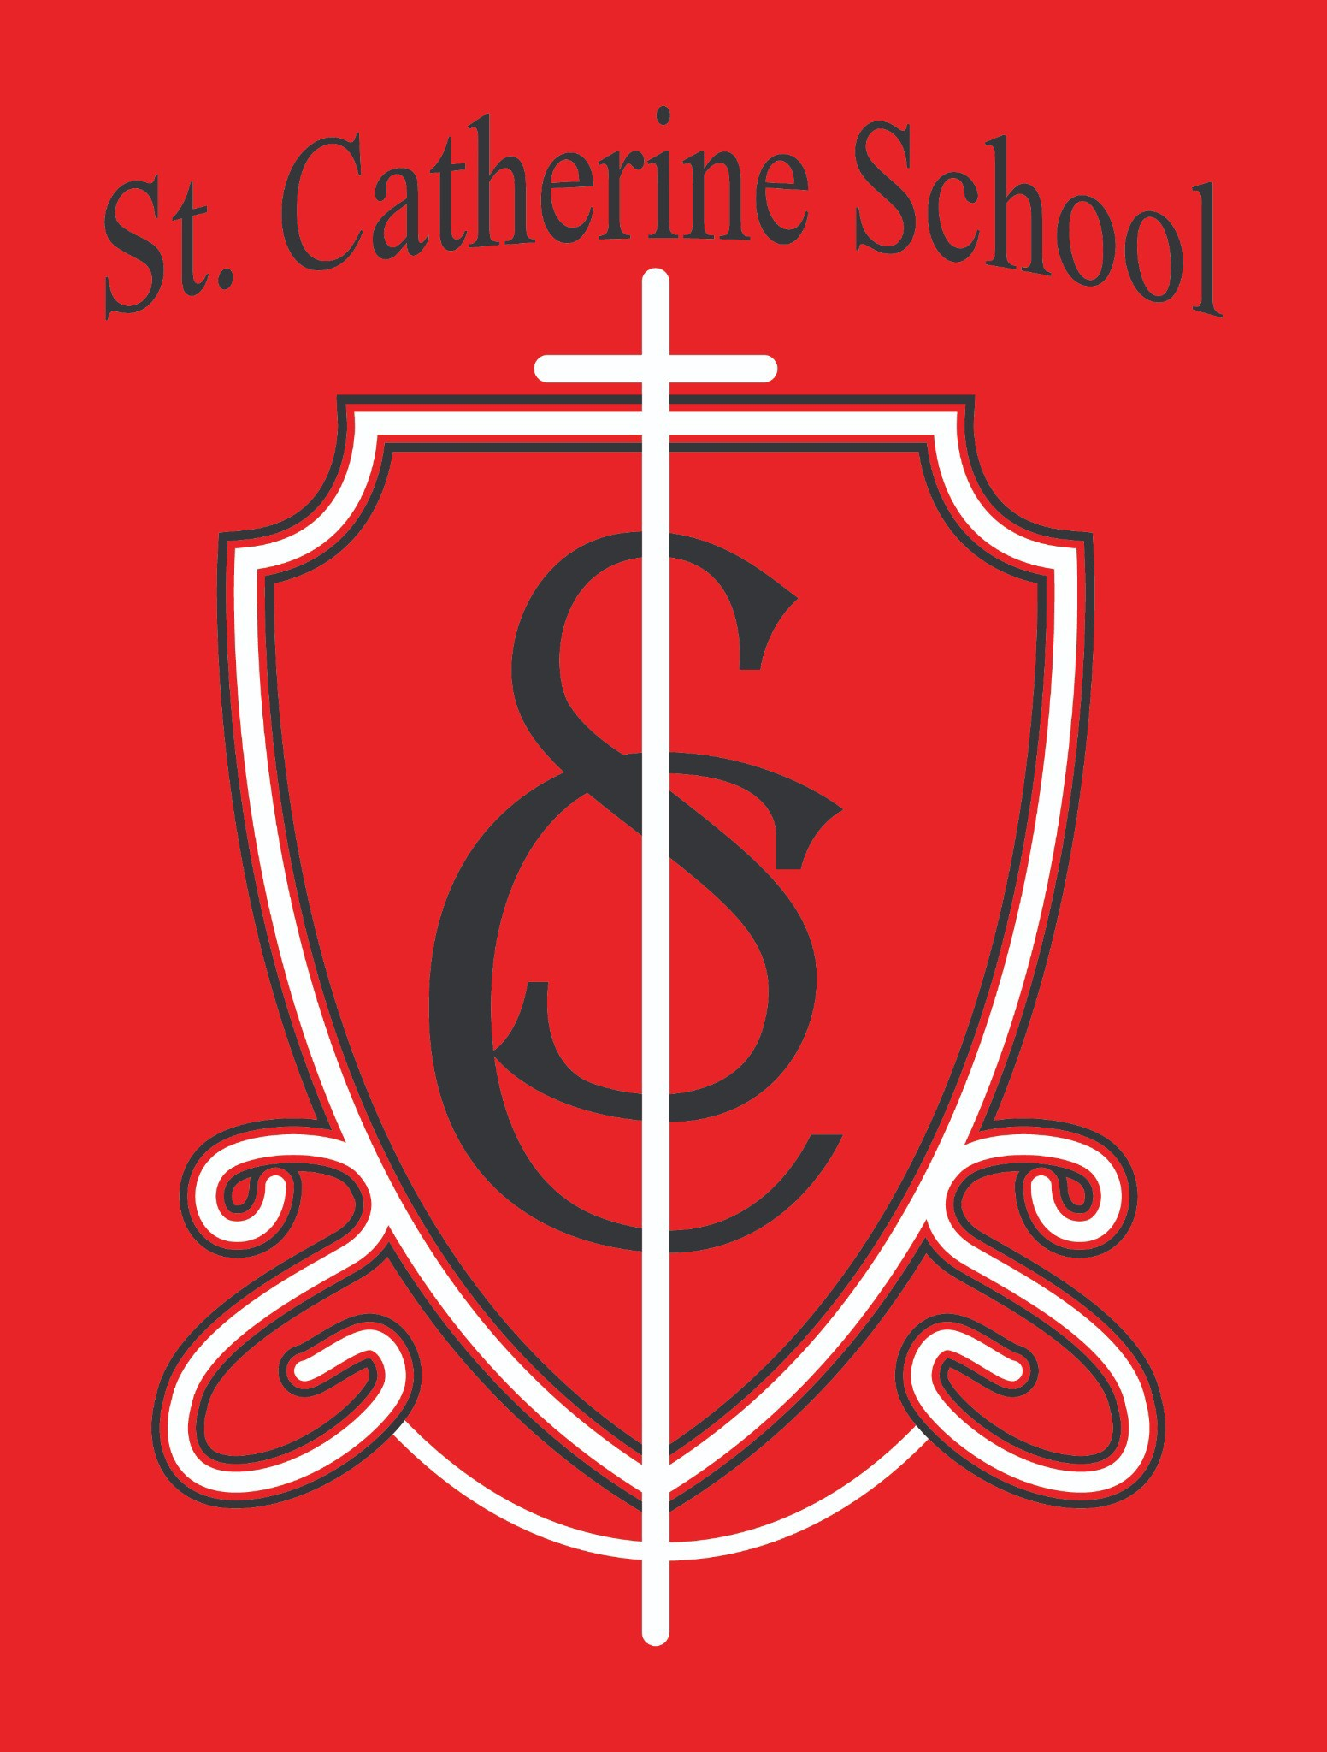

St. Catherine School Weekly Newsletter
https://www.stcatherine.k12.nd.us/parents

Principal's Message
Dear St. Catherine Families,
As we enter this sacred time of Holy Week and the Easter season, we are reminded of the ultimate sacrifice of Jesus Christ, who gave His life so that we may live in grace. It is a powerful reminder of God’s love for each of us, freely given and always present. My hope is that this Easter season brings renewal, peace, and joy to each of you and your families.
On a personal note, I was blessed this week to complete my coursework at the University of Mary with the successful presentation of my graduate portfolio. This marks the final step in my program, and I will participate in the hooding and commencement ceremonies on April 25th. I am incredibly grateful for the opportunity to continue growing in my vocation and for the support of this community along the way.

Reminders

No School – Friday, April 3 (Good Friday)
No School – Monday, April 6 (Easter Monday)

No School – April 7–10 (NCEA Break/Easter Break) School Resumes – Monday, April 13

We recognize this is a long break, and we are grateful that our instructional staff will be attending the National Catholic Educational Association Conference in the Twin
Cities to invest in their professional growth and better serve our students.

School WILL be in session on Friday, April 17 (public school does not have school that day)

Summer Childcare Reminder:

If you need childcare this summer, please register as soon as possible. Our school-age program will be capped once capacity is reached.
Tuition & Food Service Billing:

All balances must be paid in full or a payment plan established by June 30 (end of fiscal year).
Tuition Assistance Deadline:
Applications are due May 15. Please contact the office with any questions.

Staffing Updates
We are excited to officially welcome Ms. Halley Thoreson to our staff for the 2026–2027 school year as our Physical Education and Resource Teacher. Ms. Thoreson will support upper-level academic needs, assist students with learning needs beyond the regular classroom, and lead our physical education program. We are very excited to have her continue her work with our students in this expanded role.
We are also hiring for a part-time Music Teacher position for the 2026–2027 school year. We are open to working with non-traditional candidates and can support alternative licensure pathways for individuals with a degree in another field who feel called to teach.

St. Catherine Spotlight
Science Olympiad
Congratulations to the students selected for our regional Science Olympiad team! We are incredibly proud of their hard work and dedication. Thank you to Mrs. Gulmon, Mrs. Ihry, and Ms. Hilgemann for their time and effort in organizing practices and leading this year’s competition.
Growing Childcare Program
We have recently had several families reach out with interest in our childcare programs. We are very thankful for the continued referrals and support from our current school and childcare families. Your trust and word-of-mouth support are what allow our programs to grow and thrive.

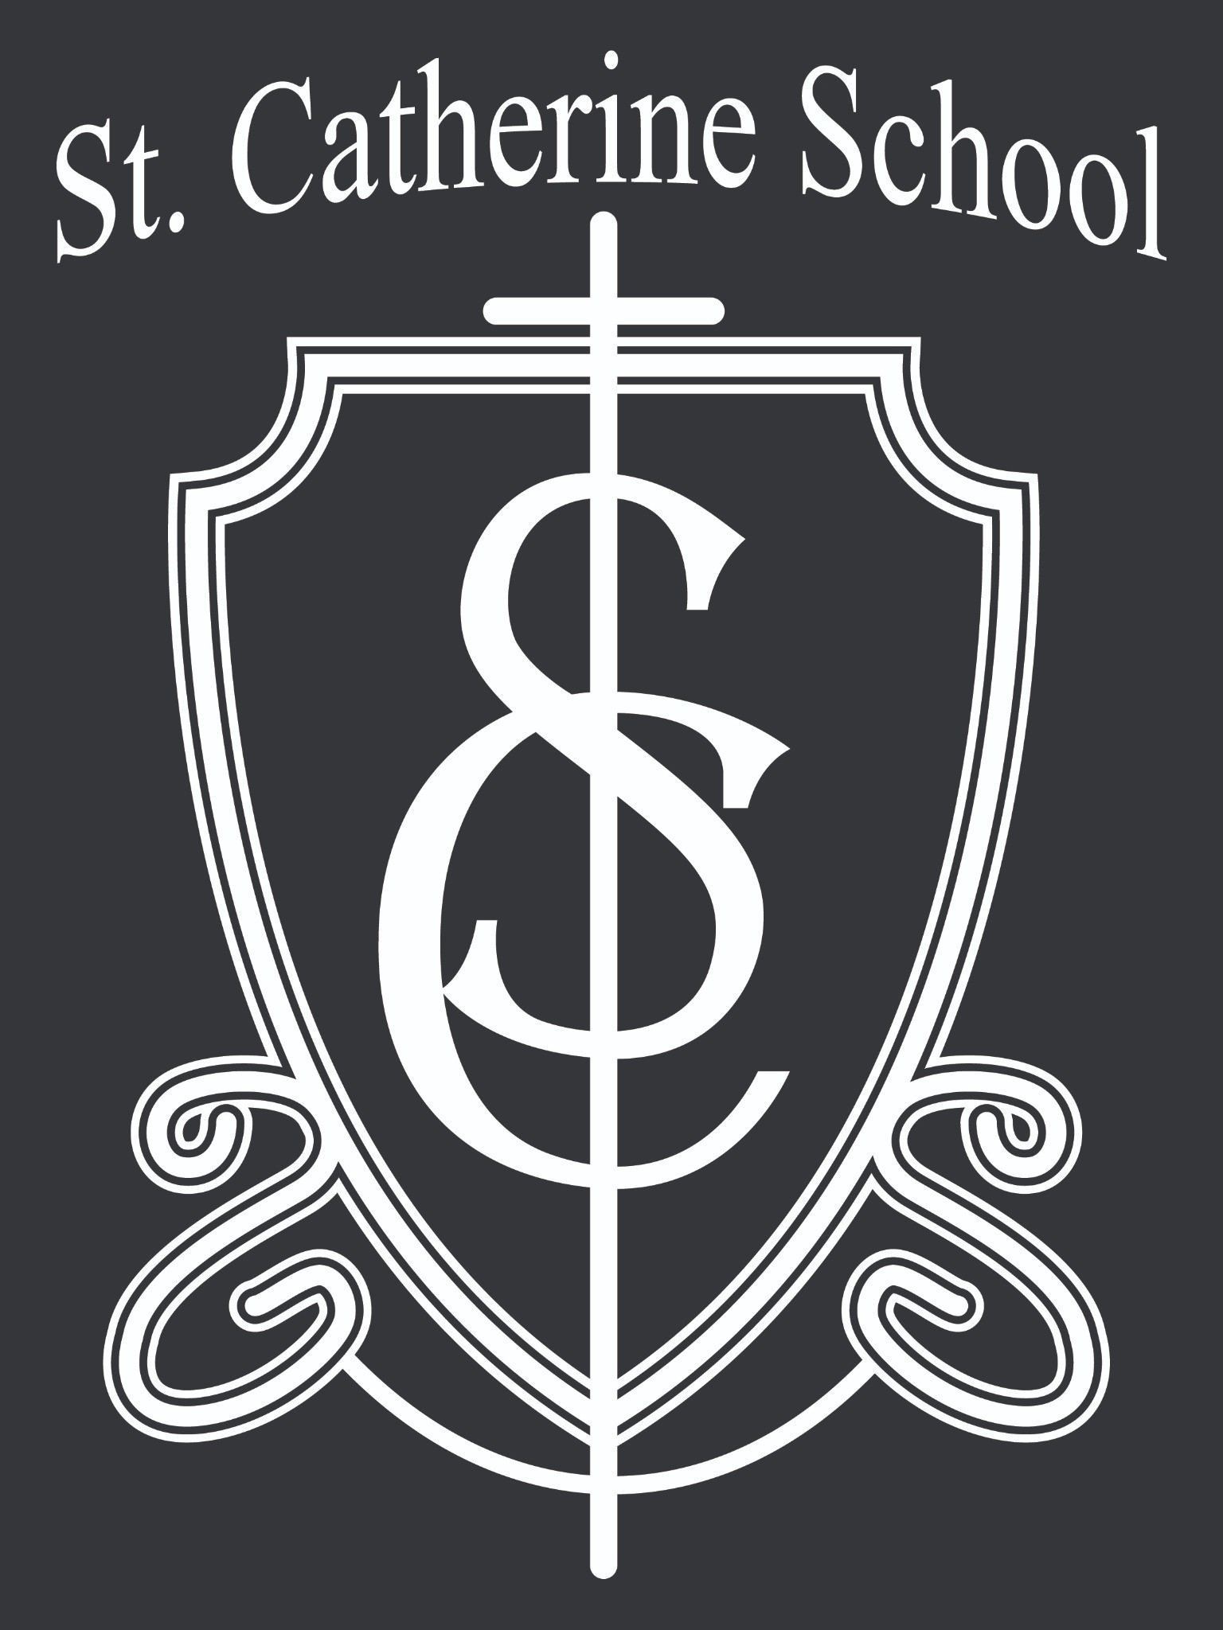

Stay Connected with St. Catherine School
📍 Address: 540 3rd Ave. NE, Valley City, ND 58072
Email: nicholas.lee1@k12.nd.us
📧
Phone: 1-701-845-1453
📞
Website: www.stcatherine.k12.nd.us
🌐
📘 Follow Us on Facebook: St. Catherine School on Facebook

“Inspiring excellence through faith, learning, and service.”

