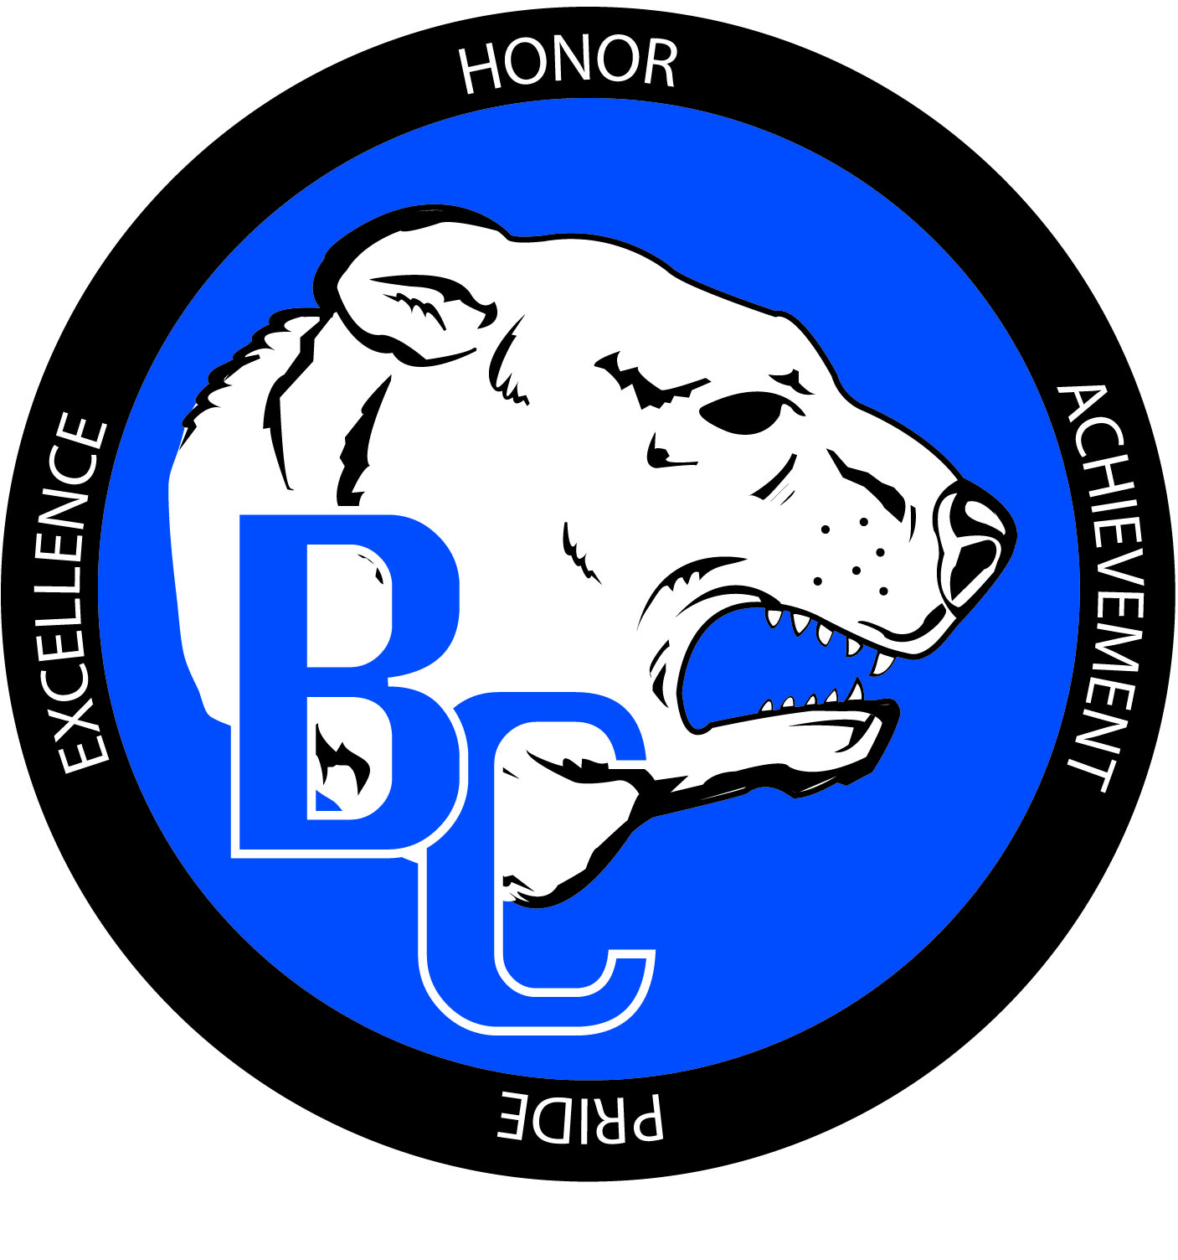
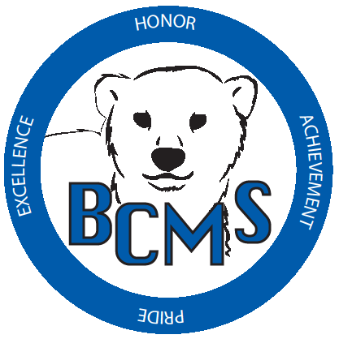
Bracken County Schools
348 West Miami Street

Brooksville, KY 41004
606-735-2523- phone 606-735-3640- fax
“Changing the world, one student at a time.”

Bracken County Schools Gifted and Talented Parent Checklist

Student Name: ______________________________ Teacher Name: _____________________
School: __________________________________ Grade: ___________ Date: _____________
Name of parent/guardian completing checklist: _______________________________________
Signature: ______________________________________

SPECIFIC ACADEMIC APTITUDE IN LANGUAGE/READING

Please check the characteristics that accurately describe your child’s typical behaviors.

- Is an avid reader
- Enjoys reading for pleasure and/or information
- Has a large, advanced and/or rich vocabulary
- Shares books with others
- Writes for fun
- Writes effectively
- Enjoys composing poems, original stories, plays, keeping a journal, or writing information pieces
- Shares writing with others
- Exhibits great desire to excel
- Is eager to tell others about discoveries and shows excitement in voice when talking about this subject
- Prefers to work individually
- Is eager to complete tasks
- Is very alert: supplies rapid answers
- Enjoys talking with others
Additional Comments:

