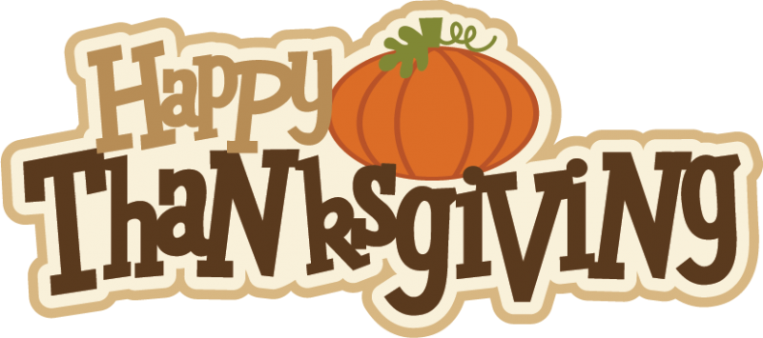
CLASS NEWS
Mrs. Williams
Date: November 22, 2022

Reading:
Skills: we will practice learned skills

Spelling:
-No list or test this week

Math:
-subtract two-digit numbers with regrouping

Special Events:
Have a wonderful Thanksgiving holiday!!

No school – November 23, 24, 25

