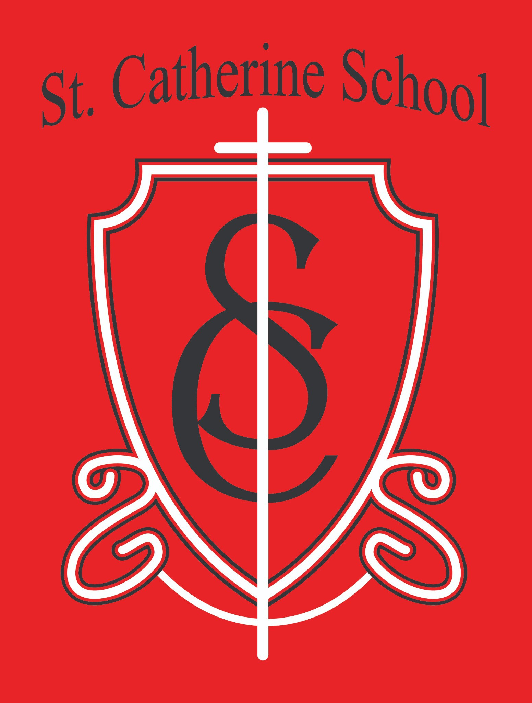

**St. Catherine School Weekly Newsletter (Week of March 10- 14)**

[**https://www.stcatherine.k12.nd.us/parents**](https://nam02.safelinks.protection.outlook.com/?url=https%3A%2F%2Fwww.stcatherine.k12.nd.us%2Fparents&amp;data=05%7C02%7CTerra.Giesen%40k12.nd.us%7Cbb2a3e7eb6eb4dedf38e08dd6565de80%7Cdbbf782acef14af186c81f9201061db6%7C0%7C0%7C638778210504693298%7CUnknown%7CTWFpbGZsb3d8eyJFbXB0eU1hcGkiOnRydWUsIlYiOiIwLjAuMDAwMCIsIlAiOiJXaW4zMiIsIkFOIjoiTWFpbCIsIldUIjoyfQ%3D%3D%7C0%7C%7C%7C&amp;sdata=ByNChZkVU9MGoJ6lwQqaQtnkCGSO7%2FcYuZ%2BN91LBu6Q%3D&amp;reserved=0)

# Principal's Message

Dear St. Catherine Families,

Three years ago, I answered God’s call to serve as principal of St. Catherine School. On the very same day, I was offered what I thought would be my "forever job" as a teacher. But God had other plans. He led me here, and I am so thankful for that opportunity.

As I look at the completed and ongoing projects in the soon-to-open **St. Catherine Little Saints Childcare**, I am reminded once again that **God provides**. This journey has strengthened my faith and my belief that this community is exactly where I am meant to be. I have attached a before and after picture of the daycare work! Lots more pictures to come!

I want to take a moment to thank **you**—for trusting us with your children, for partnering with our school, and for making the educational choice that is best for your family. Your trust is a gift, and we do not take it lightly.

# Reminders

* **Daycare Updates** 🏫

We are seeking a **quality daycare director**—the full job description and application can be found here: [**St. Catherine Employment**](https://nam02.safelinks.protection.outlook.com/?url=https%3A%2F%2Fwww.stcatherine.k12.nd.us%2Femployment&amp;data=05%7C02%7CTerra.Giesen%40k12.nd.us%7Cbb2a3e7eb6eb4dedf38e08dd6565de80%7Cdbbf782acef14af186c81f9201061db6%7C0%7C0%7C638778210504730381%7CUnknown%7CTWFpbGZsb3d8eyJFbXB0eU1hcGkiOnRydWUsIlYiOiIwLjAuMDAwMCIsIlAiOiJXaW4zMiIsIkFOIjoiTWFpbCIsIldUIjoyfQ%3D%3D%7C0%7C%7C%7C&amp;sdata=vWMEex75e7j9mN2AlGw6YN7R0Pga%2F6T121bb3gEqiRY%3D&amp;reserved=0).

Our daycare transformation is well underway! The space is receiving **a new ceiling, updated lighting, fresh paint, brand-new flooring**, and **updated bathrooms and kitchen areas**.

A **new washer and dryer** have been installed to help maintain a clean and fresh environment for our Little Saints!

St. Catherine Little Saints Childcare will be a **faith-based center** serving our school, parish, and Valley City community, **honoring the dignity of the whole child— socially, emotionally, spiritually, academically, and physically**.

* **Sacrament Rehearsal & Confirmation Mass for 3rd Grade Students receiving the Sacraments of First Eucharist and Confirmation** ⛪

**Rehearsal:** Wednesday, March 19th at 6:30 PM in the church.

**Confirmation Mass with Bishop Folda:** Friday, March 21st at 5:00 PM.

**Sponsors & Candidates must arrive in the social hall by 4:30 PM.**

* **Winter Gear Reminder** ❄

Please send winter gear **back to school**. The playground is still drying out, and it’s easier for kids to remove layers than to add them. Teachers will determine needed clothing each morning.

* **Early Dismissal – April 2nd** ⏰

**School will dismiss at 12:15 PM**.

**Lunch will be served** and **buses will run** as usual.

* + **Easter Break – April 17-21** 🐣

**No school in observance of Easter.**

* + **Virtue of the Week – Fortitude: Perseverance (March 17–28)** 💪

**Focus:** Completing tasks despite difficulties.

**Saint:** St. Monica

**Scripture:** *"Daughter, your faith has saved you."* (Mark 5:25–34) **Application:** Encouraging students to **push through challenges** and track progress on **long-term goals**.

**Tuition Assistance – TAP Application Reminder** 💰

**Tuition assistance applications** for the 2025-2026 school year are now open. Applications must be submitted through **FACTS Grant & Aid**.

**Deadline: May 15, 2025** (Early applications encouraged for faster award decisions).

📅

## Apply here: [FACTS Sign-In](https://nam02.safelinks.protection.outlook.com/?url=https%3A%2F%2Fonline.factsmgt.com%2Fsignin%2F414FV&amp;data=05%7C02%7CTerra.Giesen%40k12.nd.us%7Cbb2a3e7eb6eb4dedf38e08dd6565de80%7Cdbbf782acef14af186c81f9201061db6%7C0%7C0%7C638778210504756416%7CUnknown%7CTWFpbGZsb3d8eyJFbXB0eU1hcGkiOnRydWUsIlYiOiIwLjAuMDAwMCIsIlAiOiJXaW4zMiIsIkFOIjoiTWFpbCIsIldUIjoyfQ%3D%3D%7C0%7C%7C%7C&amp;sdata=M%2BF8T9WukvPXw%2Bqx%2FRymLpcI4hylL2yC%2FXE77J6hSD8%3D&amp;reserved=0)

### If you have questions, please contact the school office for assistance.

**St. Catherine Spotlight**



* + **3rd & 4th Grade at the Water Festival**

🌊

Thank you to **VCSU and Prairie Waters** for hosting our students at the Water Festival! It was a fantastic experience for hands-on learning about water conservation and the environment.

* + **Pi(e) Day Celebration Was a Success!**

🥧

Our **early Pi(e) Day on March 13** was a huge hit! We loved celebrating with our school and parish families, and there’s a **good chance we’ll keep this tradition around**—because what’s better than a slice of pie before a four-day weekend? Not much!

Stay Connected with St. Catherine School

📍 **Address:** 540 3rd Ave. NE, Valley City, ND 58072

**Email:** [nicholas.lee1@k12.nd.us](mailto:nicholas.lee1@k12.nd.us)

📧

**Phone:** 1-701-845-1453

📞

**Website:** [www.stcatherine.k12.nd.us](https://nam02.safelinks.protection.outlook.com/?url=https%3A%2F%2Fwww.stcatherine.k12.nd.us%2F&amp;data=05%7C02%7CTerra.Giesen%40k12.nd.us%7Cbb2a3e7eb6eb4dedf38e08dd6565de80%7Cdbbf782acef14af186c81f9201061db6%7C0%7C0%7C638778210504779146%7CUnknown%7CTWFpbGZsb3d8eyJFbXB0eU1hcGkiOnRydWUsIlYiOiIwLjAuMDAwMCIsIlAiOiJXaW4zMiIsIkFOIjoiTWFpbCIsIldUIjoyfQ%3D%3D%7C0%7C%7C%7C&amp;sdata=Ymfd8f20y%2FdflLgJFpwu4X5zkNUvhdy8FoxFj6Rgew0%3D&amp;reserved=0)

🌐

📘 **Follow Us on Facebook:** [St. Catherine School on Facebook](https://nam02.safelinks.protection.outlook.com/?url=https%3A%2F%2Fwww.facebook.com%2Fst.catherineschoolvc%2F&amp;data=05%7C02%7CTerra.Giesen%40k12.nd.us%7Cbb2a3e7eb6eb4dedf38e08dd6565de80%7Cdbbf782acef14af186c81f9201061db6%7C0%7C0%7C638778210504798452%7CUnknown%7CTWFpbGZsb3d8eyJFbXB0eU1hcGkiOnRydWUsIlYiOiIwLjAuMDAwMCIsIlAiOiJXaW4zMiIsIkFOIjoiTWFpbCIsIldUIjoyfQ%3D%3D%7C0%7C%7C%7C&amp;sdata=CA5tV6DWSqxOsjHy0WrZfpF52uvQVEveDavmVKgbKgs%3D&amp;reserved=0)

*“Inspiring excellence through faith, learning, and service.”*