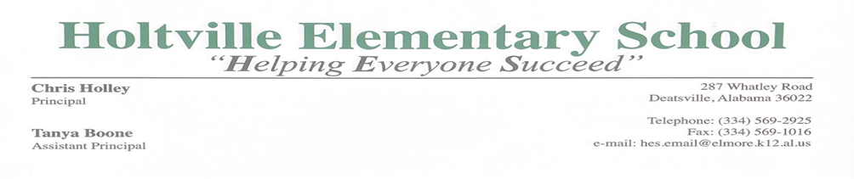

**Kindergarten**

**School-Parent Compact**

*Holtville Elementary and the parents of the students participating in activities, services, and programs funded by Title I, Part A of the Every Student Succeeds Act of 2015 (ESSA) (participating children), agree that this compact outlines how the parents, the entire school staff, and the students will share the responsibility for improved student academic achievement and the means by which the school and parents will build and develop a partnership that will help children achieve the State’s high standards.*

**This home/school compact is in effect during school year 2022-2023**

School Responsibilities

**Holtville Elementary School will**:

1. **Provide high-quality curriculum and instruction in a supportive and effective learning environment that enables the student to meet the State’s student academic achievement standards.**

HES teachers will provide purposeful and engaging learning activities to help student achieve high levels of success on state mandated assessments. STAR assessments will be used as a means to monitor progress of students’ attainment of state standards.

1. **Hold parent-teacher conferences during which this compact will be discussed as it relates to the individual child’s achievement.** Parent conferences deemed necessary by the parent or teacher will be held by phone or in person to discuss student achievement. The signed school copy of this compact will be kept in the homeroom teacher’s student file and all parent conferences/notifications will be documented on the compact.

1. **Provide parents with frequent reports on their child’s progress.** Teachers will keep parents informed by using daily assignment planners, access to weekly grades through PowerSchool Parent Portal, Progress Reports, and Report Cards.
2. **Provide parents reasonable access to staff.**

Staff will be available for consultation with parents through various means. Staff email addresses will be provided to each parent. School staff may be contacted during school hours by the use of voice mail. Parents may also communicate to the teacher by the use of the daily Assignment Book. Parents may call the office and set up a phone conference to communicate with teachers about their child’s progress.

1. **Provide parents opportunities to volunteer and participate in their child’s class, and to observe classroom activities**. Upon receiving a cleared background check, parents may observe or volunteer to help in a teacher’s classroom after notifying the homeroom teacher. Parents need to check in through the office when visiting or volunteering in a classroom. *Due to COVID 19, access to the building may be limited.
2. **Ensure regular two-way meaningful communication between family members and school staff, to the extent practicable, in a language that family members can understand.**

Teachers will keep parents informed by using the daily assignment planners, Weekly PowerSchool updates, Progress Reports, Report Cards and Promotion Policies. Teachers will have access to a county interpreter and Language line as needed to communicate. We, also, have an in-house bilingual teacher.

**Parent Responsibilities**

**As parents, we will support our child’s learning in many ways. We will:**

1. Monitor attendance.
2. Make sure homework is completed correctly.
3. Monitor amount of television watched/electronic gaming.
4. Promote positive use of my child’s extracurricular time.
5. Participate and stay informed, as appropriate, in decisions relating to my child’s education.
6. Communicate with the school by promptly reading all notices from the school or the school district either received by my child or by mail and responding as appropriate.
7. Volunteer in my child’s classroom, if possible. *Due to COVID 19, access to the building may be limited.
8. Serve, to the extent possible, on advisory groups, such as Title I advisory committees and parental involvement committees.

**Student Responsibilities**

**As a student, I will do my best. I will:**

1. Do my homework every day and ask for help when it is needed.
2. Give to my parents or the adult who is responsible for my welfare all notices and information received by me from my school every day.
3. Practice Kindergarten skills at least 15 minutes every day outside of school time.



**Holtville Elementary School**

**2021-2022**

**HES Kindergarten – School-Parent Compact**

*SIGNATURE PAGE*

_______________________________________________ ________________

Principal Date

_______________________________________________ ________________

Teacher Date

_______________________________________________ ________________

Parent Date

_______________________________________________ ________________

Student Date

Documentation of Parental Contact:

|  |  |  |  |
| --- | --- | --- | --- |
| ***Method of Communication*** | ***Date*** | ***Parent Signature***  ***(if applicable)*** | ***Teacher Signature/Initial*** |
|  |  |  |  |
|  |  |  |  |
|  |  |  |  |
|  |  |  |  |
|  |  |  |  |
|  |  |  |  |
|  |  |  |  |
|  |  |  |  |
|  |  |  |  |

*Examples of communication: Parent Report Day, phone conversations, parent-teacher conferences. Notes between teacher and parents will also be kept on file.*