Are you looking for some healthy snack ideas for your kids?
Here are some snack ideas for you to try with your family!

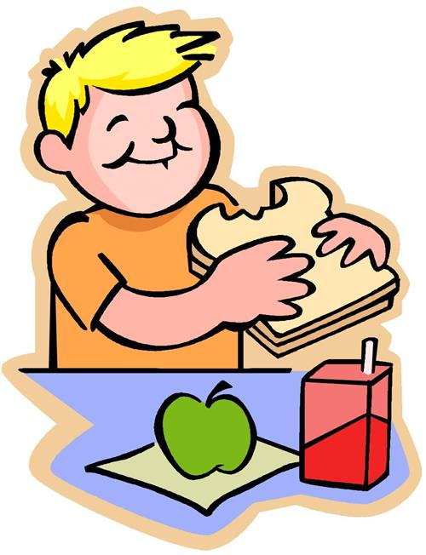

Apple and 2 tablespoons of Peanut Butter

Fresh Vegetables with 2 tablespooms of Hummus or Ranch

1/2 cup of Nuts and Dried Fruit of Your Preference

3 Cups of Popcorn and 1/4 cup of Almonds

1 English Muffin with 1 tablespoon of Nut Butter

10 Crackers with a Cheese Stick

½ Cup of Frozen Yogurt with ¼ Cup of Nuts

6 Ounces of Fruit Flavored Yogurt with 1 Tablespoon of Nuts

7-8 Grapes with ¼ cup of Walnuts

9-13 Tortilla Chips with ½ Cup Salsa

