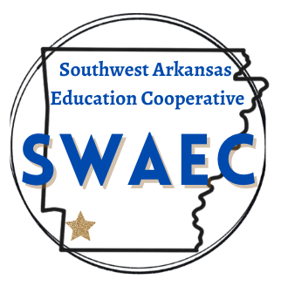

**DATE: August 13, 2025**

**TO: S.W.A.E.C. Superintendents**

**FROM: Phoebe Bailey, Director**

**SUBJECT: August Board Meeting**

**The monthly Southwest Arkansas Education Cooperative Board Meeting will be held on Thursday, August 21, 2025, 10:30 A.M., at the Co-op., Hope, AR.**

**Agenda:**

1. **Call to Order**
2. **Old Business**
   1. **Approval of Minutes for June**
3. **Financial and Expenditure Reports for June and July**
4. **New Business**
   1. **Dennis Copeland, AR Rural Ed**
   2. **Personnel Slate for Approval**
   3. **David Hampton- Business Continuity Plan Approval**
   4. **Monica Morris- Teacher Center Update**
   5. **Phoebe Bailey- Director update:** 
      * + **Teacher Growth LEA Insights**
        + **Proxy Forms**
        + **State and Federal Updates**
   6. **Other Items May Be Added As Necessary**

2502 South Main Street • Hope, AR 71801 • 870-777-3076