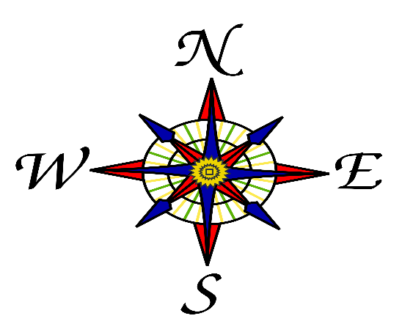

CLASS NEWS
Mrs. Williams
Date: September 12, 2022

Reading: compare/contrast story settings; renaming telling parts of sentences; identify character traits

Language: more plural nouns

Spelling: words with –ed endings (change y to i)

Math: even/odd numbers; ordinal numbers

Science/Social Studies: map skills

Upcoming Events:
- Book Fair – Week of September 26

- Early Dismissal @ Noon – Wednesday, September 28

- Conferences – Thursday, September 29 - No School for Students Friday, September 30 is a REGULAR SCHOOL DAY

