LEGAL NOTICE

The SCHOOL BOARD OF GADSDEN COUNTY, FLORIDA, announces its School Board Workshop, and its Regular School Board Meeting, to which all interested persons are invited and opened to the public.

DATE: Tuesday, May 27, 2025

School Board Workshop Regular Meeting
TIME: 4:30 P.M. 6:00 P.M.

PLACE: School Board Meeting Room
Max D. Walker School Administration Building
35 Martin Luther King, Jr. Blvd.

Quincy, Florida

PURPOSE OF THE SCHOOL BOARD WORKSHOP: For Board members to discuss financial data issues; other such business as may be ready for consideration.

PURPOSE OF THE REGULAR SCHOOL BOARD MEETING: To ratify payment of bills, consider personnel actions, consider bids and quotations, consider and/or act on proposal and/or adoption of Administrative Rules, and such other business as may be ready for consideration.

A copy of this agenda may be obtained by writing to, or otherwise contacting: The School Board of Gadsden County, Florida, Attention: Mr. Elijah Key, Superintendent of Schools, 35 Martin Luther King, Jr. Blvd., Quincy, Florida 32351.

Notice is hereby given that if a person decides to appeal any decision made by the Board with respect to any matter considered at the meeting, he will need a record of the proceedings, and for such purpose he may need to ensure that a verbatim record of the proceedings are made, which records would include the testimony and evidence upon which the appeal is to be based.

Dated this 22nd day of May, 2025 A.D.

THE SCHOOL BOARD OF GADSDEN COUNTY, FLORIDA
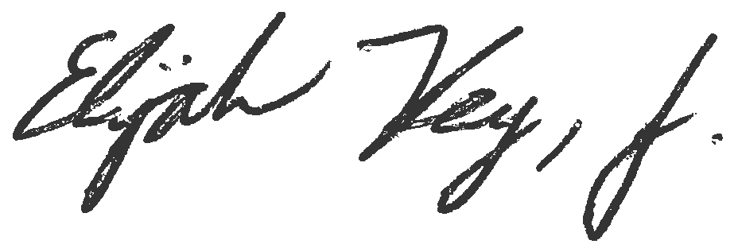

__________________________________

Elijah Key, Superintendent of Schools

